MSCI 432 Course Notes

Production and Service Operations Management

Paolo Torres

**University of Waterloo**

**Winter 2021**

Table of Contents

1 Operations Management and Demand Forecasting (I) 1

1.1 Operations Management 1

1.1.1 Basic Premise of Supply and Demand 1

1.1.2 Operations as an Aggregate Function 1

1.1.3 What Operations Managers Do 1

1.1.4 The Importance of Collaboration 2

1.1.5 Concept of Value Added 2

1.1.6 Stakeholder Management 2

1.2 Demand Forecasting 2

1.2.1 Forecast Commonalities 3

1.2.2 Requirements for a Useful Forecast 3

1.2.3 How it is Done 3

1.2.4 Judgemental Approaches 3

1.2.5 Quantitative Approaches 3

1.2.6 Time Series Modeling 3

1.2.7 Forecasting Accuracy 6

1.2.8 Dealing with Control Charts 7

2 Demand Forecasting (II) and Product Design 8

2.1 Demand Forecasting 8

2.1.1 Trend Adjusted Forecasts (TAF) 8

2.1.2 Review of Seasonality 9

2.2 Product Design 12

2.2.1 Product Design Process 12

2.2.2 Sequential Steps in New Product Developments 12

2.2.3 Sources of New Product Ideas 13

2.2.4 Key Issues in Product Design 13

3 Capacity Planning and Process Design/Facility Layout 14

3.1 Strategic Capacity Planning 14

3.1.1 Overview 14

3.1.2 Effective Capacity Planning 15

3.1.3 Focusing on Long-Term Demand 15

3.1.4 Basic Capacity Requirement Question 15

3.1.5 Major Concerns When Assessing Various Capacity Alternatives 16

3.1.6 Break-Even Analysis 16

3.2 Process Design and Facility Layout 17

3.2.1 General Overview 17

3.2.2 Process Types 18

3.2.3 Process Considerations – Matching Process to Product Type and Volume 18

3.2.4 Automation 18

3.2.5 Process Design 19

3.2.6 Fail-Safe Service Process 19

3.2.7 Service Process Design 19

3.2.8 Basic Layout Types 19

3.2.9 Assembly Line Balancing 20

4 Quality Management and Statistical Process Control 22

4.1 Quality Management 22

4.1.1 Quality Overview 22

4.1.2 Quality Certifications 23

4.1.3 Hazard Analysis Critical Control Point (HACCP) 23

4.1.4 Problem Solving, Process Improvement, and Quality Tools 23

4.2 Statistical Quality Control 23

4.2.1 Elements of Statistical Process Control (SPC) Process 23

4.2.2 Control Charts 24

5 Supply Chain Management (SCM) 29

5.1 SCM Part 1 29

5.1.1 SCM 29

5.1.2 The Need for SCM and Potential Benefits 29

5.1.3 Bullwhip Effect 29

5.1.4 Strategic and Tactical/Operational Activities in SCM 30

5.1.5 Efficient Replenishment Systems 30

5.1.6 Information Technology Used in SCM 30

5.1.7 Requirements and Key Steps in Creating Effective SCM 30

5.1.8 Reasons for Outsourcing 31

5.1.9 CPFR and the Value of Strategic Planning 31

5.1.10 SCOR Performance Metrics Model 31

5.2 SCM Part 2 31

5.2.1 Responsibilities and Activities of Purchasing 31

5.2.2 Benefits of E-Commerce 32

5.2.3 Value Analysis and Spend Analysis 32

5.2.4 Supplier Management and Partnership 32

5.2.5 Logistics and Reverse Logistics 32

5.2.6 Process and Factors Considered When Selecting a Transportation Mode 33

6 Inventory Management (I) 35

6.1 Basics 35

6.1.1 Definition of Inventory 35

6.1.2 Why Inventories Demand Respect 35

6.1.3 Turnover Rate 35

6.2 Functions and Characteristics of Effective Inventory Management 35

6.3 Requirements for Effective Inventory Management 36

6.3.1 Efficient Order Quantity (EOQ) 36

6.3.2 Efficient Production Quantity (EPQ) 38

6.3.3 EOQ with Quantity Discounts 40

6.3.4 EOQ with Planned Shortages 41

7 Inventory Management (II) 43

7.1 Fixed Order Quantity – Reorder Point Model 43

7.1.1 ROP Using Lead Time Service Level 43

7.1.2 ROP Using Annual Service Level 44

7.2 Fixed Order Interval – Order Up to Level Model 44

7.2.1 Definition 44

7.2.2 Equations 44

7.2.3 Examples 45

7.3 Single Period Model 47

7.3.1 Characteristics 47

7.3.2 Costs 47

7.3.3 Continuous Stocking Levels 47

7.3.4 Example: Continuous Stocking Levels 48

7.3.5 Discrete Stocking Levels 48

7.3.6 Example: Discrete Stocking Levels 48

8 Aggregate Operations Planning (AOP) 50

8.1 Basic Concepts, Practical Options, Basic Strategies, AOP Techniques 50

8.1.1 Review of the Basic Concepts 50

8.1.2 Practical Options to Deal with Demand and Capacity Fluctuations 50

8.1.3 Basic Strategies Available to Operations Planners 51

8.1.4 AOP Techniques 51

8.2 AOP Relationships, Trial and Error Procedure, Trade-Off Analysis, ASP 52

8.2.1 AOP Relationships 52

8.2.2 Trial and Error Procedure 55

8.2.3 Trade-Off Analysis 55

8.2.4 Aggregate Services Planning (ASP) 58

9 Material Requirements Planning (MRP) 61

9.1 Concept of MRP, Key Requirements, Material Resource Plan 61

9.1.1 Concept of MRP 61

9.1.2 Key Requirements 61

9.1.3 Material Resource Plan 61

9.2 Review of MRP, Part Period Method, Capacity Requirements Planning 65

9.2.1 Review of MRP 65

9.2.2 Part Period Method (PPM) 66

9.2.3 Capacity Requirements Planning (CRP) 67

10 Just-in-Time, Lean Production and Project Management 69

10.1 JIT and Lean Production 69

10.1.1 JIT and Lean Production 69

10.1.2 The Goals of Lean Production 69

10.1.3 Product Design 69

10.1.4 Process Design 70

10.1.5 Personnel/Organization 71

10.2 Project Management 73

10.2.1 Definition of a Project, Nature of a Project Manager’s Job 73

10.2.2 Project Planning 73

10.2.3 Project Scheduling 74

10.2.4 PERT/CPM Technique and Deterministic Activity Durations 74

# Operations Management and Demand Forecasting (I)

## Operations Management

### Basic Premise of Supply and Demand

* As consumers, we decide how much we want to buy and how much we are willing to pay
* Consumers hold the cash and as such are the ultimate decision makers
* This underlies OM as it goes to the heart of the environment in which firms operate

### Operations as an Aggregate Function

**What is Operations Management?**

* OM is the management of activities and resources that create goods and provide services
* Companies use OM to improve efficiency and effectiveness

**Why Study Operations Management?**

* A large percentage of a company’s expenses occur in the OM area
* A large number of all jobs are in the OM area
* Activities in all other areas are interrelated with OM activities

**Three Basic Functions:**

1. Operations: Create goods and services
2. Finance: Provide funds and the economic analysis of investment proposals
3. Marketing: Assess customer wants and needs and communicate them to others

**Types of OM Decisions:**

* Design (strategic) decisions that are medium to long term and deal with capital equipment and other physical assets (equipment needs, production capacity, etc.)
* Day-to-day operations involve the everyday decisions such as scheduling, packaging, quality control, and labour requirements

### What Operations Managers Do

**Defining the Role of the Operations Manager:**

* Core (manufacturing)
* Support (maintenance, accounting, HR, purchasing)
* Managerial (general administration)

**The Operations Manager’s Job:**

|  |  |
| --- | --- |
| **Management Process** | **Field of Responsibility** |
| Planning | Capacity, location, make or buy |
| Organizing | Centralization, specialization, staffing |
| Controlling | Inventory, quality, motivation |
| Directing | Scheduling, incentive plans, work orders |

**Establishing Priorities:**

* Pareto Phenomenon: A few factors account for a high percentage of the occurrence of some event(s)
* 80/20 Rule: 80% of problems are caused by 20% of the activities

### The Importance of Collaboration

* A clear and comprehensive systems-based approach for issues is in demand
* Coordination between marketing and operations is essential for success
* For example, changing a package form needs to account for inventory costs and order quantities, existing packaging inventories, new equipment needs, plant layout, etc.

### Concept of Value Added

* Difference between the cost of goods and the value of outputs
* For services, the cost of services and the value placed on those services by individuals
* Value of output is determined by the prices that consumers are willing to pay for goods

### Stakeholder Management

* “Any group or individual who can affect or is affected by the achievement of an organization’s objective” (Freeman, 1984)
* Stakeholders may include customers, employees, suppliers, financiers, etc.

## Demand Forecasting

* Underlies strategic planning when it comes to plant or service design
* Essential for budgeting and determining capital requirements for both inputs and projects
* Dictates medium-term operations and affects short-term operations

### Forecast Commonalities

1. Rely, to some extent, upon past demand and criteria identified as affecting that demand
2. Forecasts of aggregate demand for similar goods is more accurate than forecasts for individual items within a category
3. Increasing forecast horizons introduces greater uncertainty and reduced reliability

### Requirements for a Useful Forecast

1. Forecast should be long enough to make it relevant
2. Limitations on accuracy must be clearly stated
3. Forecasting method should be reliable
4. Operations forecasts should be expressed in units

### How it is Done

1. Determine why you are forecasting (who wants it and what will they use it for)
2. Assess and state the required levels of detail and accuracy
3. Establish a forecasting horizon
4. Gather historical data
5. Select a forecasting method
6. Complete the forecast
7. Monitor its accuracy

### Judgemental Approaches

* Includes things such as hunches, personal opinions, non-quantitative observations
* Can be tainted by personal bias
* Developed as a non-quantitative analysis of historical data or analysis of subjective data

### Quantitative Approaches

* Utilize hard data from the past (untainted from personal bias)
* Time series models (identifies patterns in data and projects these trends into the future)
* Associative models (describes demand in terms of independent causal variables)

### Time Series Modeling

* A time-ordered sequence of observations taken at regular intervals over a period of time
* Assumes that future values of the series can be estimated from past values

**Data Behaviour:**

* Average (level): Horizontal pattern
* Trend: Persistent upward or downward pattern
* Seasonality: Regular wavelike pattern that corresponds with some repeatable event
* Cycles: Lasts more than one year and looks at longer-term patterns
* Irregular Variations: One-time events that tend to skew the data
* Random Variations: Multitude of minor events that combine to affect the data

**Methods:**

Naïve Method:

* Assumes that the value of the data for the last period will be the value of the next period
* Can be applied to average, trend, and seasonal data

|  |  |  |  |
| --- | --- | --- | --- |
| **Period** | **Actual** | **Change** | **Naïve Forecast** |
|  |  |  |  |
|  |  |  |  |
|  |  |  |  |

**Averaging Methods:**

* Three types: moving average, weighted moving average, and exponential smoothing
* Requires stable data and can handle random variations but not irregular data points

Moving Average Method:

* Average of recent observations are used as the basis for the current forecast
* Choice of the number of data points used for the calculation will affect the sensitivity of the average to the most recent data point

|  |  |
| --- | --- |
| **Period** | **Demand** |
| 1 | 42 |
| 2 | 40 |
| 3 | 43 |
| 4 | 40 |
| 5 | 41 |

Weighted Moving Average Method:

* Assigns a heavier weight to more recent data points
* Sum of the weights must equal to one

Exponential Smoothing:

* Current forecast that is based upon the previous period plus a portion of the difference between the actual outcome in the period and the quantity forecast for that period
* Notation:
* For example, if previous forecast was 42 units, previous actual demand was 40 units, and , the new forecast would be:
* Then, if the actual demand turned out to be 43, the next forecast would be:

**Associative Forecasting:**

* If I want to predict ridership from a new train station, what data might I look at?

1. Find (predictor) variables associated with ridership at other stations
2. Create a model that shows the relationship between the predictor variables and the predicted variable (ex. ridership)
3. Technique is regression analysis (ex. Simple linear regression with one variable, multiple regression that can be non-linear)
4. Test the model to see which variables are most useful in predicting ridership ()
5. Use the model to predict ridership, given the values of the predictor variables

**Associative Models:**

* Predictor Variables (): Used to predict values of the variable of interest () – independent variables
* Linear Regression: Process of finding a straight line that best fits a set of points on a graph – least squares estimation
* Multiple Regression: Models with more than one predictor variables – computations complex, created with computer

**Correlation and Excel:**

* Correlation Coefficient (): Measure of strength of the relationship between two variables
  + Ranges from (moves in same direction) to (moves in opposite direction)
* measures proportion of variation in the values of that is “explained” by the predictor variables in the regression model
  + Ranges from to (higher values means more useful predictors)

**Linear Regression Assumptions:**

* Predictions are being made only within the range of observed values
* Variations around the line are random and normally distributed

### Forecasting Accuracy

* Definition: A judgement or measurement of how accurate the forecast is to actual results from the demand being forecast (or predicted)
* Presence of random variables such as changes in tastes, preferences, and values of consumers make it almost impossible to create a perfect prediction of future demand

**Forecasting Error:**

* In words: The error for period is simply the difference between the actual demand and the forecast demand for the same period
* **Bias:** Sum of forecast errors, if positive then forecasts are underestimating demand, if negative then forecasts are overestimating demand

**Three Methods for Measuring Accuracy:**

* **Mean Absolute Deviation:**
* **Mean Squared Error:**
* **Mean Absolute Percent Error:**
  + is the value of individual forecast errors, is the number of observations

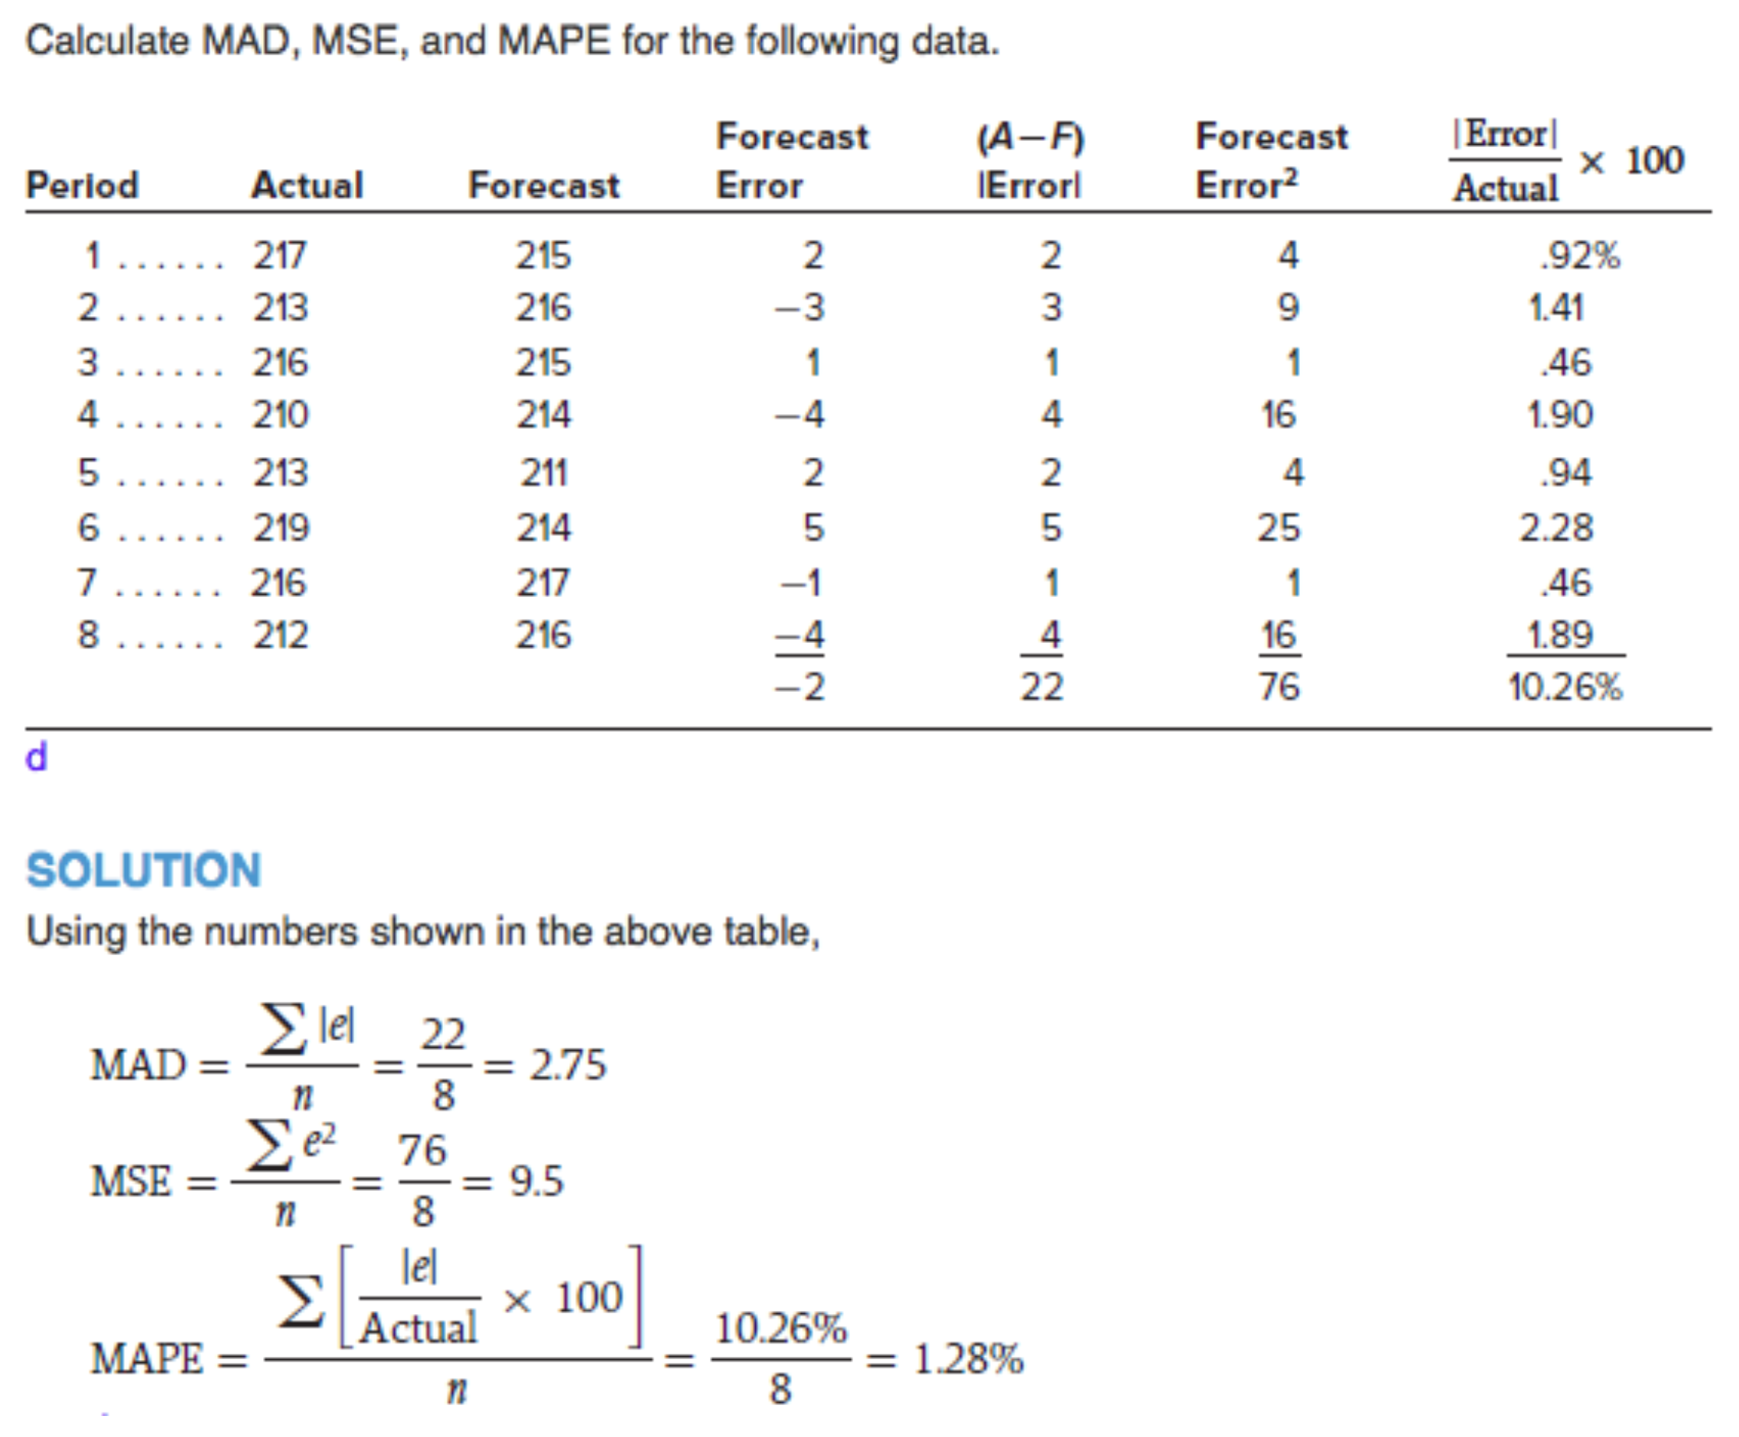

### Dealing with Control Charts

* Objective: Measure the accuracy of the forecasts within a set of prescribed boundaries
* Control limits “” based upon the square root of the mean squared error:

**Solution Process:**

1. Setup the required data table and make the necessary calculations
2. Check average forecast error and comment on its proximity to zero
3. Calculate the square root of the forecast errors
4. Determine the 2s control limits
5. Compare forecast errors to the control limits

# Demand Forecasting (II) and Product Design

## Demand Forecasting

### Trend Adjusted Forecasts (TAF)

* Slightly more complicated version of exponential smoothing:
* : Smoothed series at the end of period
* : Smoothed trend at the end of period
* and are arbitrary smoothing constants
* is the actual data from period

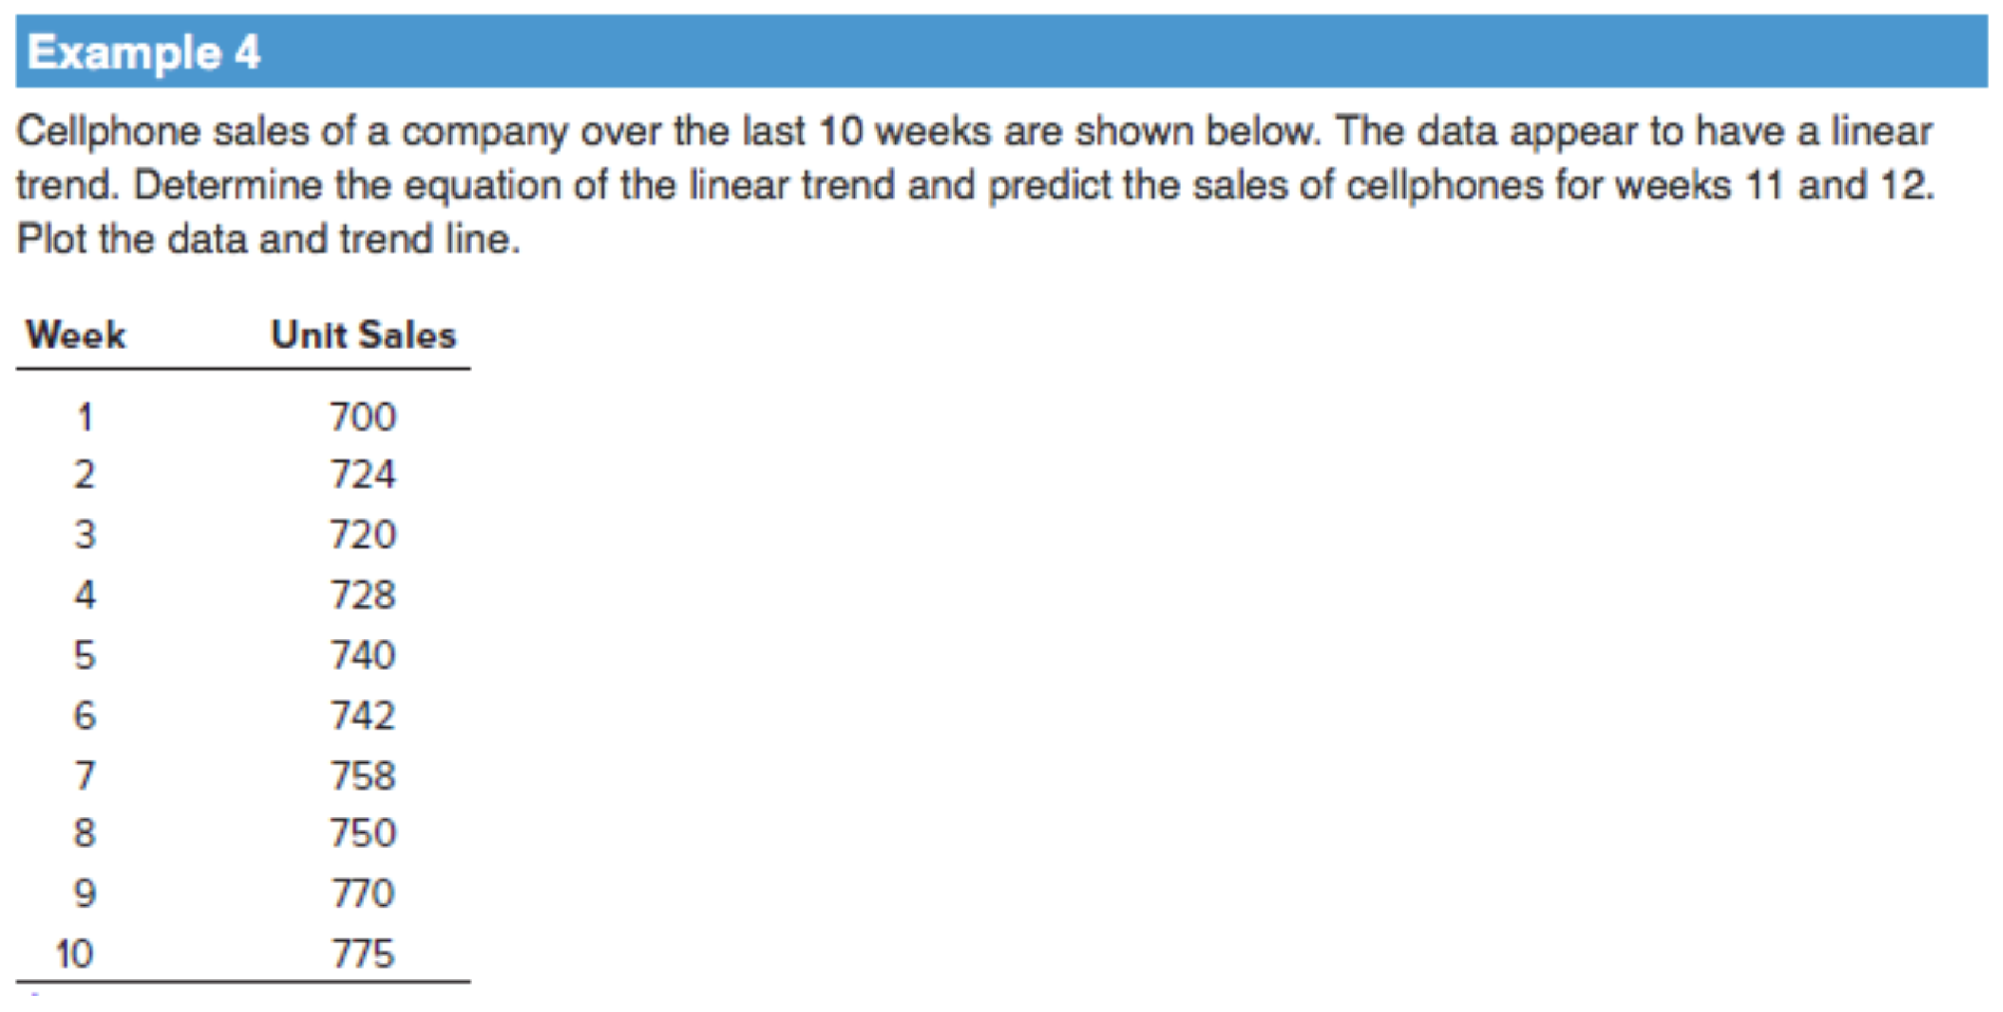

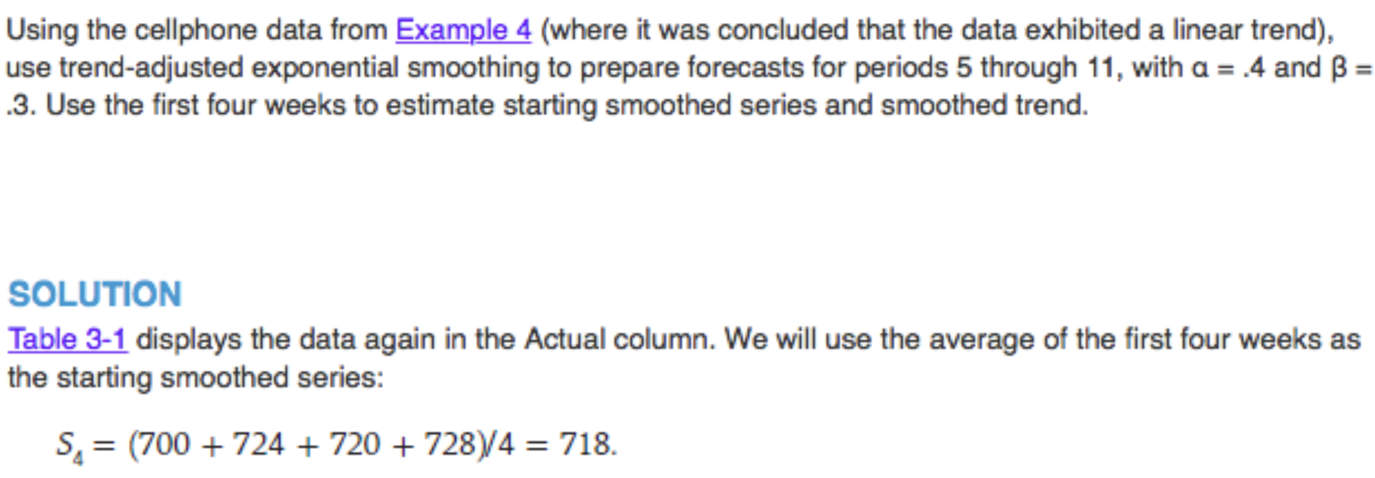

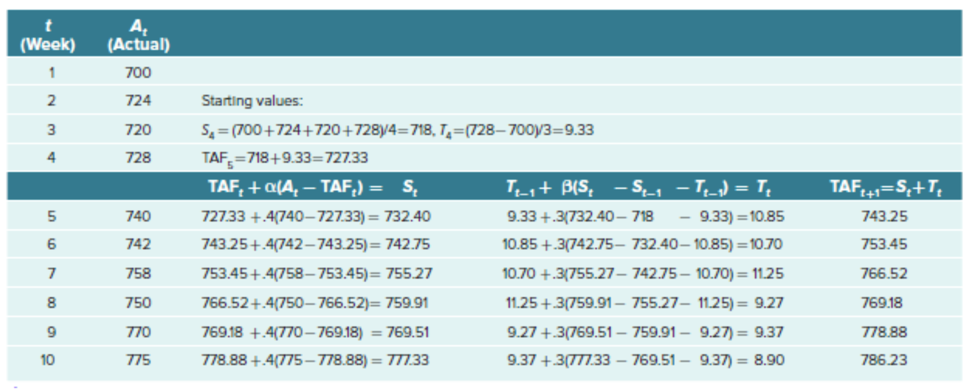

### Review of Seasonality

* Seasonal data is defined as data that exhibits a repeating pattern that is tied to some regularly occurring event (summer ice cream sales, winter natural gas sales, etc.)
* Expressed as the amount of deviation from the period average, by using the average over the length of the repeating pattern to calculate an adjustment factor
* Seasonality is measured relative to the trend

**Computing Seasonal Relatives:**

* Need to identify the trend in the data in order to compare seasonal values to some average
* Decompose data into smaller segments through use of a centered moving average (CMA)
* Number of periods in CMA is equal to the number of “seasons” portrayed in the data
* Example: Quarterly data, use a 4-period CMA

|  |  |  |  |
| --- | --- | --- | --- |
| **Period** | **Historical Value** | **CMA** | **Seasonal Relative** |
|  |  |  |  |
|  |  |  |  |
|  |  |  |  |

**Steps in Dealing with Seasonal Data:**

1. Write out the given data in table form
2. Calculate the appropriate Centered Moving Average (CMA)
3. Use CMA to calculate seasonal relatives
4. Average and adjust the seasonal relatives to the relevant seasonal data
5. Use the “adjusted” averaged seasonal relatives to de-seasonalize the original data
6. Describe the data (does it exhibits a linear trend, upward or downward)
7. Using calculated (GIVEN) Linear Trend Equation, calculate the forecasts for the periods
8. Re-seasonalize forecast using the average seasonal relatives calculated in Step 4

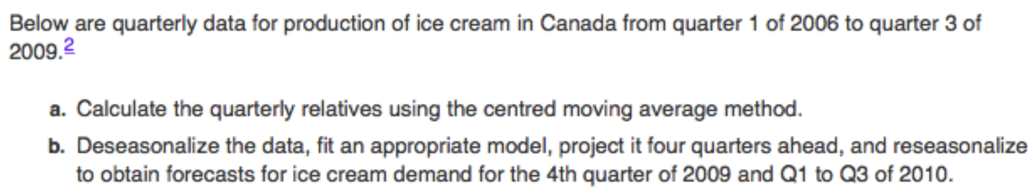

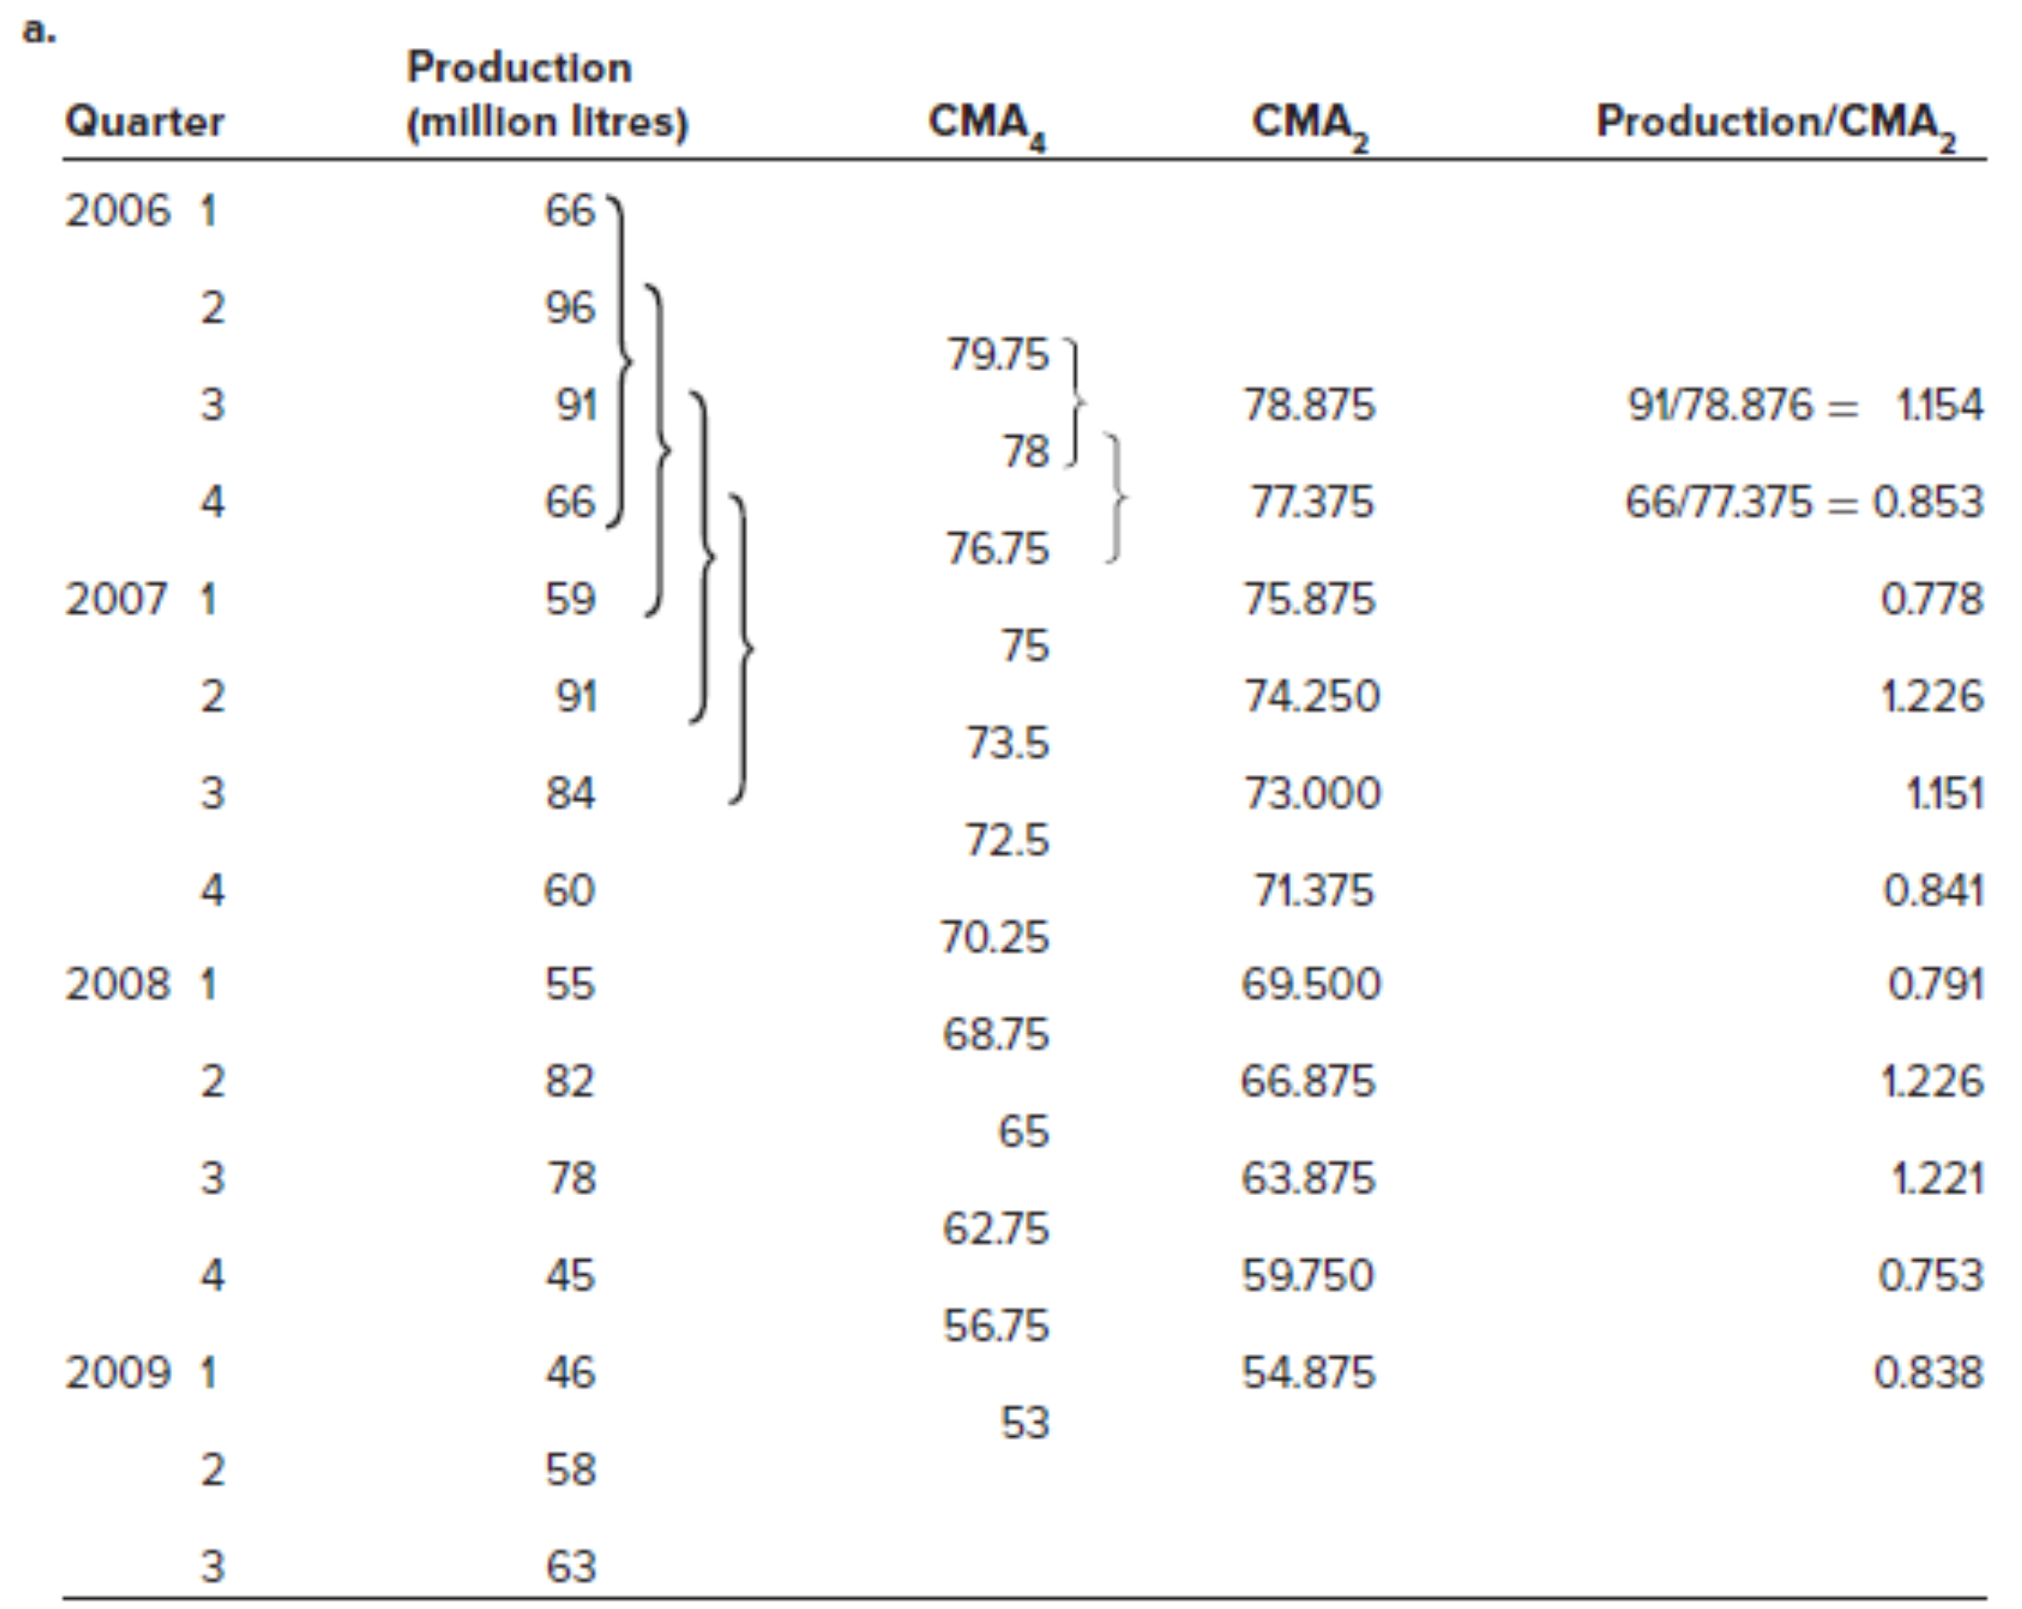

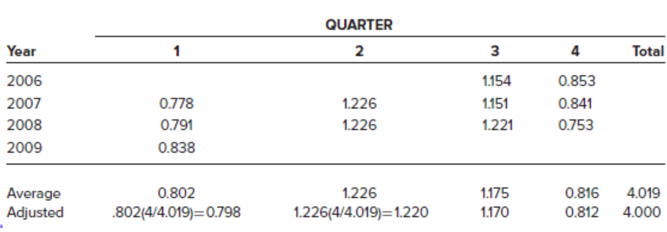

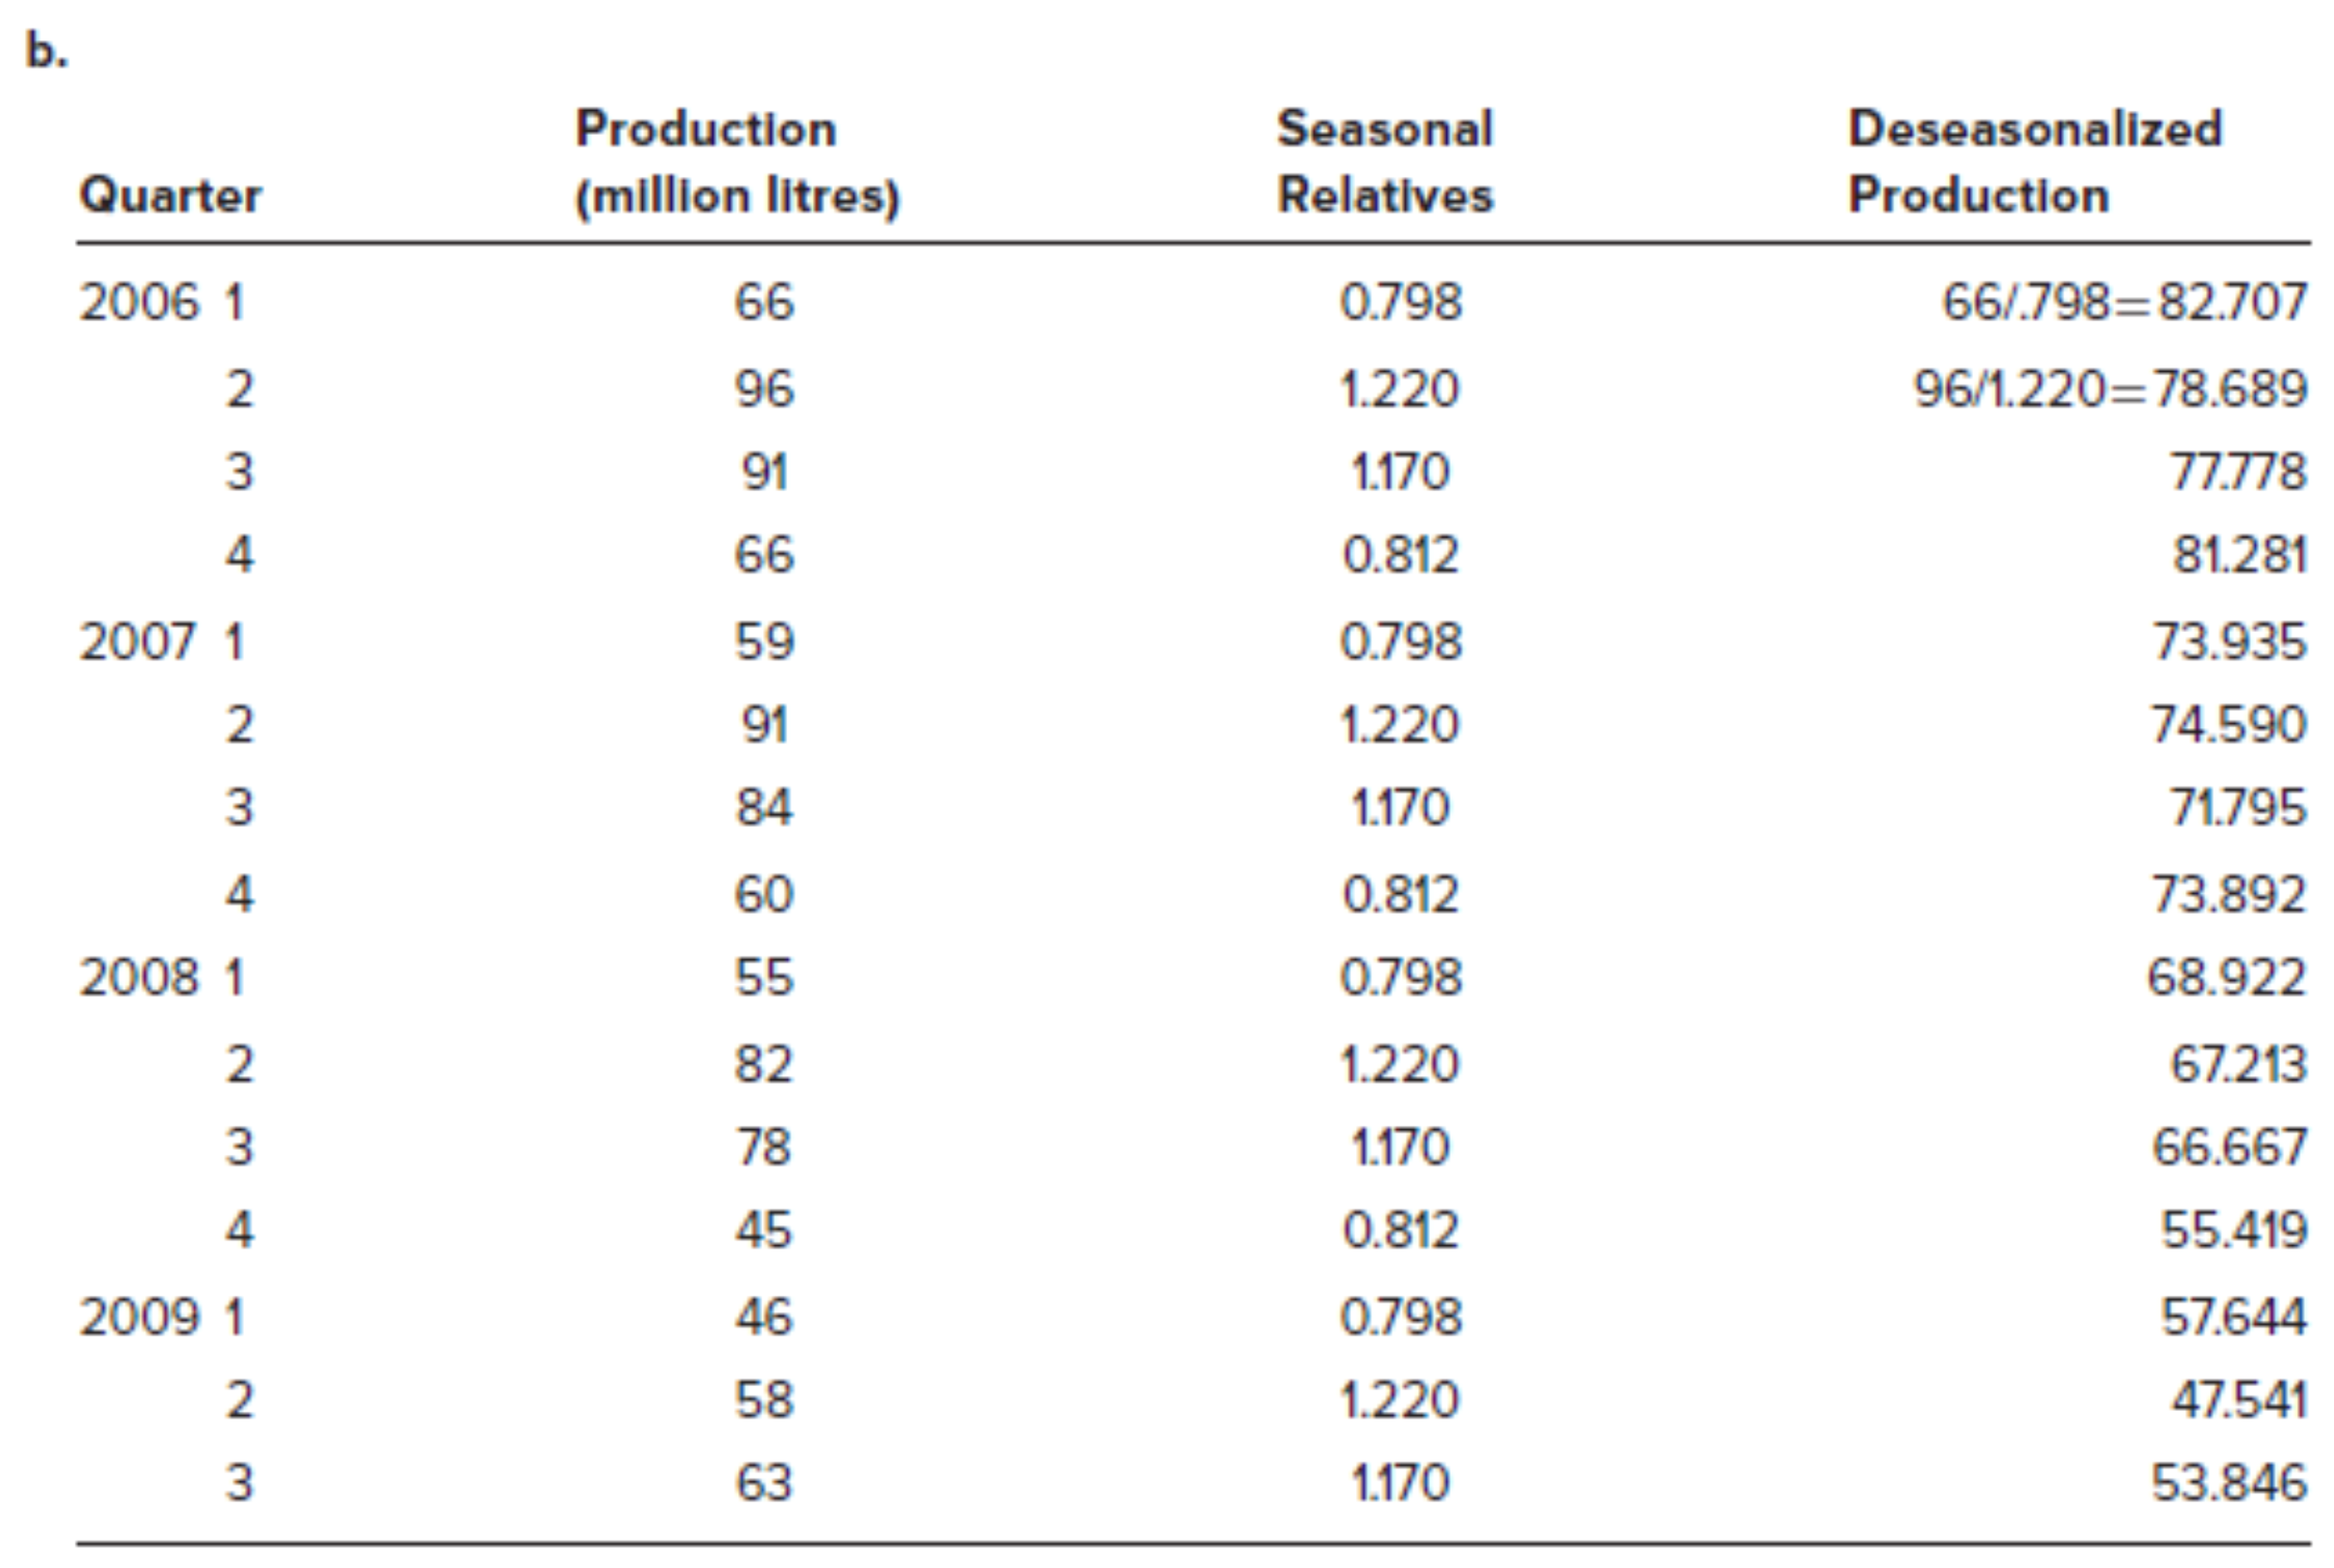

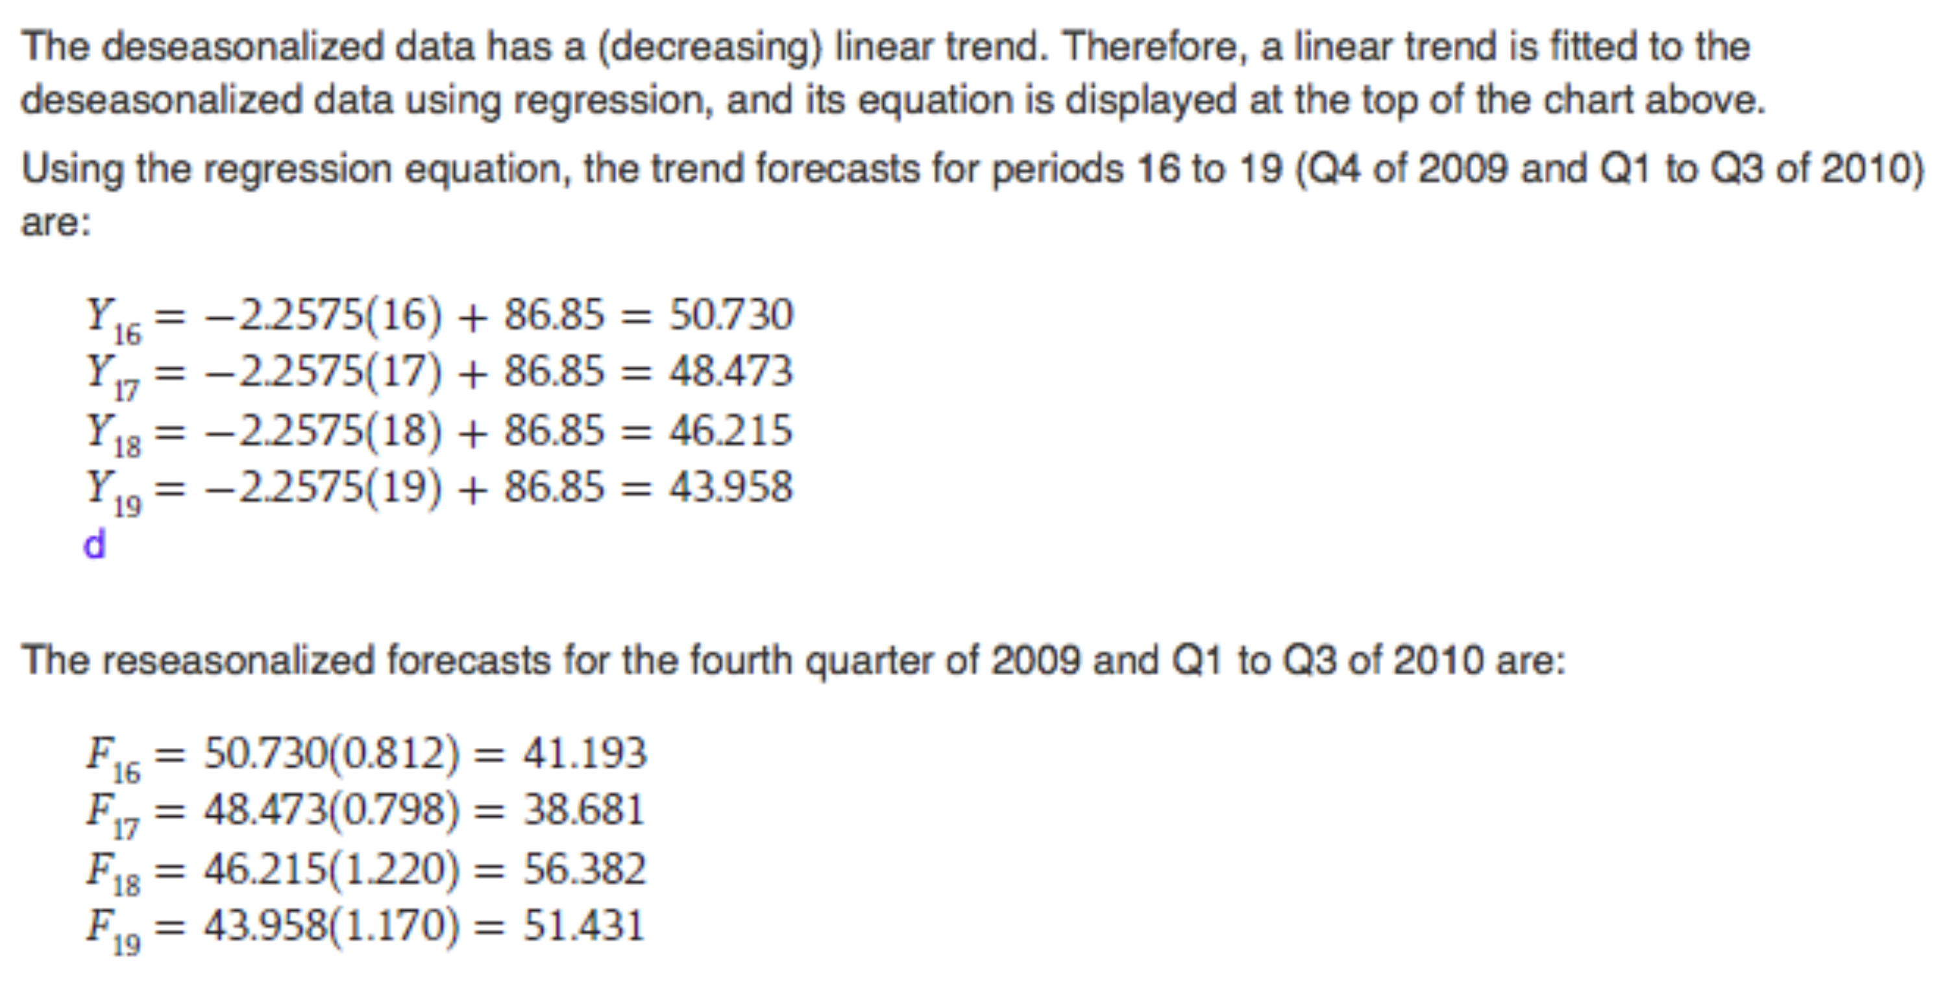

## Product Design

Product Design:

* Determines the form and function
* Is expensive and time consuming
* Governs the level of product quality and hence the level of customer satisfaction
* Contributes to competitive advantage

### Product Design Process

* Product Approval Committee: Management team
* Core Teams: Members from all aspects of the organization
* Phase Reviews: Milestones
* Structural Development: Structured and explicit project management technique

### Sequential Steps in New Product Developments

* Idea Generation
* Build a Business Case: Market and Competitive Analysis
* Development: Product attributes we need to meet or exceed customer expectations?
* Testing and Validation
* Launch

### Sources of New Product Ideas

* Customers, front-line production workers, suppliers, competitive products, R&D

### Key Issues in Product Design

**Standardization**

* Every consumer receives the same product
* High volumes of the same product reduce costs through economies of scale
* Can reduce the level of variety in product offerings
* May breed a climate of resistance of product improvements and modifications

**Design for Mass Customization:** Attempts to reach a compromise between the benefits of standardization for the producer and the desire of consumers for variety and customization

**Reliability:** Ability of a product (or part) to perform for its intended use under normal conditions

**Robust Design:** Products that can stand up under a wide range of operational environments

**Legal and Ethical Issues:** Product liability (injuries), ethical issues (sub-standard products)

**Design for the Environment:** Energy efficient, minimization of waste/packaging, etc.

**Concurrent Engineering:** Bringing design engineering staff into direct work with others

**Computer Assisted Design (CAD):** Computerizes design to avoid hand-drawn designs

**Design for Manufacturing and Assembly:** Ease can be incorporated into the design

**Component Commonality:** Occurs when a component can be used in multiple products

# Capacity Planning and Process Design/Facility Layout

## Strategic Capacity Planning

### Overview

* **Capacity:** Upper workload limit that a production unit can accommodate
* **Production Rate:** Measured in terms of the units of production per unit of time
* **Capacity Time Frames:** Long-term (1-5 years), medium-term (next 12 months), short-term (up to 12 weeks)
* **Strategic Capacity Planning:** Systematic determination of facility and equipment needs

**Importance of Long-Term Capacity**

* Capacity directly impacts the ability of the company to meet future demand
* Effective capacity planning optimizes operating costs
* Capacity decisions have a direct impact on initial capital costs
* Capacity involves long-term commitment of resources
* Capacity can directly affect competitiveness

**Measuring Capacity**

* Design Capacity: Max amount of output that can be produced under ideal conditions
* Effective Capacity: Amount of output that can realistically be made given delays, etc.
* Efficiency: Ratio of actual output to effective capacity:
* Utilization: Ratio of actual output to design capacity:

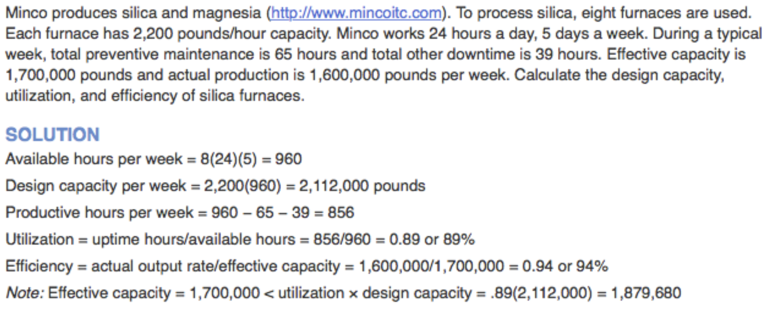

**Factors Influencing Capacity**

Facilities and equipment, products, workers, planning and operations, external factors

### Effective Capacity Planning

1. Forecast demand for a period of years or more
2. Calculate the capacity required to meet that demand
3. Measure existing in-house capacity and if necessary, begin discussing how additional capacity can be achieved

### Focusing on Long-Term Demand

1. Identify the trend as expressed over time (growth, decline, cyclical, stable)
2. Consider forecasting technique (regression, judgemental)

### Basic Capacity Requirement Question

1. Have a reasonably accurate forecast of annual demand
2. Know standard run times for each product on its respective machine
3. Know the number of hours worked per day
4. Know the number of workdays per year

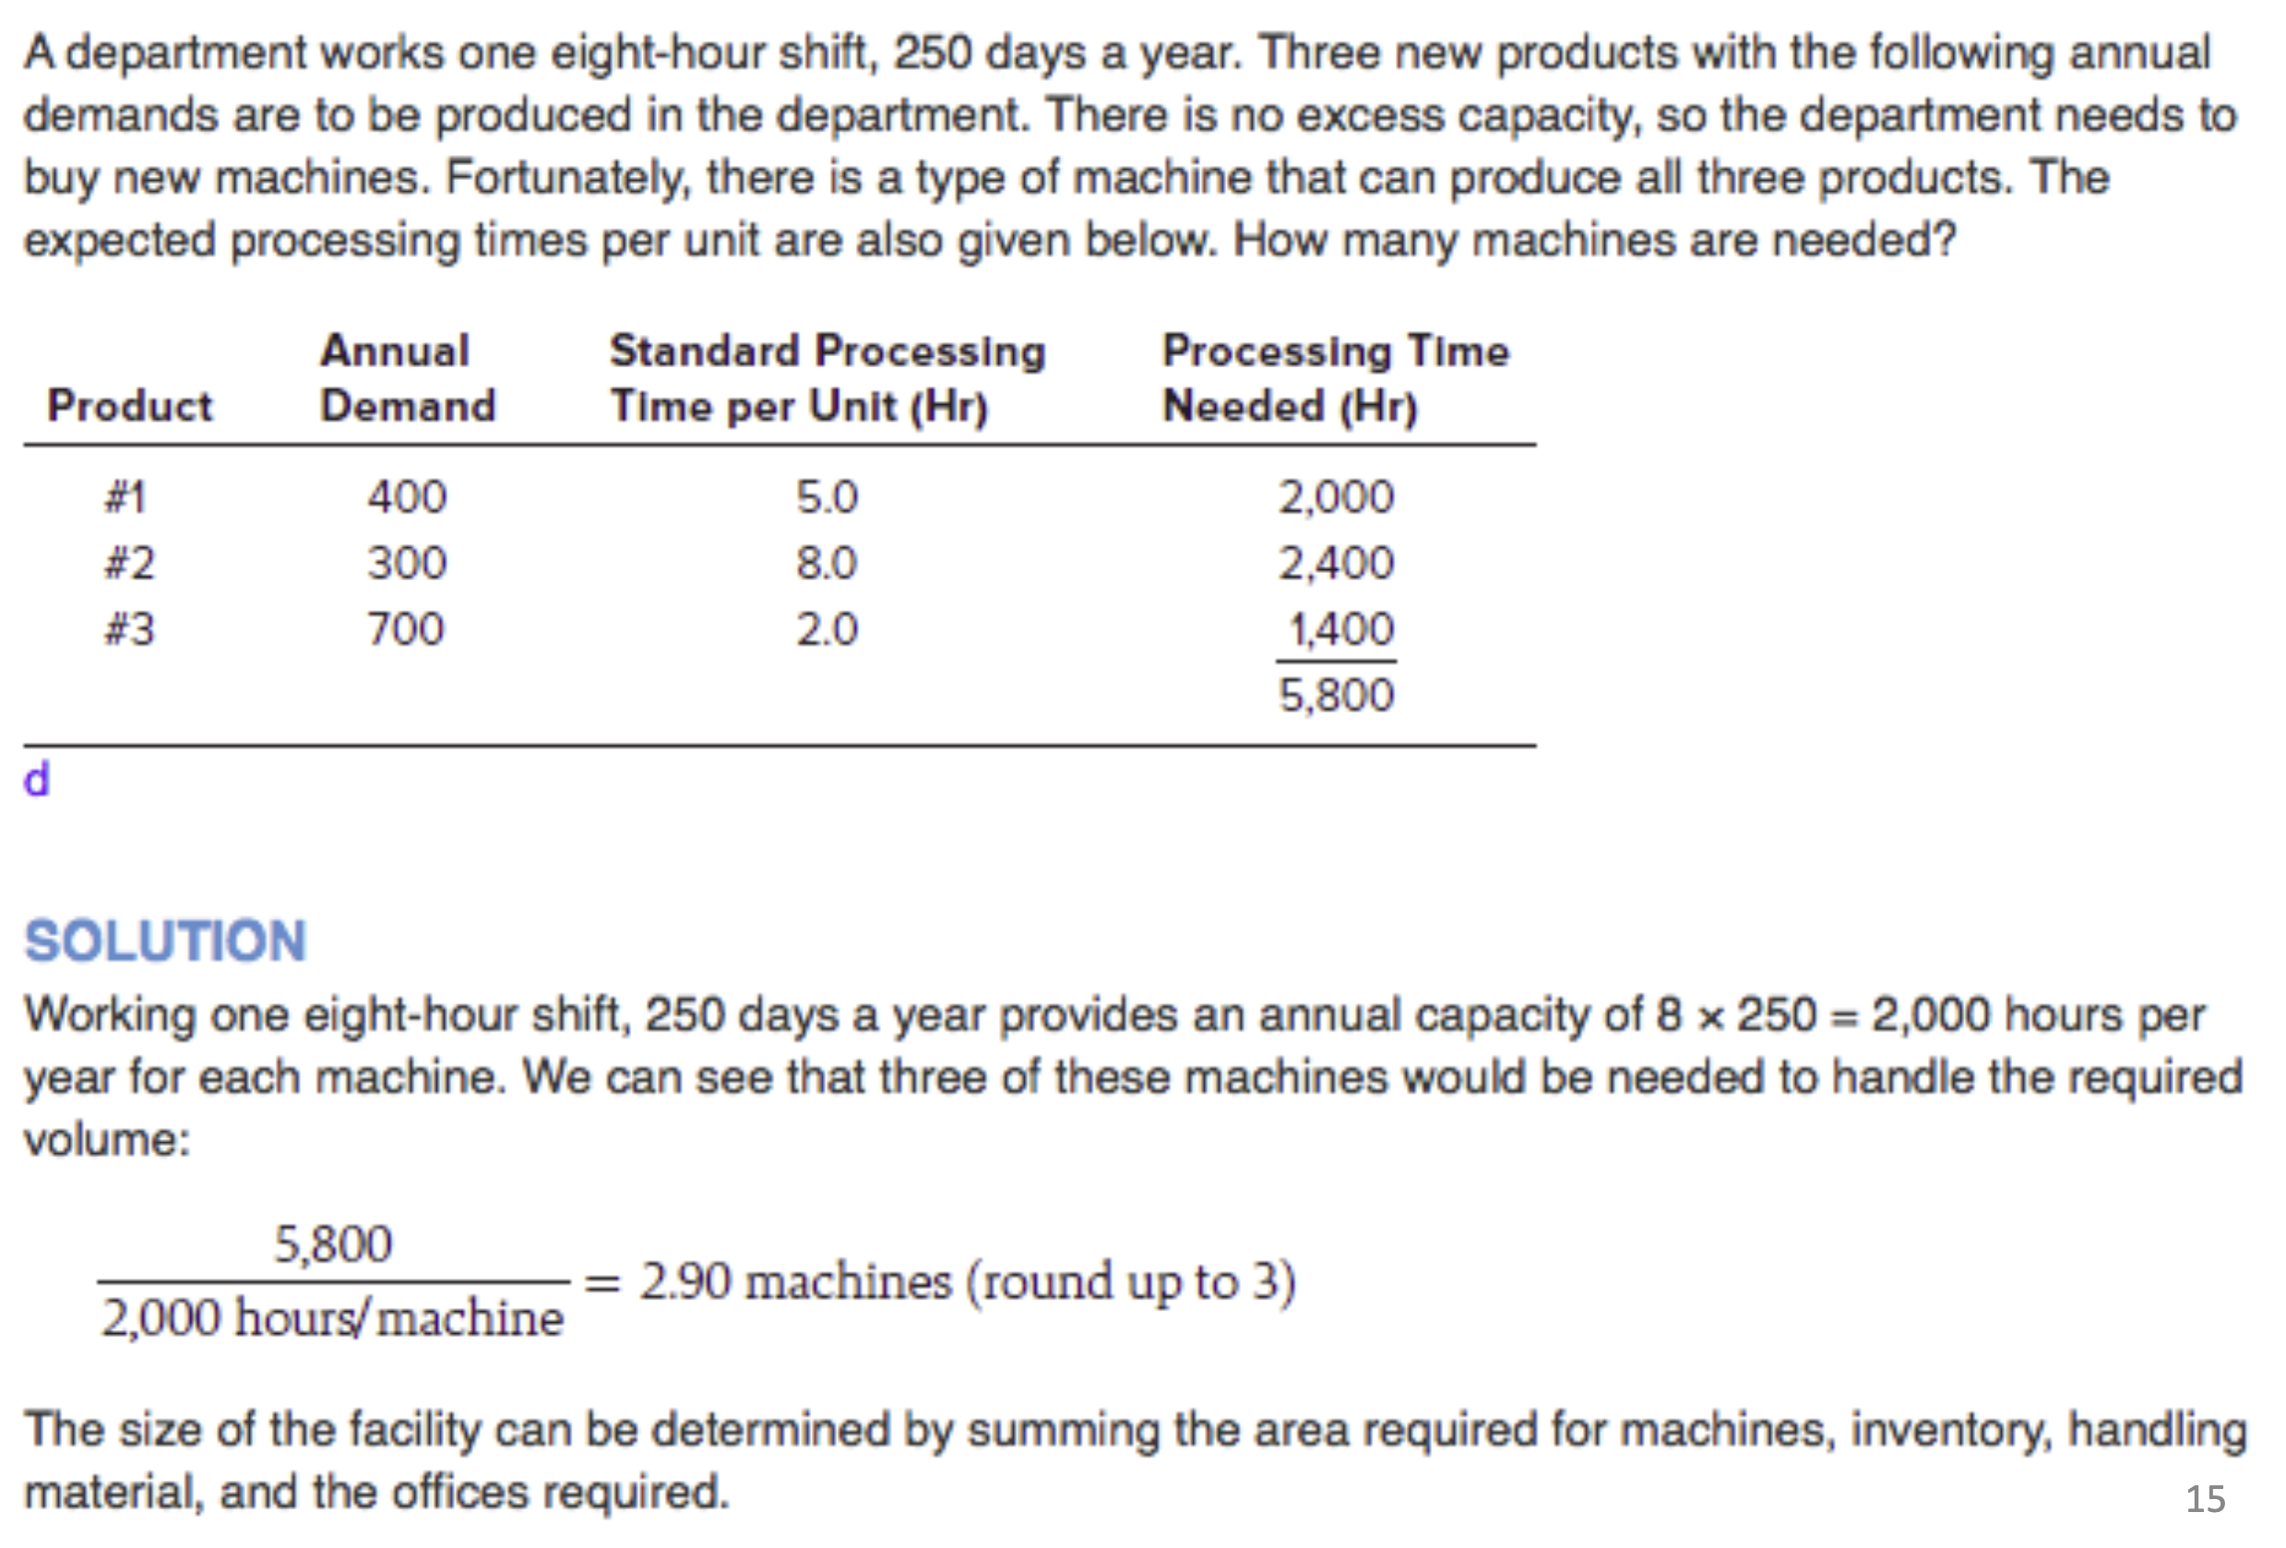

### Major Concerns When Assessing Various Capacity Alternatives

* Design flexibility into system
* Differentiate between new and mature products
* Look at the organization in its entirety
* Prepare to deal with large (chunkier) increases in capacity
* Attempt to smooth out capacity requirements as dictated by consumer demand
* Use of capacity cushions
* Identify the optimal operating level

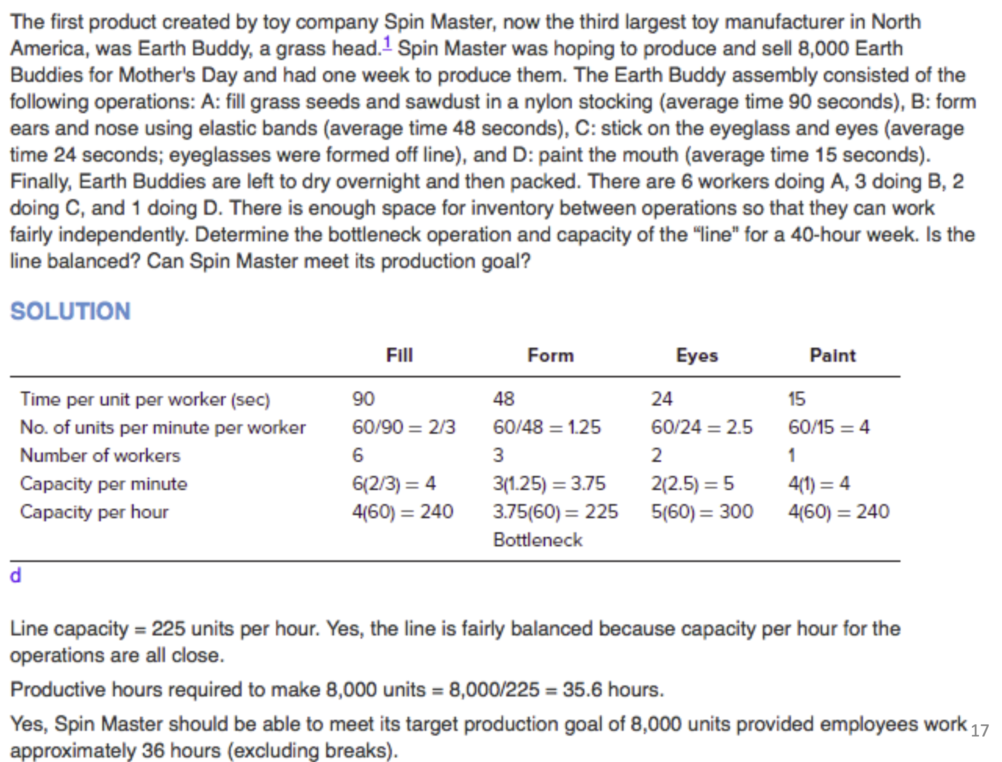

### Break-Even Analysis

* + Focuses on the relationship between costs, revenues, and volumes
  + Goal is to determine the quantity at which the alternative capacity arrangement being considered will provide an economic advantage profit

**Costs**

* + Fixed Costs () are independent of volume produced
  + Variable Costs () are entirely dependent upon how much is produced
  + Assume that variable costs () remains constant per unit of output () regardless of the volume produced

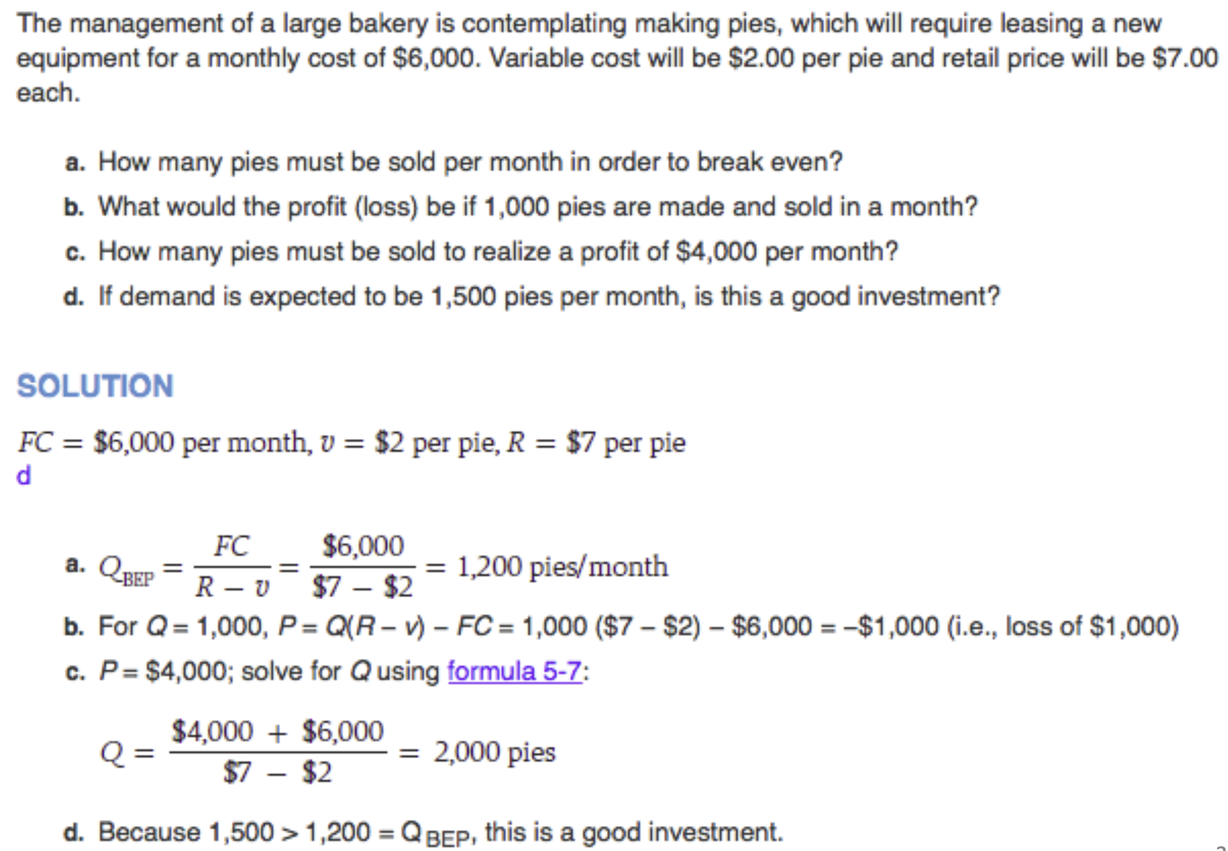

## Process Design and Facility Layout

### General Overview

**Process Design** and **Plant Layout** have long-term consequences for a company affecting:

* Long-term feasibility of the company
* Ability of the firm to meet its mission statement
* Morale of the workforce who actually operate the equipment and effectively run the plant
* The ability of the firm to meet its long-term strategic goals

### Process Types

**Job Shop**

* Low volume of highly variable customized goods or services
* Process is intermittent
* Employs skilled workers
* Uses highly flexible equipment that can be used on a wide variety of applications

**Batch Processing**

* + This describes a firm that produces a moderate quantity of a good or service
  + Process is intermittent (i.e., by batch scheduled)
  + Equipment is not as flexible as it is in a job shop
  + Workers are skilled but not as skilled as those in a job shop

**Repetitive Process**

* + Marked by higher volumes of more standardized goods
  + Lower skilled workforce – this is changing
  + Equipment is not very flexible

**Continuous**

* + High volumes of highly standardized output
  + Production is continuous and there is not typically counted
  + Low skilled workforce

### Process Considerations – Matching Process to Product Type and Volume

* **Focused Factory Concept:** High volume shops that specialize in a particular output
* **Hybridization:** Some organizations have been able to combine volume and specialization in their product offerings

### Automation

* Using machinery with sensing and control devices that enable it to operate automatically
* Advantages: Low variability, contrasts to labour, strategy necessary for competitiveness
* Disadvantages: Costly, inflexible, can adversely affect worker morale
* Types: Fixed automation, programmable automation, flexible automation

### Process Design

* Determines the form and function of how the production of goods and services take place
* Involves the allocation of resources, the sequencing of activities and control mechanisms

**Process:** Determine state of inputs, outline objectives (speed, type, cost, quality, dates, etc.)

**Conceptualize:** , assess alternatives, incremental/hierarchical, flow diagram

**Select:** Establish design of choice, build a prototype (computer model) of the process and test it

**Create:** Specify machinery, determine labour requirements, design placement and work centers

**Implement:** Buy equipment, hire and train workers, initiate trial runs

### Fail-Safe Service Process

* Customer presence infers that quality and delivery problems are going to have immediate consequences
* This suggests that the service provider has a great incentive to ensure that the process is fail-safe, i.e., not prone to failure or on the positive side, to manage process design

### Service Process Design

Service process design involves the direct or indirect involvement of the customer or of something belonging to the customer.

### Basic Layout Types

**Product (Line):** Arranges the process (plant layout) linearly according to the progressive steps by which a product is made.

**Process (Functional)**: Arranges production resources together according to the similarity of function.

**Cellular:** Layout in which different machines are arranged in a cell that can process items that have similar processing requirements.

### Assembly Line Balancing

* + Assigning tasks to workstations such that the workstations have approximately equal time requirements
  + Cycle time is determined by the desired output rate:
  + Number of workstations is determined by the cycle time, the sum of task times, and the ability to bundle activities into appropriately sized workstations:
  + **Precedence Network:** A diagram that shows the task and their precedence requirements
  + **Balancing Rules:** Assign the tasks with the longest time, assign the task with the most followers

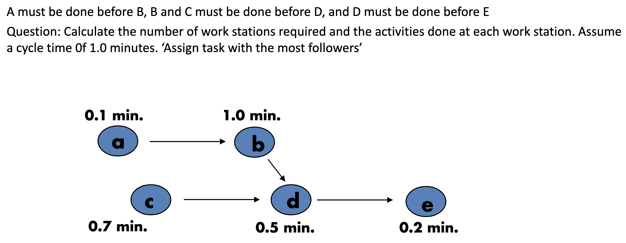

|  |  |  |  |  |  |
| --- | --- | --- | --- | --- | --- |
| **Workstation** | **Time Remaining** | **Eligible** | **Assign Task** | **Revised Time Remaining** | **Station Idle Time** |
|  |  |  |  |  |  |
|  |  |  |  |  |  |
|  |  |  |  |  |  |

Two measures of facility layout effectiveness:

In this example:

**Dealing with Variable Task Times**

* Task times vary due to worker fatigue, boredom, mechanical failures, shortages, etc.
* Solutions: Reduce variability in the task time themselves, allow for use of buffer inventories, build some idle time into the process itself, cross training workers

**Resolving Bottlenecks**

* The task time of the slowest workstation will determine the cycle time for the entire line
* Solutions: Parallelize workstations to decrease process time in half, cross train workers

# Quality Management and Statistical Process Control

## Quality Management

### Quality Overview

* **Quality:** The ability of a product or service to consistently meet or exceed customer expectations
* Evolution: craftsmanship (pre-industrial revolution), division of labour (industrial revolution), quality assurance (1950s), quality management systems (1970s), TQM/continuous improvement (1980s), Six Sigma/statistical tools (today)
* Dimensions: Performance, aesthetics, special features, conformance, reliability, durability, serviceability (example: quality of car)
* Service: Tangibles, convenience, reliability/consistency, responsiveness, time, assurance, courtesy (example: service of car repair)
* Determinants: Product design, process design, production
* Benefits: Improved quality, better reputation, increased market share, higher profitability
* Costs: Failure (defective), appraisal (inspection, testing), prevention (training, planning)

**Deming’s 14 Steps to Quality:**

1. Create constancy of purpose toward improvement
2. Management must adopt the TQM philosophy
3. Cease dependence on inspection
4. Minimize total cost
5. Improve constantly and forever
6. Institute training
7. Institute leadership to act on quality issues
8. Drive out fear
9. Work as a team
10. Eliminate exhortations, and fix the system
11. Eliminate work standards and MBO
12. Remove barriers to pride of workmanship
13. Institute education and self-improvement
14. The transformation is everybody’s job

### Quality Certifications

* ISO 9001: Set of international standards on quality management and quality assurance, critical to international business
* ISO 14000: Family of standards related to environmental management

### Hazard Analysis Critical Control Point (HACCP)

* A quality control system, similar to ISO 9001, designed for food processors
* Main steps: Hazard analysis, determination of the critical control points, creation of the HACCP plan

### Problem Solving, Process Improvement, and Quality Tools

* Problem solving: Define problem, collect data, analyze problem, generate potential solutions, choose a solution, implement solution, monitor solution
* PDSA cycle: Plan, do, study, act
* Six Sigma: A business process for improving quality, reducing costs, and increasing customer satisfaction ()
* Quality tools: Flowcharts, check sheets, histograms, Pareto charts, scatter diagrams, control charts, cause-and-effect diagrams, run charts
* Methods for generating ideas: Brainstorming, quality circles, interviewing, etc.

## Statistical Quality Control

* **Statistical Quality Control:** Uses statistical techniques and sampling to monitor and test the quality of goods and services (acceptance sampling – accept or reject, statistical process control – if process is operating within acceptable limits)
* Inspection: The appraisal of goods/services against standards

### Elements of Statistical Process Control (SPC) Process

**Statistical Process Control:**

* The quality control steps
* Type of variations
* Control charts
* Designing control charts
* Individual unit and moving range charts
* Control charts for attributes
* Using control charts

**Types of Variations:** Random variation (natural), assignable variation (source can be identified)

### Control Charts

**Purpose:** To monitor process output to distinguish between random and assignable variation

**Designing Control Charts:**

1. Determine a sample size
2. Obtain 20 to 25 samples
3. Establish and graph preliminary control limits
4. Plot sample statistic values on control chart
5. Are any points outside control limits (CL)?
   1. NO: Assume no assignable cause
   2. YES: Investigate and correct

**Control Charts for Variables:** Variables generate data that are measured, sample mean/range

**Upper and Lower Control Limits for Sample Mean Chart:**

Where:

**Example:**

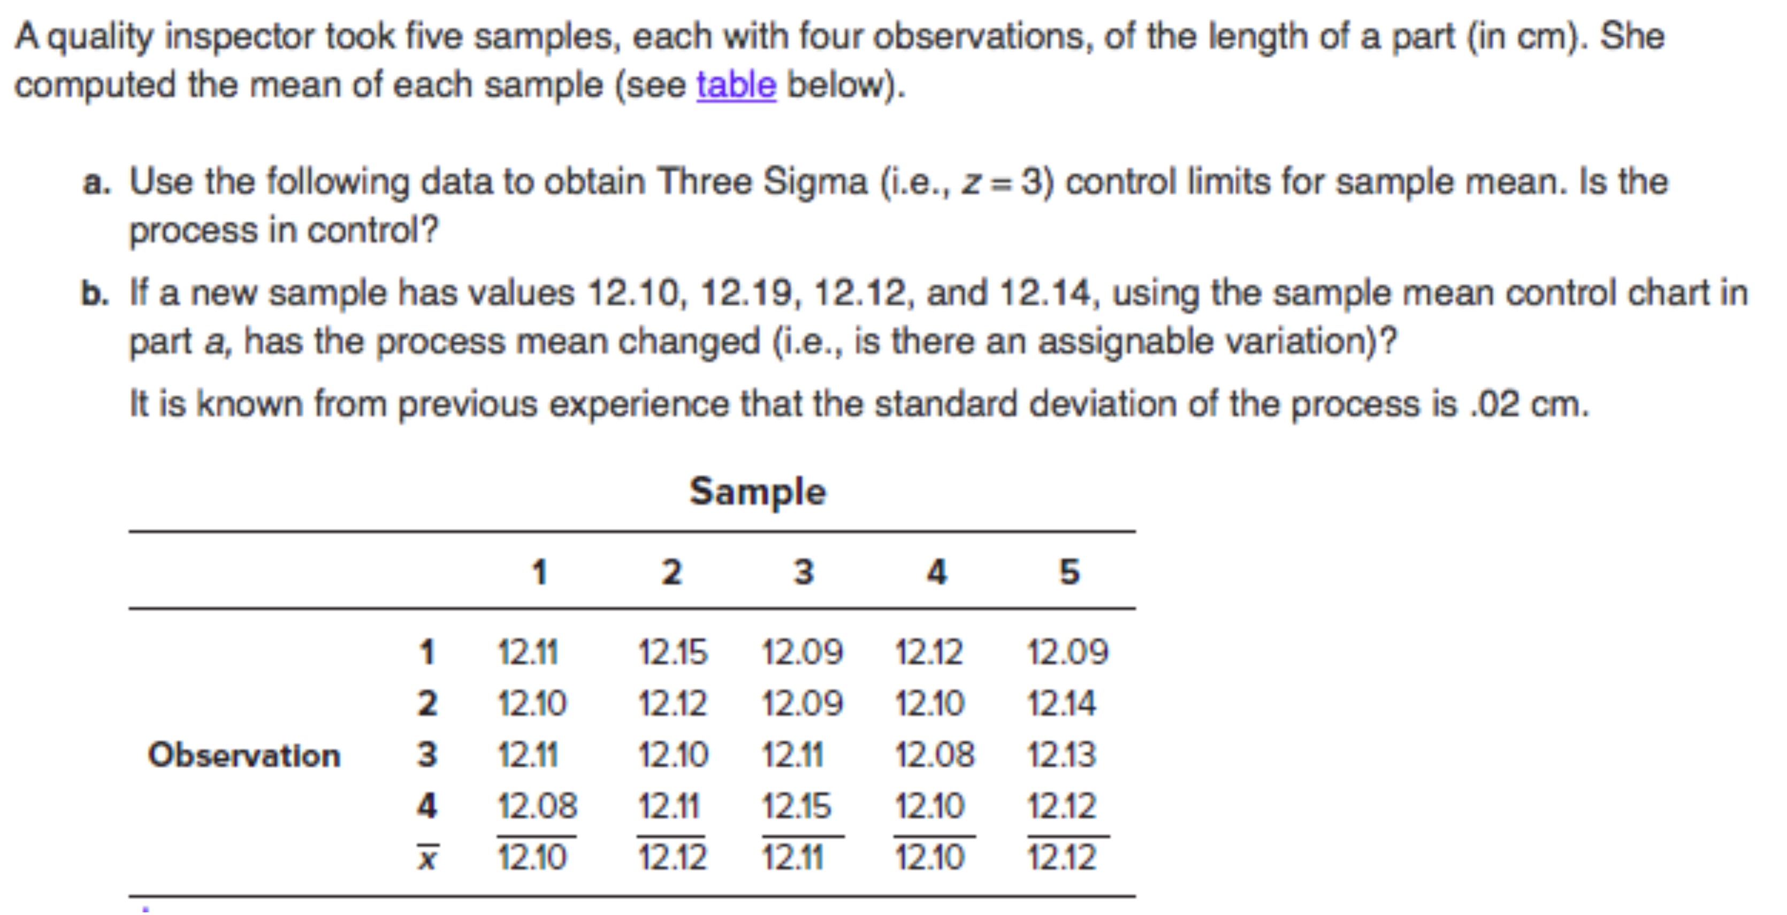



All sample means fall between the control limits; the process is in control.

Because , the process mean has not changed.

**Upper and Lower Control Limits Alternate Method:**

Where:

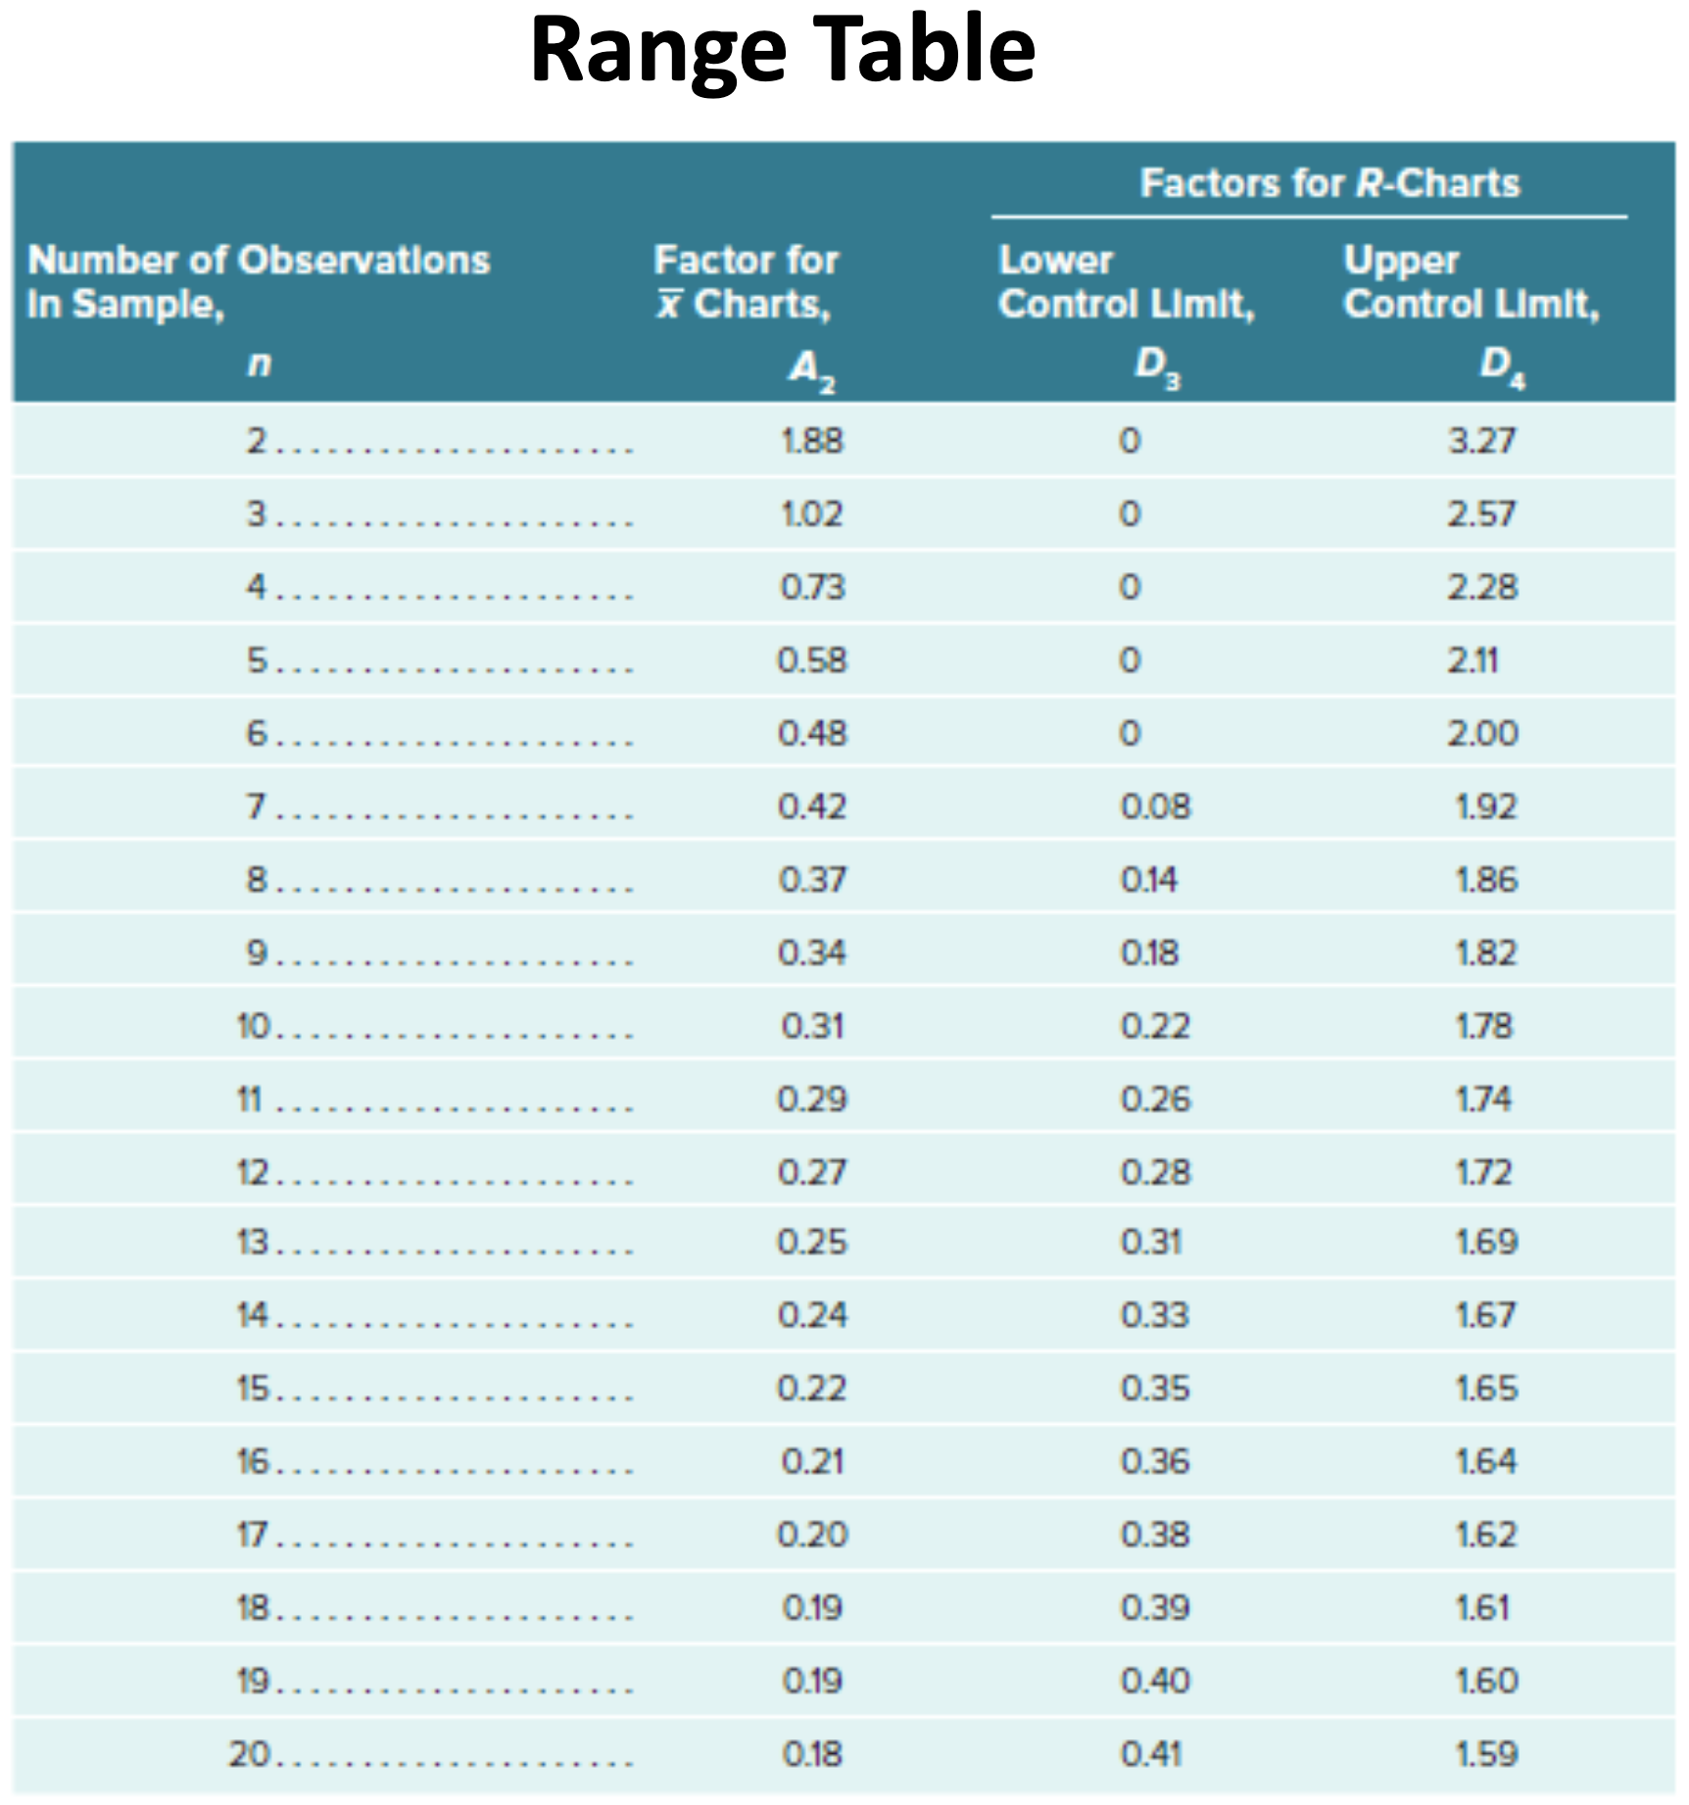

**Example:**

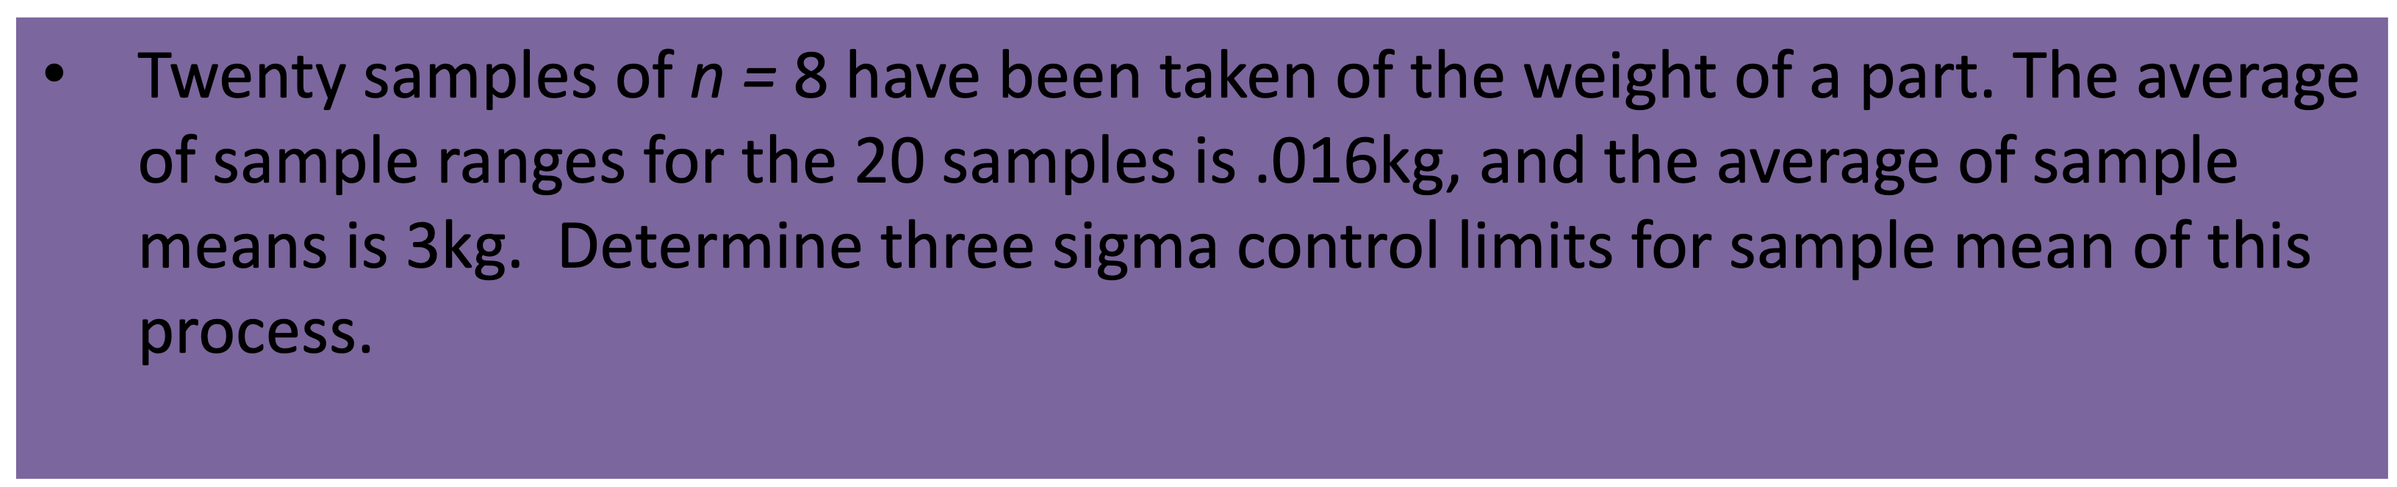

**Upper and Lower Control Limits for Sample Range Control Chart:**

**Example:**

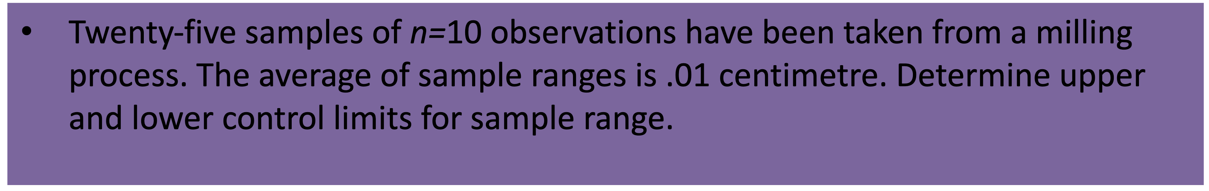

**Example:**

Calculate sample means, sample ranges, grand mean, and average of sample ranges:

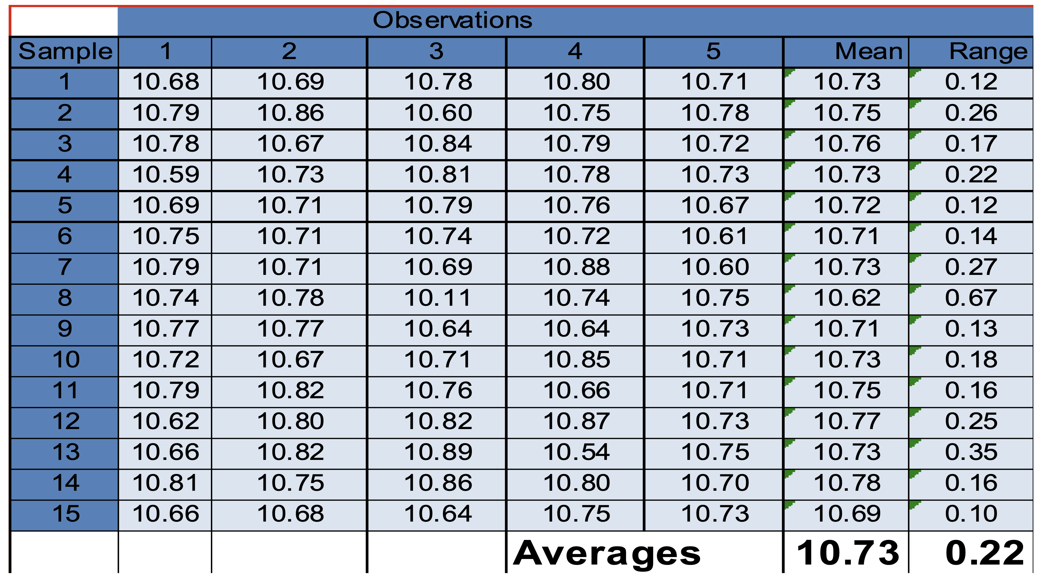

Determine control limits:

Create sample mean chart and plot values:

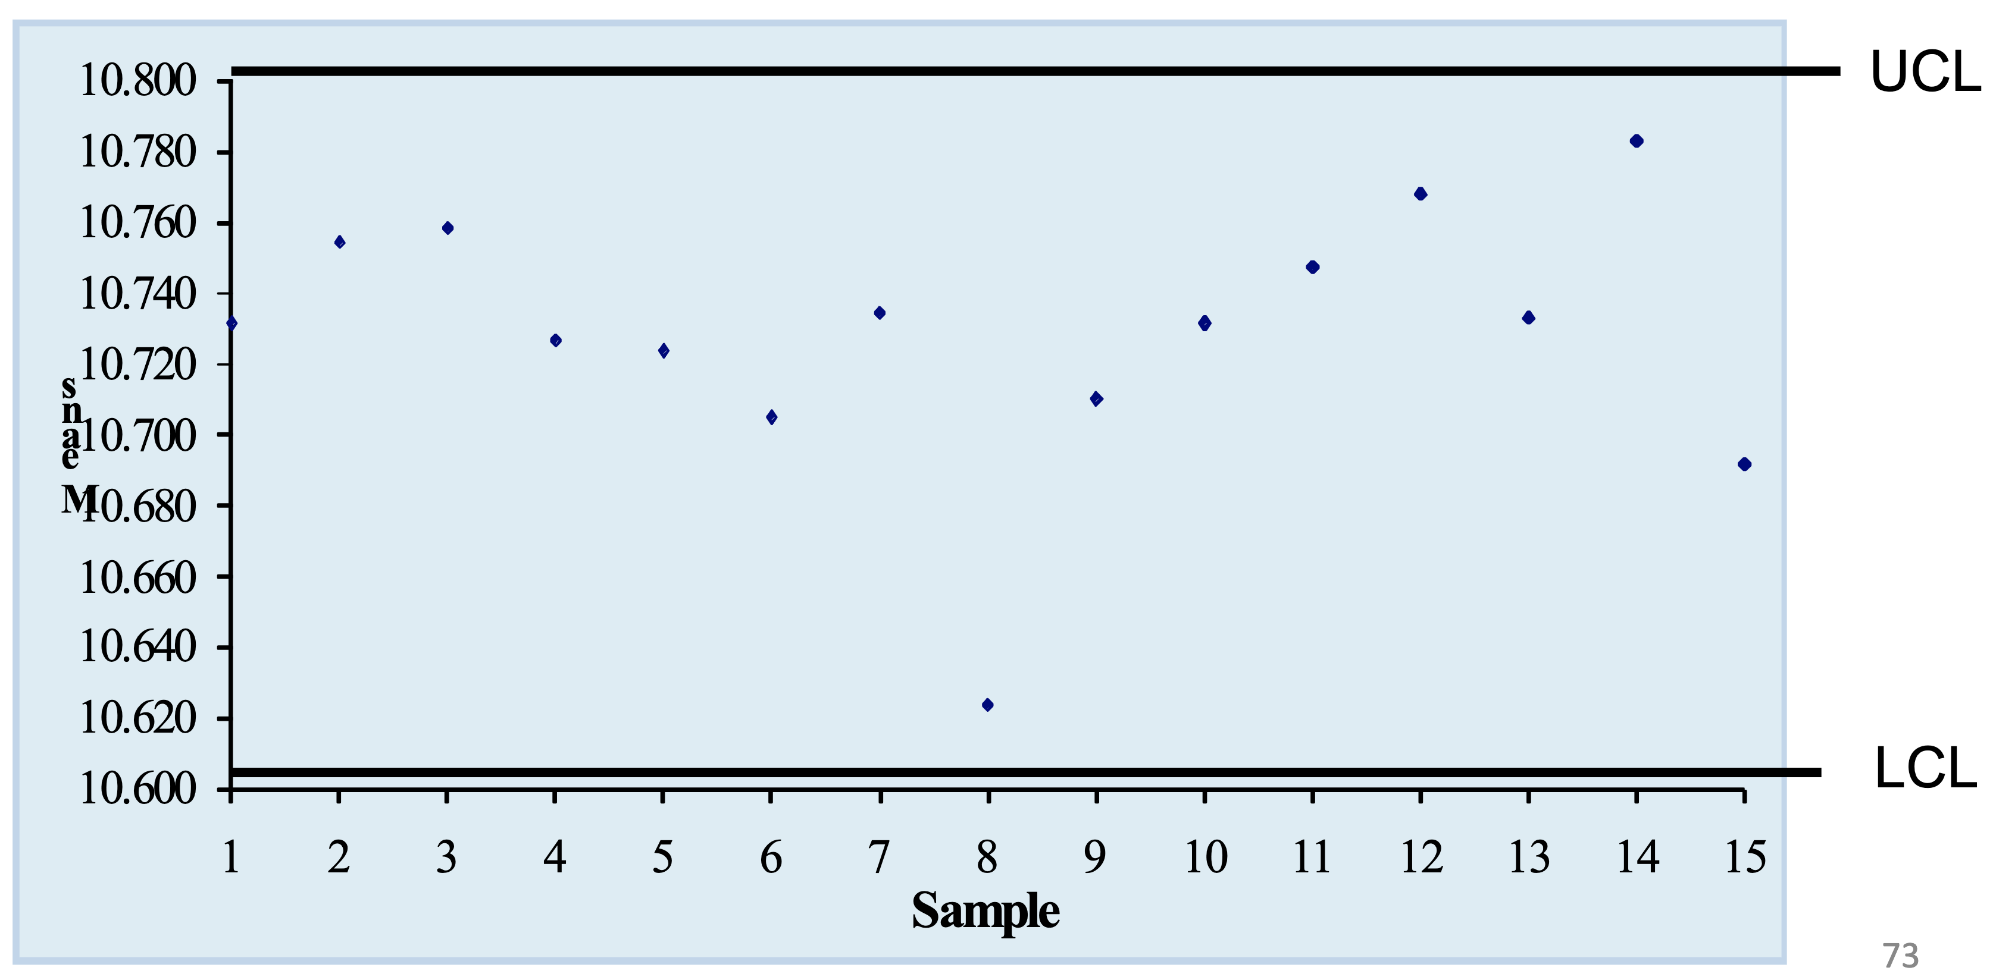

Create sample range chart and plot values:

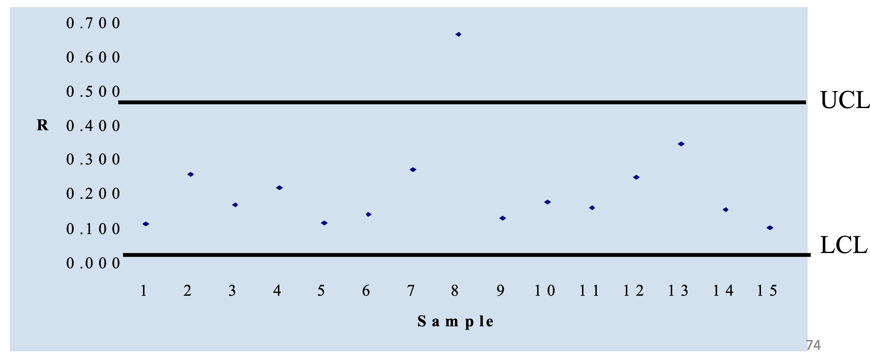

# Supply Chain Management (SCM)

## SCM Part 1

### SCM

* **Supply Chain:** A sequence of organizations that produce a good or provide a service and get it to the marketplace.
* **Supply Chain Management:** The cooperation, collaboration and coordination of facilities such as manufacturing plants, warehouses, distribution centers; and activities such as production and physical delivery of goods.
* **Value Added:** The creation of a good’s value as it moves through production and distribution.

### The Need for SCM and Potential Benefits

**Prime Objective of SCM:** To get the product to the marketplace as efficiently (i.e., least costly) as possible to increase the firm’s effectiveness in meeting consumer demand.

**Drivers of Supply Chain Management:**

* Ongoing need to improve operations and increase efficiency
* Increased occurrence of outsourcing
* Freer trade and increasing globalization
* Increasing levels of e-commerce
* Increasing competition (using lean or JIT)
* Desire to effectively control inventories (Bullwhip effect)

### Bullwhip Effect

**Bullwhip Effect:** Demand/order variability gets progressively larger the further back in a supply chain is the company.

* **Causes:** Isolation of manufacturing from the retail sector, errors in forecasting, promotional pricing, trade show effect.
* **Implications:** Strain on manufacturing capacity, rescheduling, increased inventory holdings resulting in increased costs and shelf-life issues.
* **Remedies:** Make product to order, increase inventories.

### Strategic and Tactical/Operational Activities in SCM

**Strategic:** Agreement of goals between supply chain members, desired product characteristics, expected response times to consumer demand, information system requirements, target fill rate.

**Tactical/Operational:** Forecasting, purchasing/ordering, transportation of material, warehouse and inventory control, scheduling of production and distribution, customer service functions.

### Efficient Replenishment Systems

* **Quick Response:** Just-in-time inventory replenishment (used in retailing).
* **Efficiency Consumer Response (ECR):** Expanded version of quick response initiative which includes some collaboration (used in the grocery industry).
* **Vendor Managed Inventory (VMI):** Agreement for supplier to access and maintain customer’s inventory (used in convenience stores).

### Information Technology Used in SCM

* **Distribution Requirements Planning (DRP):** A system for synchronizing replenishment schedules across the supply chain; is a push system (based on forecasts).
* **Management Information System (MIS):** Tools used to gather and access, analyze, and share information; two types are planning software and execution software.
* **Electronic Data Interchange (EDI):** Direct, computer-to-computer transmission of transactions between organizations.
* **RFID Technology:** Used to track goods in supply chain with RFID tags attached to them, transmits product information to receiver, eliminates need for manual counting.

### Requirements and Key Steps in Creating Effective SCM

**Requirements:**

* Formation of close relationships based upon trust, co-operation, and agreement.
* Create effective communication channels to facilitate improved co-ordination.
* Supply chain visibility and information sharing, (unexpected) event management, performance measurement.

**Key Steps:**

* Develop strategic objectives and tactics
* Integrate and coordinate internal activities
* Coordinate with suppliers and customers
* Coordinate planning and execution across the supply chain
* Form strategic partnerships

### Reasons for Outsourcing

* **Outsourcing:** Buying goods or services instead of producing or providing them in-house.
* **Reasons**: Lower cost, gain expertise and knowledge, gain flexibility, increase capacity.

### CPFR and the Value of Strategic Planning

* **Collaborative Planning, Forecasting, and Replenishment (CPFR):** Practical test as to the sincerity and effectiveness of a co-operative and effective supply chain.
* Three step process: Planning, initial forecasting, and replenishment

### SCOR Performance Metrics Model

**Supply Chain Operations Reference (SCOR) Model:**

|  |  |
| --- | --- |
| **Perspective** | **Metrics** |
| Reliability | Perfect order fulfillment |
| Responsiveness | Lead time |
| Agility | Upside flexibility/adaptability |
| Costs | Supply chain management cost, COGS |
| Assets management | Cash-to-cash cycle time, return on fixed asset +/- inventory |

## SCM Part 2

### Responsibilities and Activities of Purchasing

* **Purchasing:** Involves the procurement of raw materials, parts needed for manufacturer, machinery, repair parts for existing machinery, general office and plant supplies and the acquisition of required services; develop and implement purchasing plans.
* **Responsibilities:** Source goods and services, monitor quality of inputs, negotiate and determining prices, maintain database of suppliers and products, cost management, etc.
* **Purchasing Cycle:** Series of steps that begin with a request and ends with paying the supplier. Requisition received, supplier selected, decide how to purchase, monitor orders, receive orders, pay suppliers.

### Benefits of E-Commerce

Companies can have a global presence, improve competitiveness and quality, analyze customer interests, collect detailed information, shorten supply chain response times and costs, etc.

### Value Analysis and Spend Analysis

* **Value Analysis:** An assessment of the function of a particular manufacturing part to see if it can be modified or replaced with another part that will reduce costs without sacrificing its functionality; select item, identify function, ask questions, evaluate.
* **Price Determination:** Published prices, competitive bidding, and negotiated pricing.
* **Centralized vs. Decentralized Purchasing:** Purchasing handled by one special department vs. individual departments handling their own purchasing.
* **Spend Analysis:** The collection, organization, classification, and analysis of expenditures with the goal of reducing costs, increasing purchasing efficiency, and monitoring supplier performance.

### Supplier Management and Partnership

* Choosing suppliers, supplier relationships, supplier partnerships.
* Factors in choosing a supplier: Quality and quality assurance, flexibility, location, price, reputation and stability, lead times and reliability, other customers, service after sale.

### Logistics and Reverse Logistics

**Logistics:** The movement and storage (warehousing) of materials, finished products, and information that occur both within the facility and outside of the facility.

**Example:**

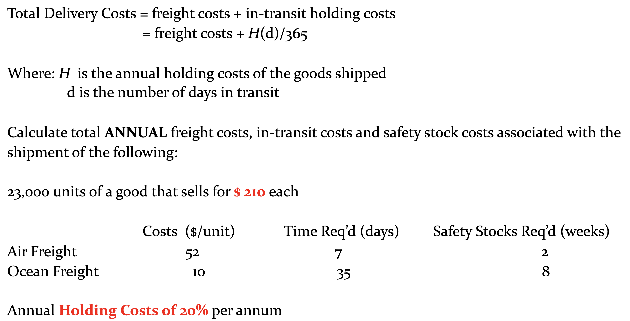

Air Freight:

Ocean Freight:

**Reverse Logistics:** The backward flow of goods returned by consumers or retailers.

### Process and Factors Considered When Selecting a Transportation Mode

* Modes of transportation: Ocean freights, trains, delivery trucks, air freights, etc.
* Speed vs. cost, balance transportation cost with inventory holding costs

**Example:** Selecting a Transportation Mode

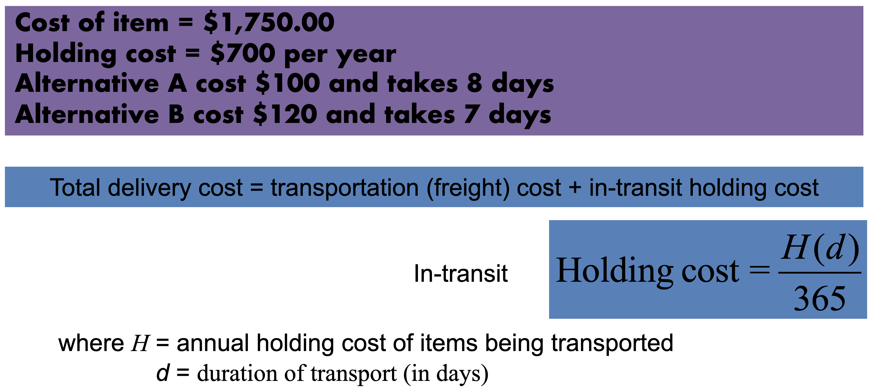

Since it costs less to hold the product one day longer than it does for the faster shipping, choose Alternative A.

# Inventory Management (I)

## Basics

### Definition of Inventory

* **Inventory:** Inventory is nothing more than a stock of goods being held in a warehouse or some other storage facility
* For example: inputs, packaging, finished or unfinished goods, spare machinery, supplies
* Inventory Management: Involves some system to plan for and manage these stocks

### Why Inventories Demand Respect

Inventories are important because they are worth money:

* Outdated **finished goods** inventories increase waste
* Excessive **input inventories** risk the changes of some goods becoming unsuitable for use
* Inventories tie up funds and will therefore drive-up costs and drive down efficiency

### Turnover Rate

## Functions and Characteristics of Effective Inventory Management

**Functions:** In-transit inventories, safety stocks, cycle stocks, seasonal stocks, buffer inventories, anticipation inventories

**Characteristics:**

* Safe Storage and Inventory Utilization: Warehouse management systems
* Tracking and Inventory Control: Periodic counting, perpetual tracking, two-bin system, bar code systems, radio frequency identification tags
* Forecasting and Lead Times: Purchase lead times
* Estimating Inventory Costs: Carrying costs, ordering costs, shortage costs
* A-B-C Product Classification

## Requirements for Effective Inventory Management

### Efficient Order Quantity (EOQ)

* Firms want to strike a balance between the costs associated with holding inventory and the costs incurred in ordering product
* For high volume/high value goods there is a double incentive to increase order frequency

**Assumptions:** Single product, annual demand needs are known, constant demand, constant lead time, single delivery per order, no quantity order discounts, no transportation discounts based upon load size

**Annual Holding Costs:**

Assumption of constant rate of use allows to define average inventory as half of the order:

, where is the order quantity

, where is the annual holding cost per unit

**Annual Ordering Costs:**

, where is annual demand and is order size

, where is per order process cost

Since annual demand is known, the annual ordering cost will be inversely related to order size

**Total Inventory Control Cost:**

* When annual demand (), holding costs (), and per unit order processing costs () are known, then total inventory holding and ordering costs () can be described as follows:
* This suggests that optimal total costs can be plotted as the minimum point on a u-shaped total cost curve, where costs increase if order size is too small but also increase if inventory levels are too high:
* Therefore, if we substitute , we can solve for minimum costs

**EOQ Example 1:**

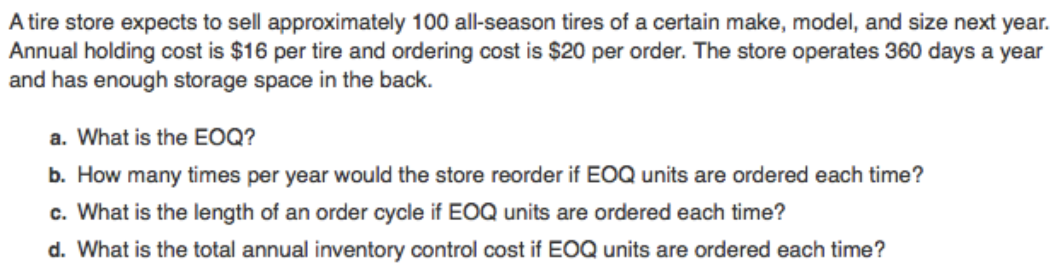

1. , round to
2. Number of orders per year:
3. Length of order cycle: , which is , or workdays or

**EOD Example 2:**



, round to 129 monitors

### Efficient Production Quantity (EPQ)

* Similar to EOQ as we are still looking at annual inventory cost control
* Rate of production exceeds the rate of consumption
* Since the good is produced in-house the ordering cost associated with EOQ is replaced by a setup cost to change over production equipment

**Analysis:**

* Variables

: maximum inventory level

: batch size or production lot size per run

: setup cost per run (cleanouts, tooling changes, etc.)

: annual demand

: production rate per day

: demand rate (consumption) per day

: holding cost

* Equations

**Example:**

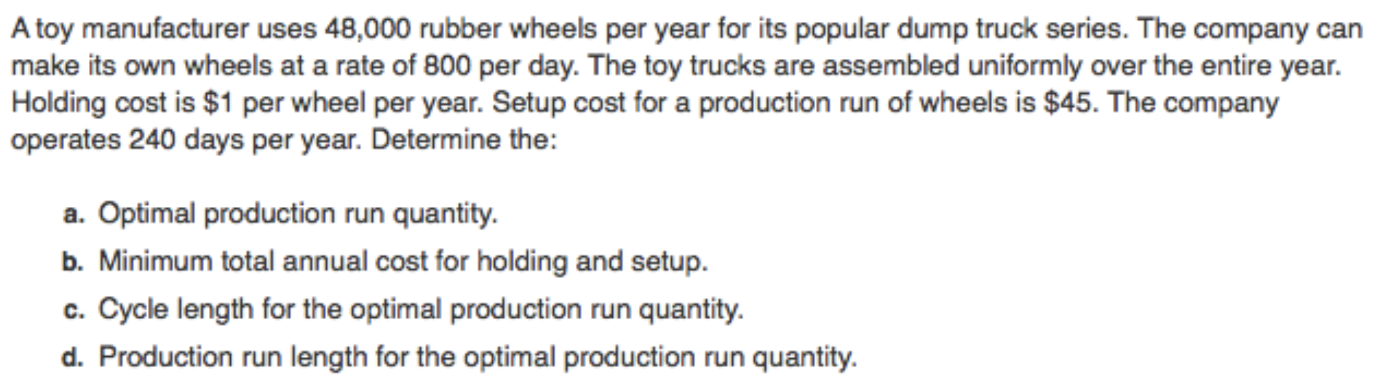

### EOQ with Quantity Discounts

* **Quantity Discounts:** Price discounts used as an incentive for purchasers to order in large quantities
* Objective: To compare the benefits of purchase price savings for buying in quantity as opposed to the increase in annual holding costs of maintaining larger average inventories

**Revised Total Cost Simplification:**

* Without quantity discounts, the efficient order quantity was selected to minimize annual holding and orders cost, such that:
* With quantity discounts we want to select an order quantity that takes the purchase price into account such that total cost can now be defined as:

**Process of Calculating EOQ (Discounts):**

1. **Finding an initial feasible EOQ:** Calculate the EOQ for each price level starting with the lowest price level, until you find a feasible EOQ
2. **Refining your choice:** If the EOQ for the lowest price unit is feasible, you are done. If it is not, then compare the **Total Costs** for each price break larger than the feasible EOQ with the **Total Cost** of the feasible EOQ

**Example:**

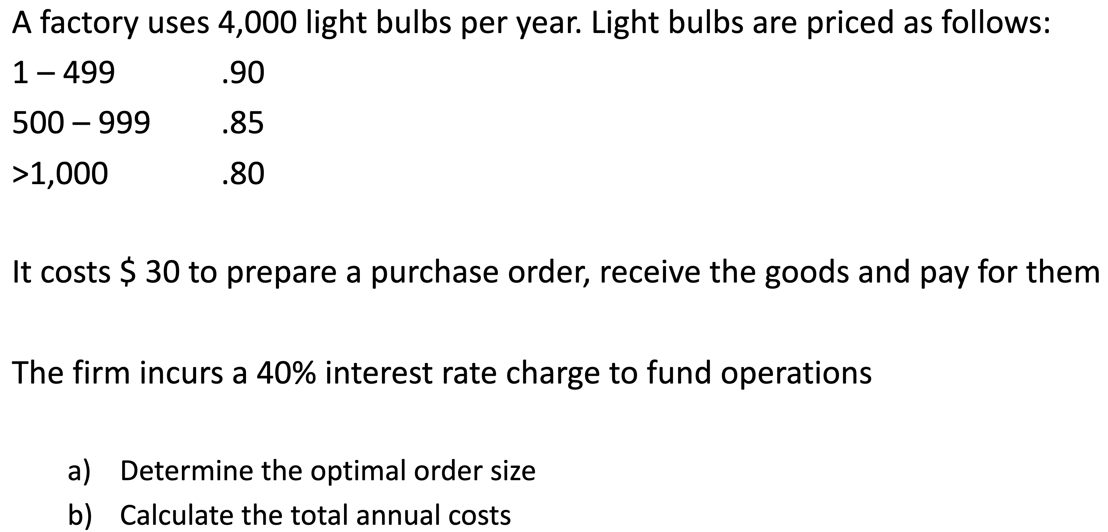

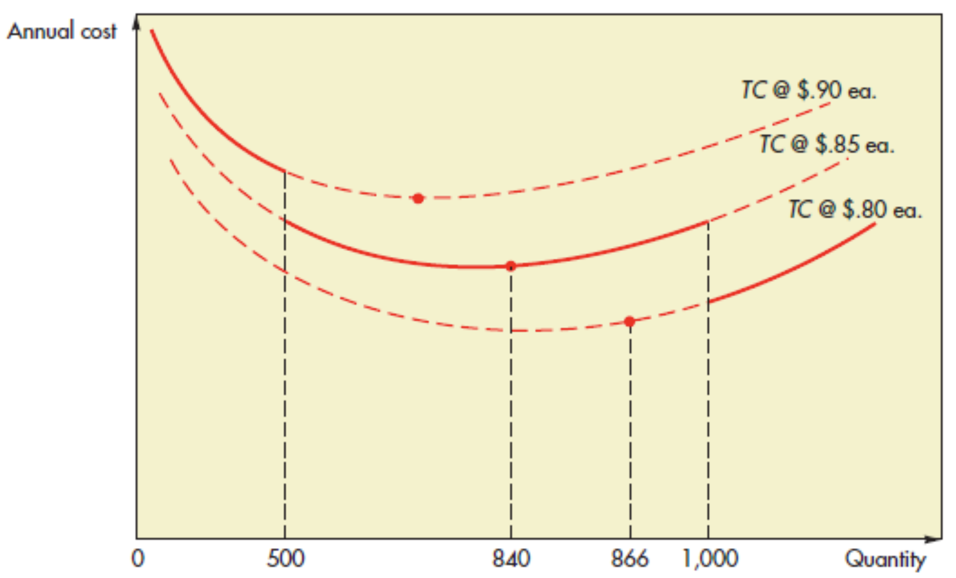

1. Find the EOQ for each price, starting with the lowest, until you locate a feasible EOQ:

Because an order size of light bulbs is fewer than units, is not feasible for the unit price of per light bulb. Next, try per unit:

This EOQ is feasible; it falls in the per light bulb quantity range ( to ).

1. Now calculate the total cost for order size, and compare it to the total cost of the break quantity larger than , i.e., units:

Because , the minimum cost order quantity is light bulbs.

### EOQ with Planned Shortages

**Assumptions:**

* High costs of some goods may encourage suppliers to allow shortages (backorders) if the market is willing and demand can wait
* Backorders will incur shortage costs with these charges proportional to the amount of time that product is backordered

**Variables:**

: the quantity that you want to order (demand you want to fill)

: the quantity that you want to backorder (demand that you are willing to defer until the next order arrives)

**Equations:**

**Example:**

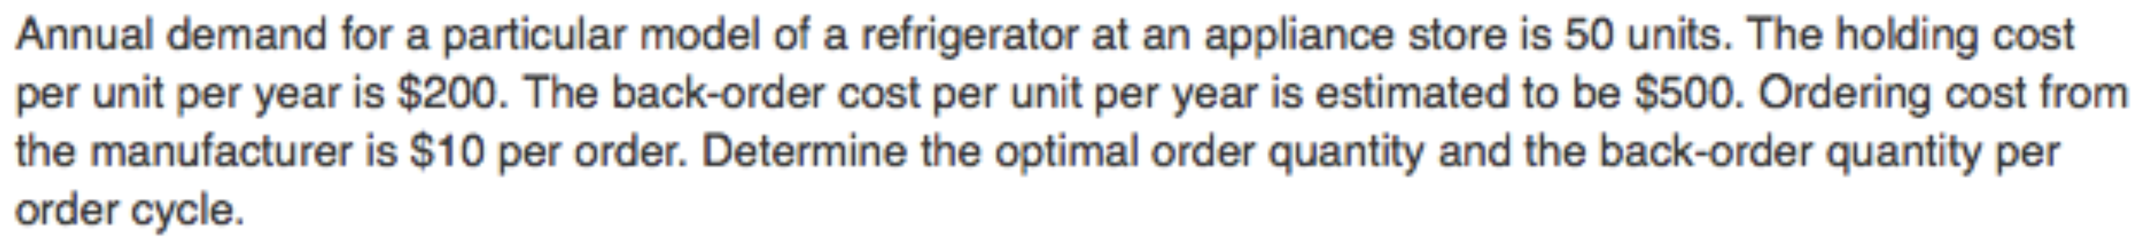

# Inventory Management (II)

## Fixed Order Quantity – Reorder Point Model

**Reorder Point:**

* Definition: The inventory level that triggers a replacement order.
* with demand and lead time being expressed in similar units of time (day, week or month).
* If demand is not constant, then a case can be made for holding extra inventory to act as insurance against a shortage – **Safety Stock**.
  + ROP inventory is now equal to .

**Safety Stocks and Service Levels:**

* Lead Time Service Levels (probability that demand supply during the lead time):
* Annual Service Level (annual fill rate):
* Both of these service levels assume demand is normally distributed during a lead time:
  + If stockout risk lead time service level, then lead time service level stockout risk
  + Then look up this probability on the Standard Normal Distribution Table to get

### ROP Using Lead Time Service Level

* When lead time demand data is known:
* When only demand is variable:
* When both demand and lead time are variable:

### ROP Using Annual Service Level

* Step 1: Calculate the standardized expected number of units that you will be short during the order cycle where:

* Step 2: Convert number to its “” equivalent using Lead Time Service Table
* Step 3: Substitute this “” value into the calculation of ROP where:

## Fixed Order Interval – Order Up to Level Model

### Definition

**Definition:** This model is used when orders are placed at fixed intervals with the amount of the order changed adjusted to bring inventory up to a pre-determined level.

**Setting Up an Order:** Determine how often you will order and then how much you will order.

### Equations

**Order Interval Notation:**

* : order interval (fraction of a year)
* : fixed order processing costs
* : variable ordering costs (per SKU)
* : number of SKUs purchased from the supplier
* : unit cost per
* : annual holding cost rate
* : annual demand of

**Step 1: Determining Order Interval**

where

**Step 2: Determining Order Up to Level**

* Definition: An up to inventory level is the amount of good that should be sufficient to last until the next order arrives.
* The order quantity is the difference between the order up to level () and the quantity of the good still on hand at the time of order placement.

### Examples

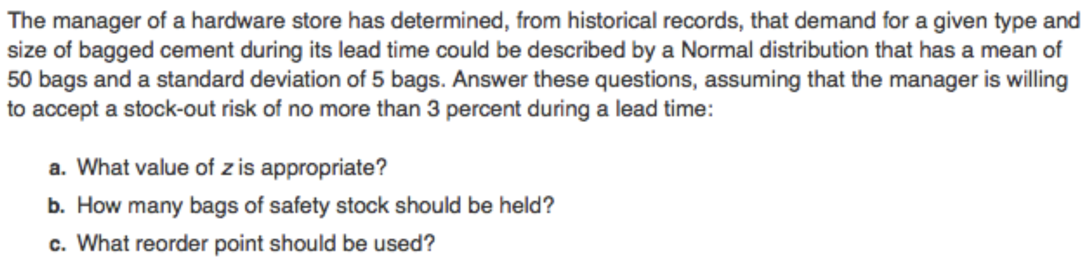

, ,

1. Service level of , obtain value of (Table 12-3 on Learn)
2. round to

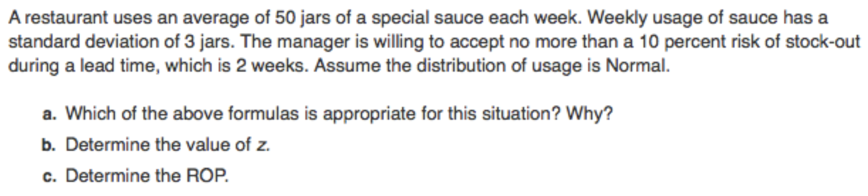

, , ,

1. Because only demand is variable (has a standard deviation):
2. Using a service level of , we obtain from the Table 12-3.
3. round to

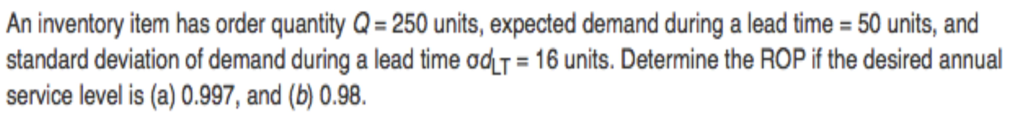

From Table 12-3, falls between with and with . Therefore, using interpolation, . Finally:

round to units.

From Table 12-3, falls between with and with . Therefore, using interpolation, . Finally:

round to units.

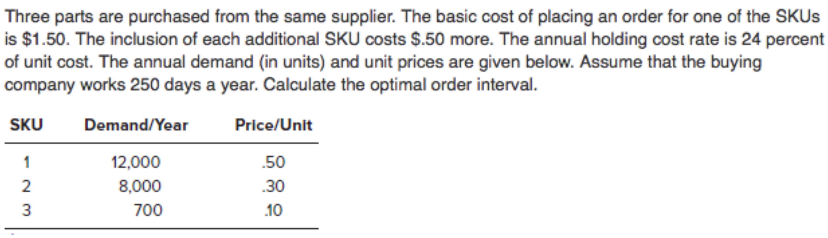

, ,

Round to 12 days.

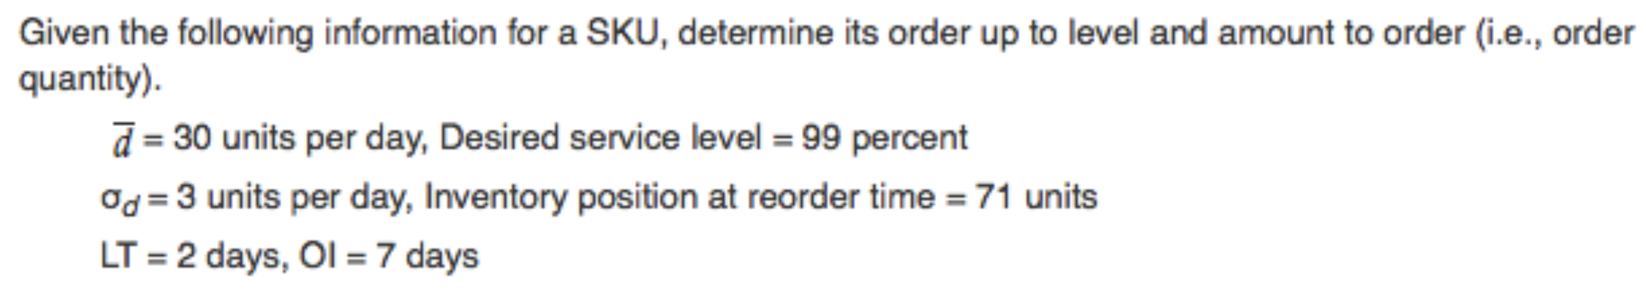

for percent desired service level from Table 12-3

## Single Period Model

### Characteristics

* Goods typically cannot be held over to the next period, and when they can they incur significant price reductions
* Objective is to choose an order quantity that will minimize shortage and excess costs.
* Described by examining shortage costs and the costs of having excess goods.

### Costs

Shortage Costs:

Excess Costs:

### Continuous Stocking Levels

* The service level () is the probability that demand will not be greater than the quantity of goods on hand:
* **Uniform Demand** distributions will have an optimal order quantity that is equal to the sum of the minimum order quantity plus an amount that is equal to the product of the and the difference between minimum and maximum order quantity levels.

**Normal Distribution of Demand:**

* Optimal where is the mean of demand and is the standard deviation of demand (both of which will be given).
* Solution process is to use and values to determine the service level and then use that service level to find the corresponding z-value and then apply the optimal equation.

### Example: Continuous Stocking Levels

A cafeteria buys muffins daily. Demand is **approximately normal with a mean of and standard deviation of muffins per day**. The cafeteria pays per muffin and charges per muffin. Find the optimal stocking level.

If service level is , then from Table 12-3,

A cafeteria buys muffins daily. Demand **varies uniformly between and muffins per day**. The cafeteria pays per muffin and charges per muffin. Unsold muffins are discarded at the end of the day. Find the service level.

### Discrete Stocking Levels

* In this case, the goal is to choose a **stocking level** that will **just** exceed demand.
* Service level is calculated as it was before with where the results are compared to the cumulative probability levels.

### Example: Discrete Stocking Levels

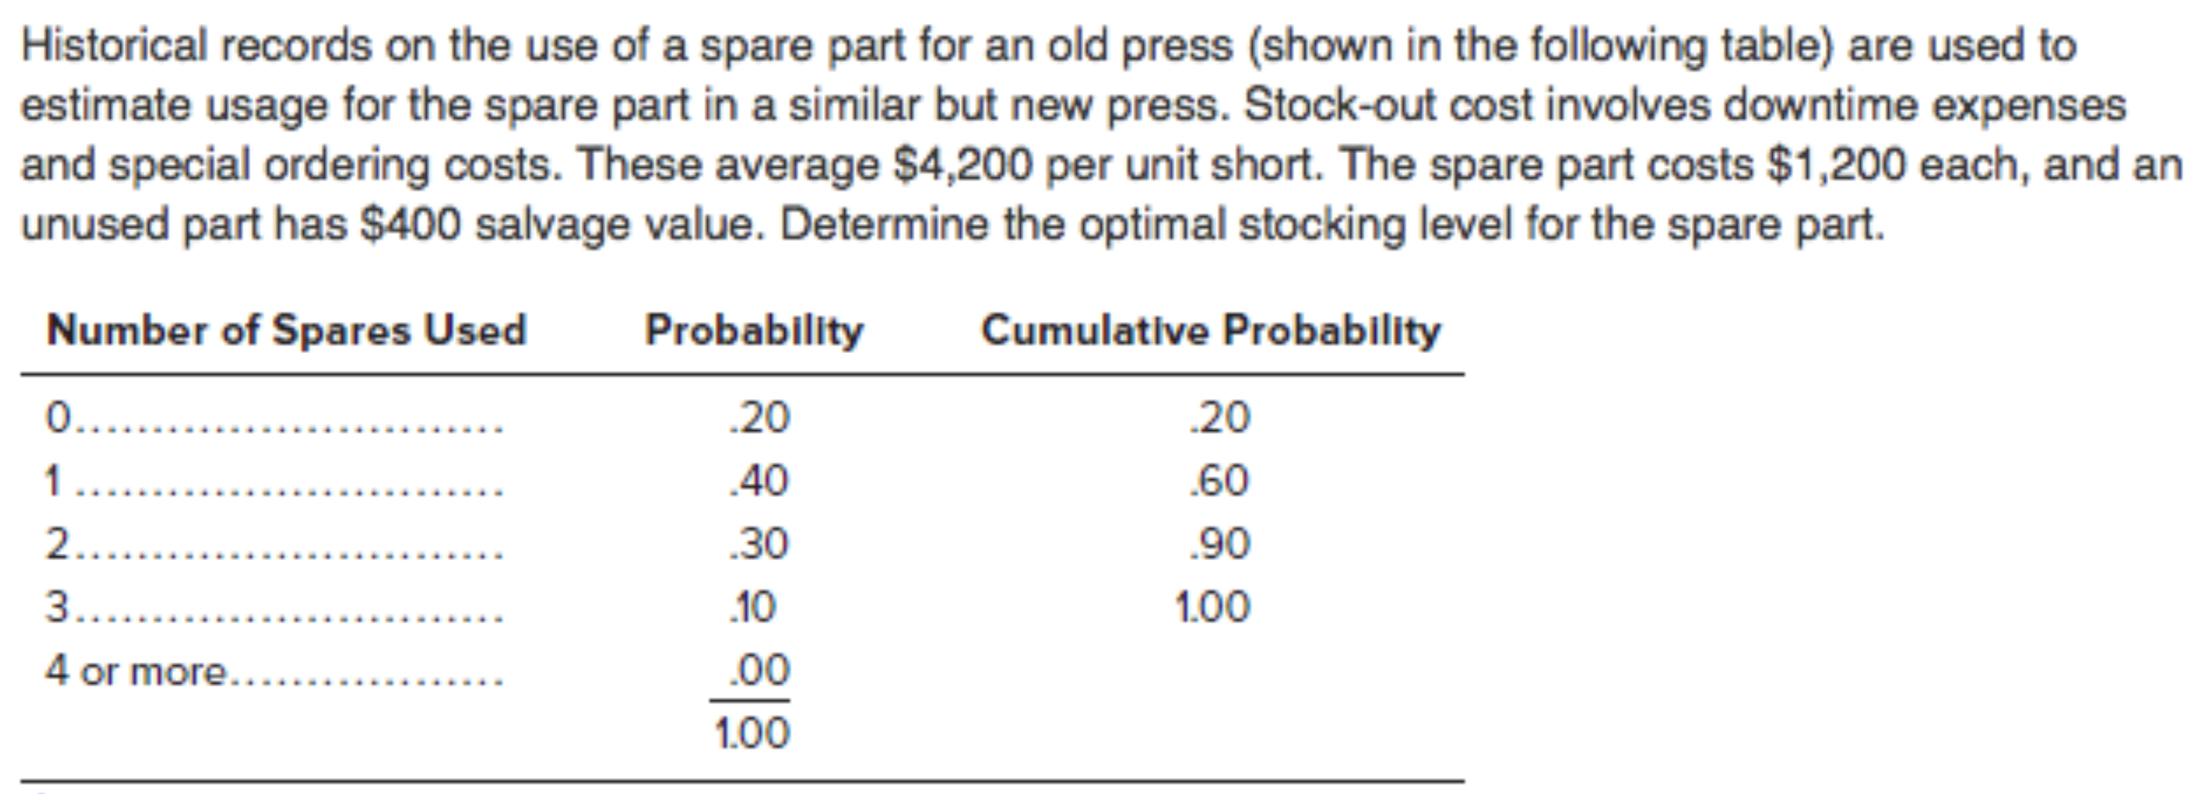

, ,

The cumulative probability column indicates the fraction of time that demand was equal to or less than some amount. For example, demand one spare occurred percent of the time, or demand two spares occurred percent of the time. Go down the table until cumulative probabilities just exceed service level of percent. This is which relates to two spares.

# Aggregate Operations Planning (AOP)

## Basic Concepts, Practical Options, Basic Strategies, AOP Techniques

### Review of the Basic Concepts

**Types of Decisions:**

* Long Term: Deal with product matrix, location, size of facilities, product flow (layout).
* Medium Term: Employment levels, output capacity, inventory levels and capacities.
* Short Term: Scheduling of production shifts and labour needs, manufacturing schedules.

**Theory and Goals Underlying AOP:**

* Products are treated (aggregated) as a single grouping of “like” products.
* Aggregate planning links sales forecasts to production (capacity) planning.
* Goal: Satisfy anticipated consumer demand at lowest possible cost through increased efficiency (inventory appropriate, adequate labour, level of finished goods stocks).

**Mechanics of AOP:**

* Best described as the activity whereby sales and operations staff undertake monthly planning for the production of all products of the same family for the next 12 months.
* Goal is to develop a production plan that realistically assesses an organization’s capacity to meet projected demand.
* Particularly useful in firms that experience seasonal demand spikes.

### Practical Options to Deal with Demand and Capacity Fluctuations

**Demand Influencing Options:**

* Price (re-issuance of price lists, differential pricing to shift demand from peak periods).
* Promotion (temporary price discounts, advertising, bonus offerings, BOGO programs).
* Early orders.
* Backorders (advance orders placed in one period for delivery in the next period).
* Exporting.
* Development of complementary products (to fill out production schedules, fill in gaps).

**Capacity Options:**

* Determining permanent workforce level (hiring and firing of workers).
* Use of overtime (incentive for some workers) and idle time strategies (inefficient labour).
* Use of temporary workers (flexibility, suited to lower skilled jobs, costs less).
* Stockpiling inventories of finished goods (stock build-up preceding high demand).
* Subcontracting

### Basic Strategies Available to Operations Planners

**Option 1:** Level Output – Workforce Strategy

* Maintain steady workforce and hopefully a constant flow of output.
* Uses inventory buildup (ensures employment during periods of slow demand, provides stocks of product to meet demand during periods of higher demand).

**Option 2:** Chase Demand Strategy

* Change output to match demand for period at hand.
* Planned output forecast demand.
* Permanent workforce numbers dictated by low period demand.
* Reduced inventory levels.

**Option 3:** Mixed Strategy

### AOP Techniques

**Techniques for AOP:**

1. Determine demand forecast for each period.
2. Determine capacities and production rates.
3. Identify pertinent policies.
4. Determine unit costs.
5. Develop alternative plans and costs.
6. Select the best plan that satisfies objectives.

**General Assumptions About the Actual Model:**

* There is only one aggregate group.
* Production is measured in the number of units.
* No allowance is made for the number of workdays in a month.
* No allowance for maintaining safety stock.
* No economies of scale.

**Calculable AOP Relationships:**

1. **Ending Inventory/Backorder** (in any period):

If , then:

If , then:

1. **Average Inventory** (in any period):
2. **Beginning and Ending**:

## AOP Relationships, Trial and Error Procedure, Trade-Off Analysis, ASP

### AOP Relationships

**Example 1:**

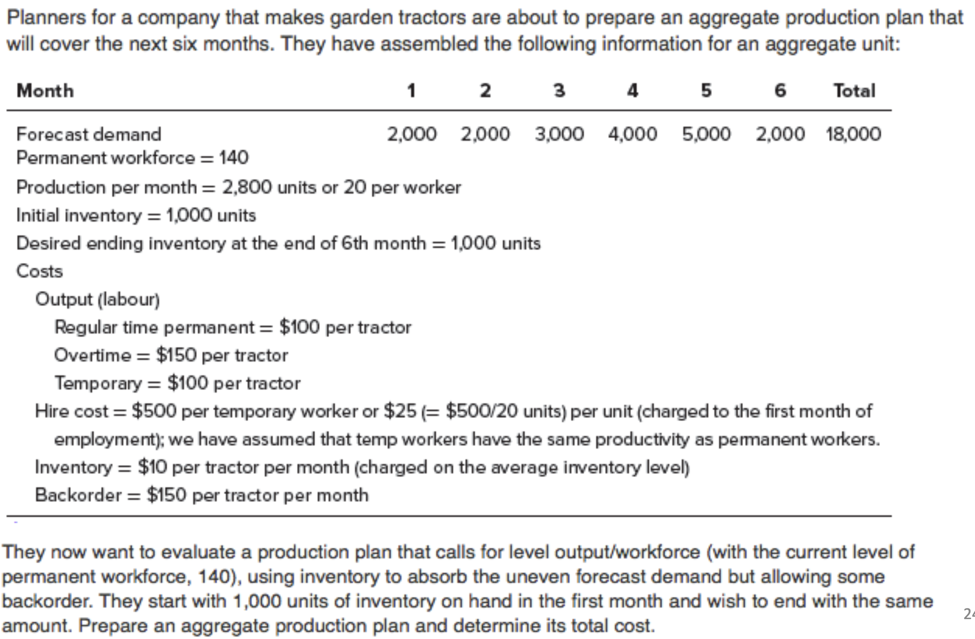

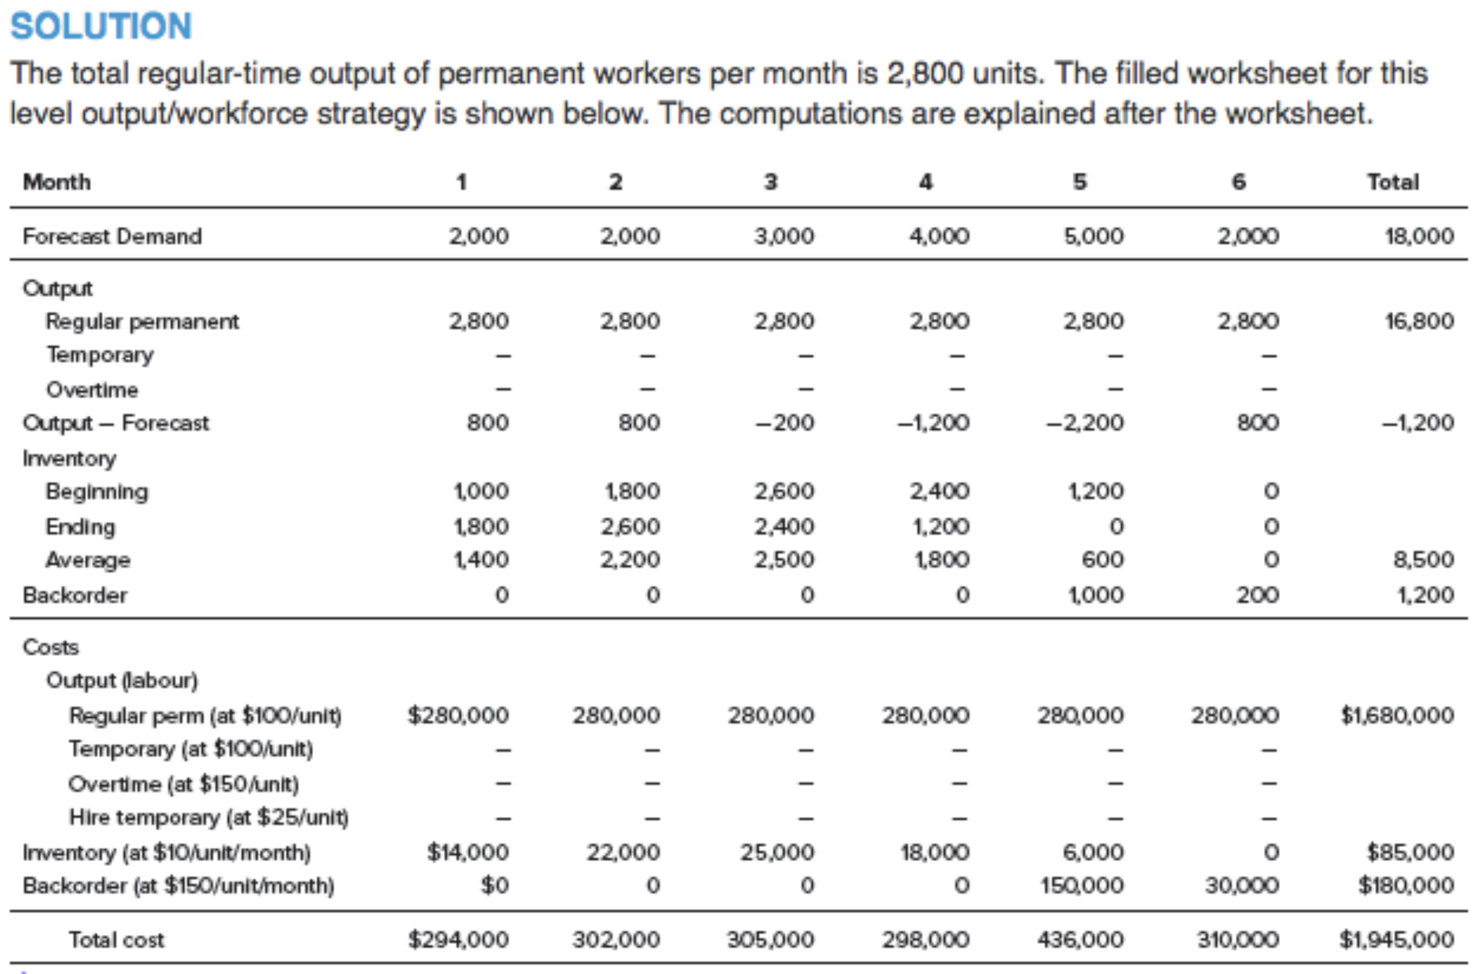

Starting with month 1,

Therefore, and . Also,

Then, . Continue with the same formulas, but note that in month 5,

Therefore, and . Also, in month 6,

Therefore, and .

The costs were computed as follows. Regular permanent cost in each month equals units per unit, or . Inventory holding cost equals average inventory per unit. Backorder cost is per unit times the number of backorders. The total cost for this plan (either sum the row totals of costs or sum the column totals of costs) is .

**Example 2:**

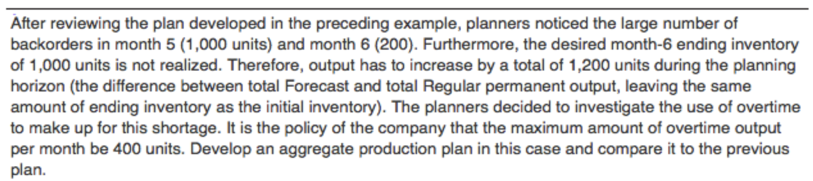

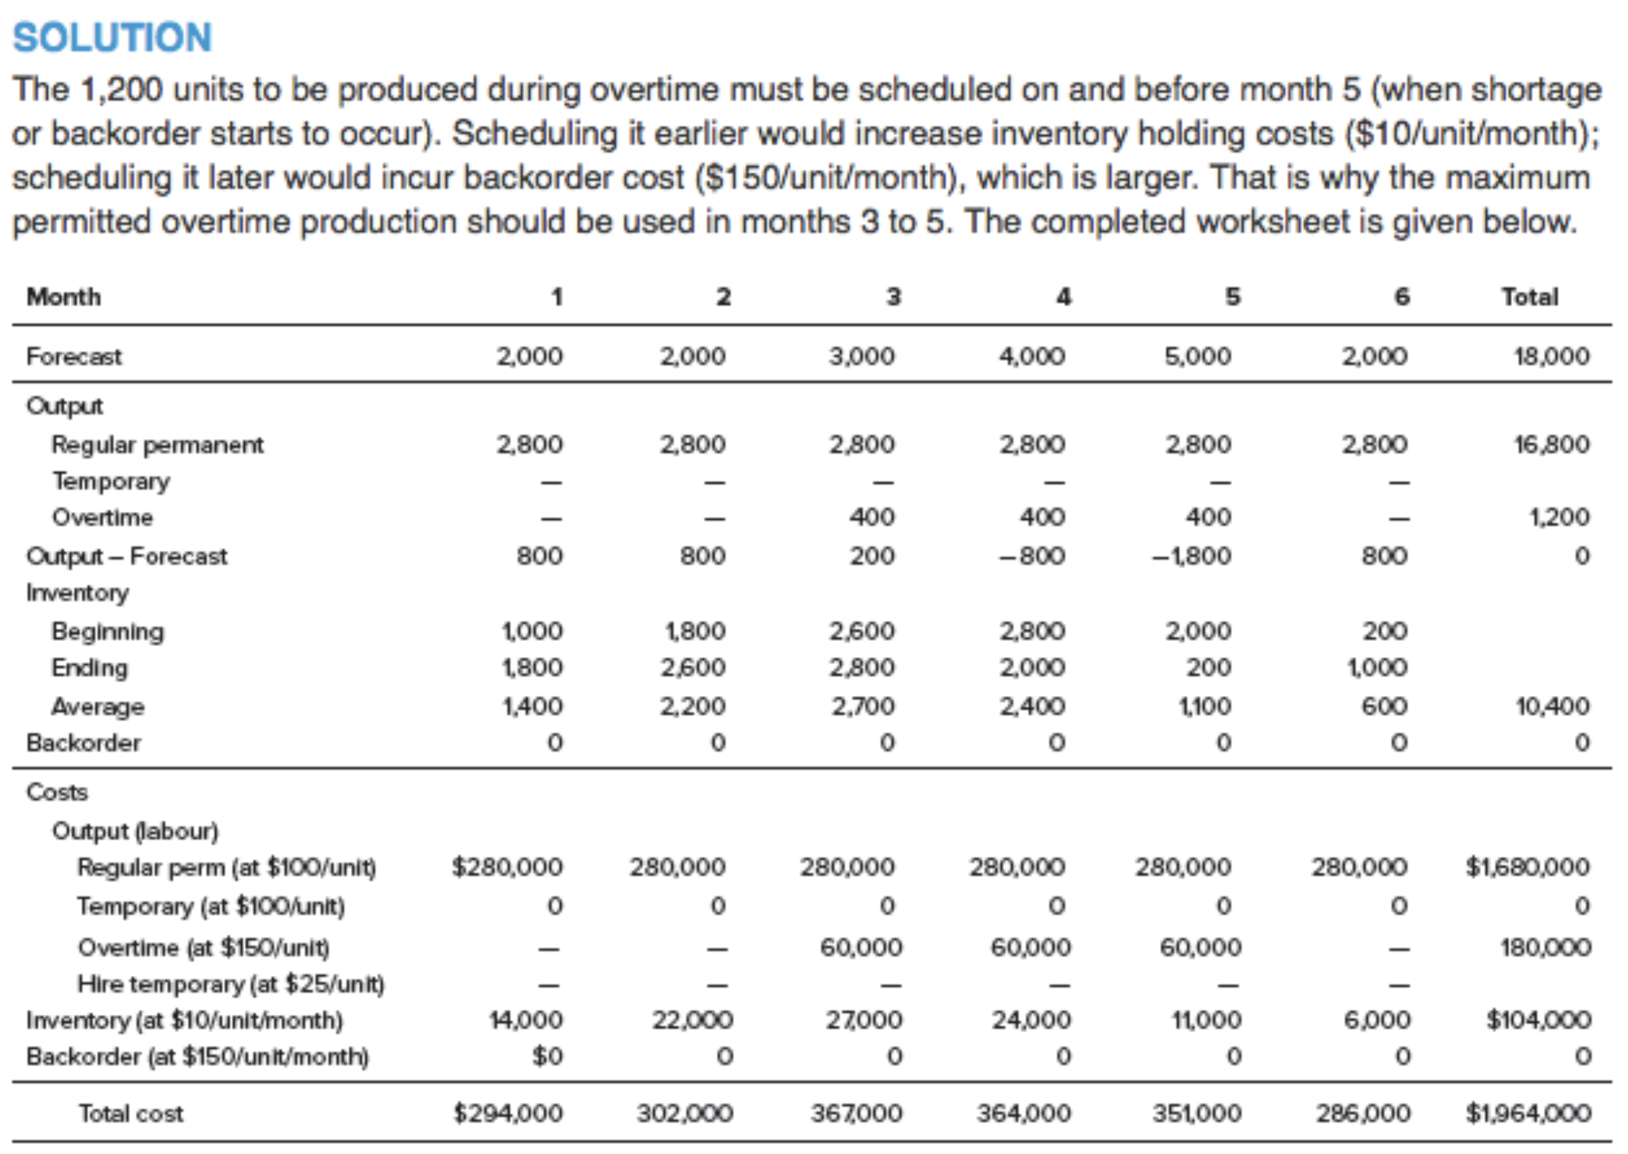

Note that, even though plan 2 has a larger total cost than plan 1, it produces more units and leaves units at the end of month 6.

Alternatively, the company can use temporary workers to meet the units short. The unit cost of temporary-worker production () is lower than unit cost of overtime production (), but there is a per unit hire cost of for units produced during the first month of employment. Overall, using temporary workers is less costly than using overtime.

**Example 3:**

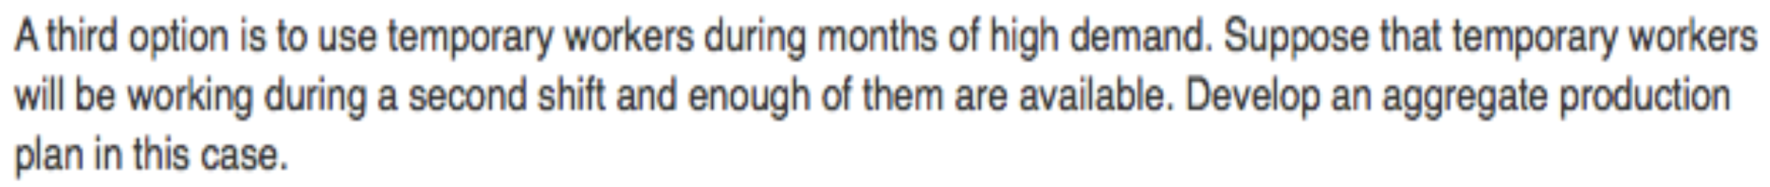

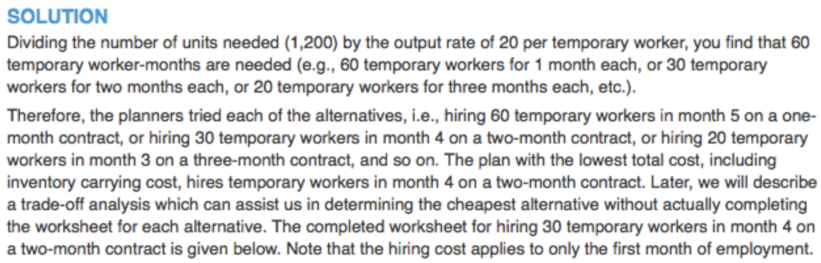

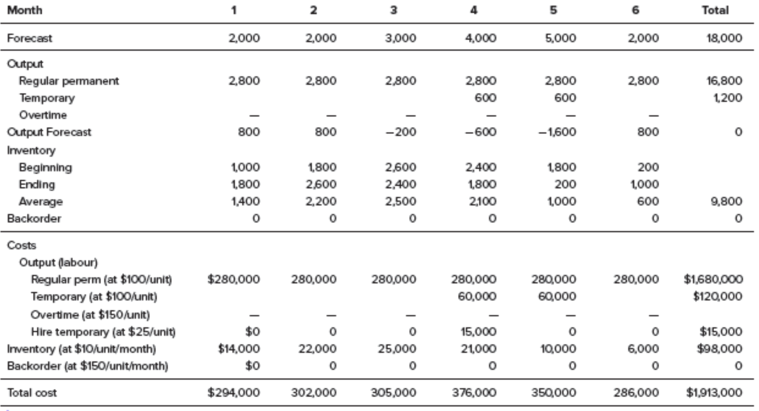

Overall, the total cost for this plan () seems to be the lowest possible, i.e., this plan seems to be optimal.

### Trial and Error Procedure

Determine output for regular labour determine total short units and periods determine cheapest way to meet units short (use trade-off analysis to compare alternatives).

### Trade-Off Analysis

* Compare unit costs of labour, inventory, and backorders.
* Without having to recalculate the total plan cost.

**Example:**

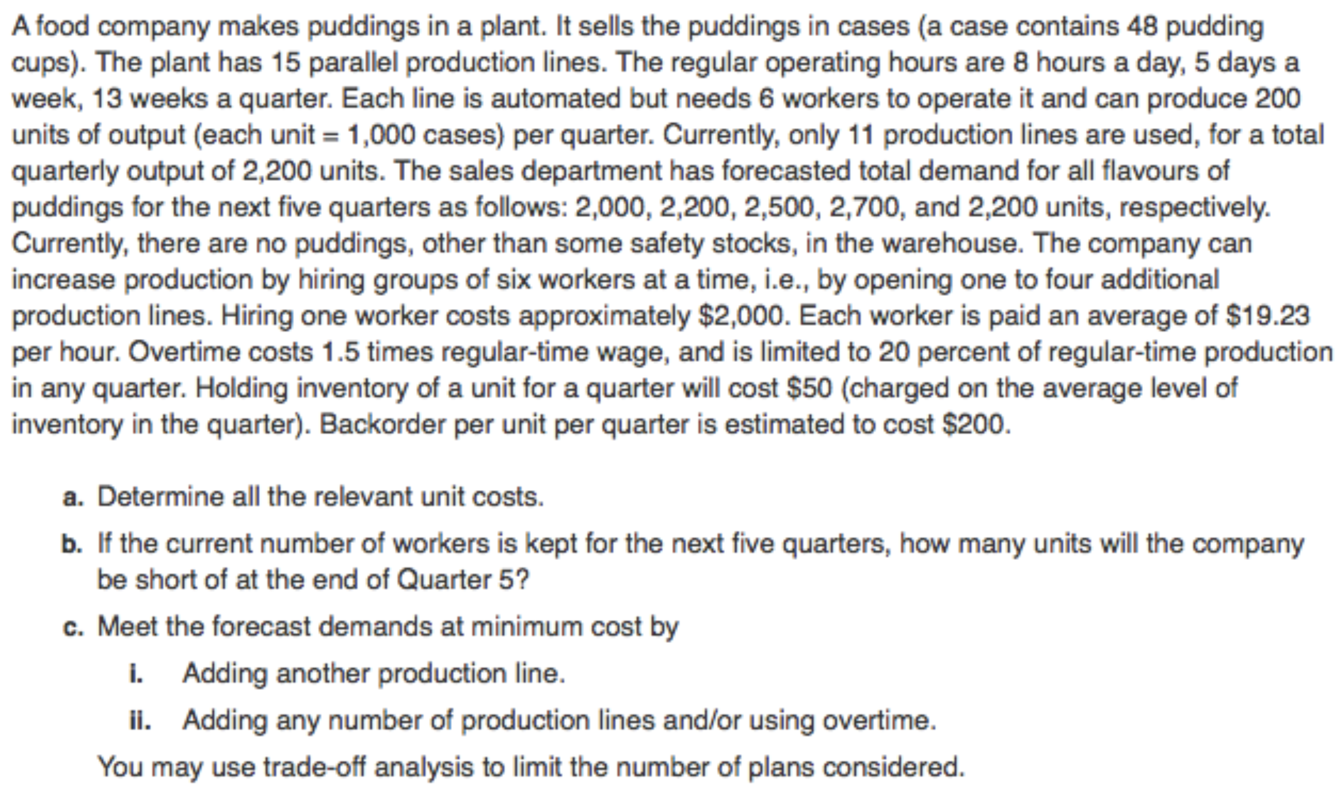

1. Labour cost per unit during regular time

Labour cost of one line for one quarter production of the line in the quarter

# of workers for the line cost per worker per quarter

wage per hour hours per quarter

hours per day days per week weeks per quarter

round to

Labour cost per unit during overtime

regular time cost

Hiring cost per unit (charged to the first quarter employed)

Hiring cost per worker # workers per line production per line per quarter

1. Number short at the end of Quarter 5

total demand forecasts regular production per quarter

units

1. i. Adding another production line.

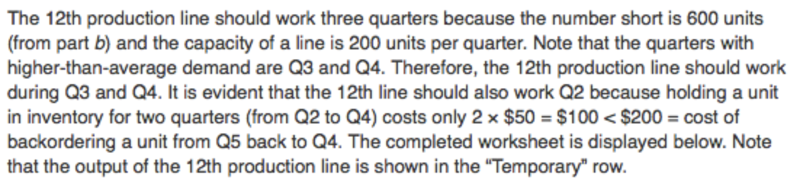

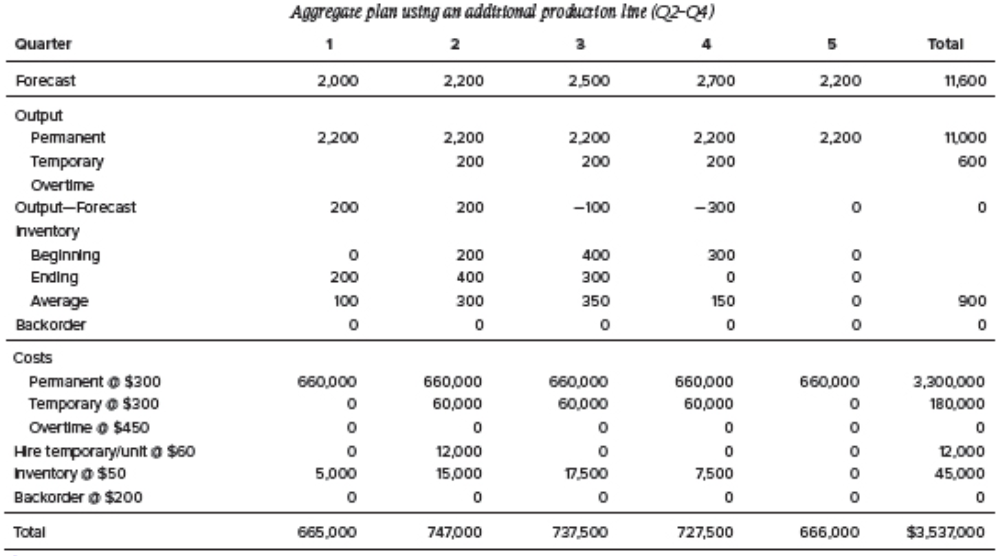

ii. Adding any number of production lines and/or using overtime.

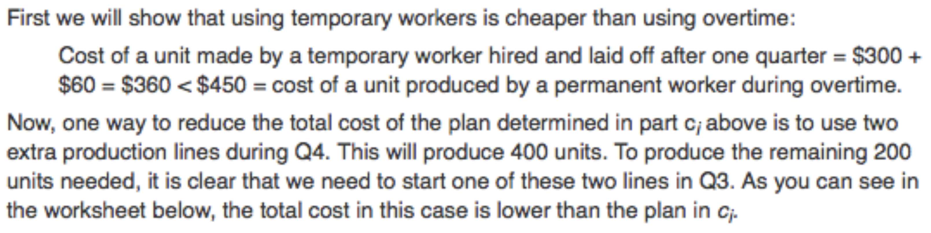

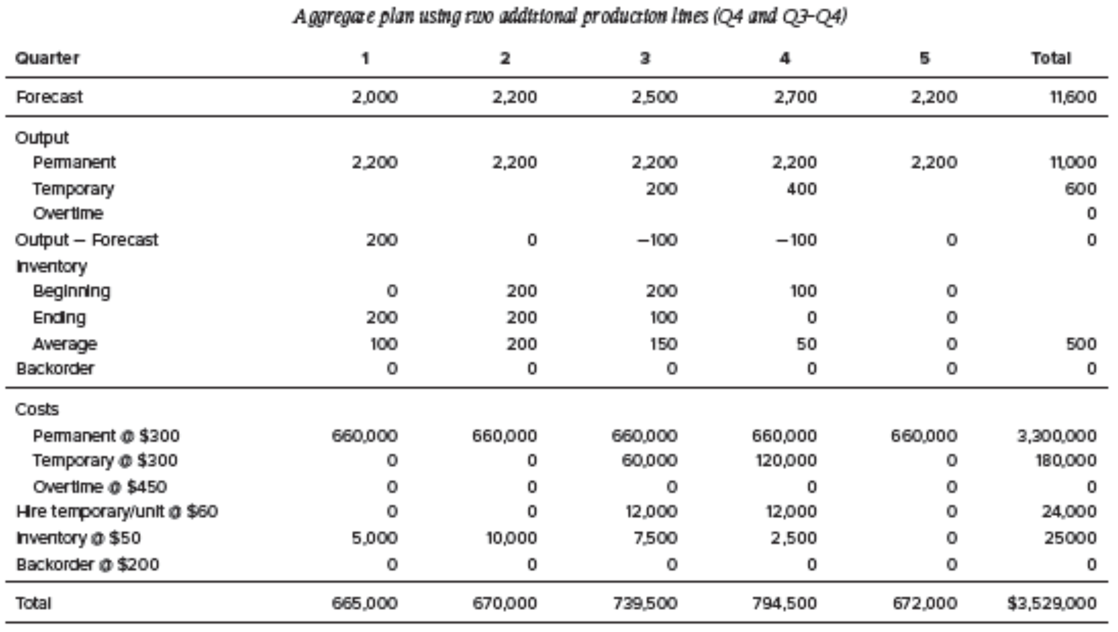

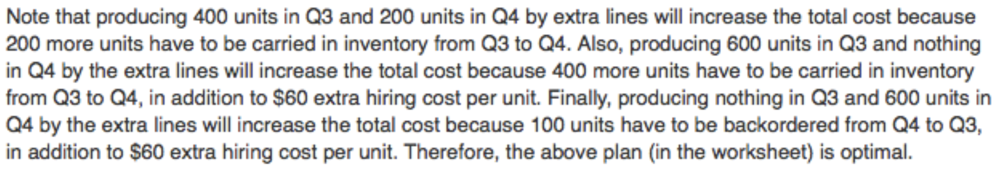

### Aggregate Services Planning (ASP)

**ASP vs. AOP:**

1. Services cannot be inventoried (**Chase Demand** strategy).
2. Service sector organizations must be measured in terms of either time or some standard measure of labour (i.e., fulltime equivalent) units.

**Yield Management:**

* A variable pricing strategy used to maximize revenue.
* Based on the premise that capacity cannot be inventoried.
* Prices are set according to availability.
* It’s all about supply and demand.
* Commonly used by airlines and all-inclusive resorts.

**Example:**

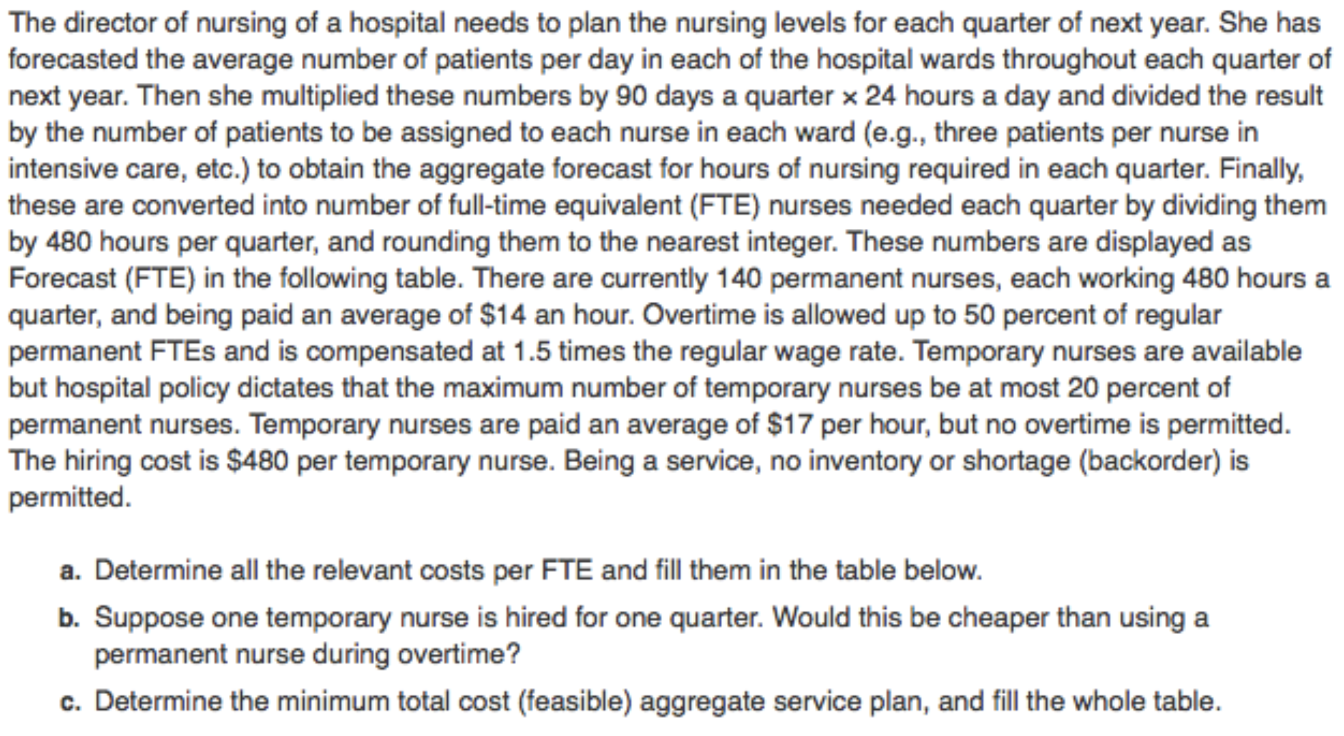

Given:

Aggregate forecast for FTE nursing:

.

permanent nurses each working .

Overtime cannot exceed of regular permanent FTEs () and is paid .

Temporary nursing staff must not exceed of permanent staff with no allowance for overtime.

.

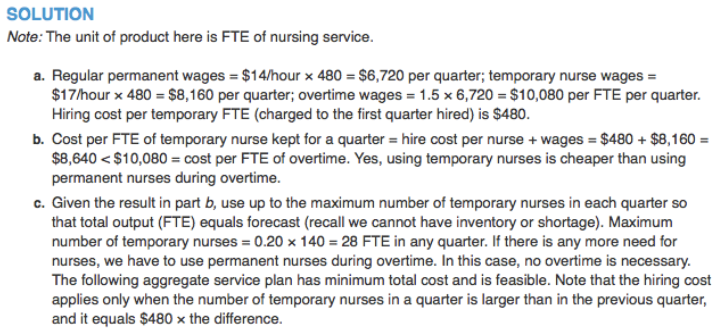

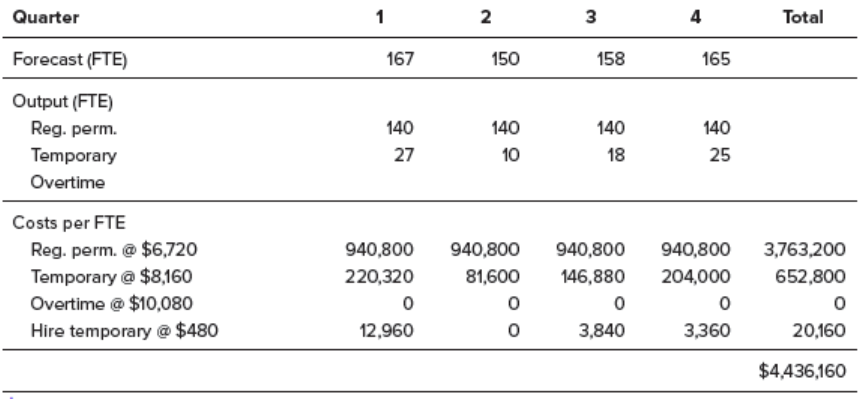

Because service capacity is perishable (e.g., an empty seat on an airplane can’t be saved for use on another flight), aggregate planners need to take this fact into account when deciding how to match supply and demand. **Yield management** is an approach that seeks to maximize revenue by using a strategy of variable pricing; prices are set relative to capacity availability. Thus, during periods of low demand, price discounts are offered to attract a wider population. Conversely, during peak periods, higher prices are posted to take advantage of limited supply. Users of yield management include airlines, hotels, and resorts.

# Material Requirements Planning (MRP)

## Concept of MRP, Key Requirements, Material Resource Plan

### Concept of MRP

**MRP:**

* Simply a planning procedure for the purchase and production of demand-dependent components.
* Contrasts sharply with the fixed order quantity, fixed order interval and single period models described previously.
* Determine the plans for purchasing and production of dependent-demand components.

**Process:**

* Convert a production plan (MPS) for a finished product into the requirement needs for dependent-demand goods using a BOM.
* Work backwards from the start-of-production date contained in the MPS, taking into account the required lead times for components goods, to plan for the purchase and receipt of the goods needed.
* Objectives: Have inventory on hand when it is required in sufficient quantities as are needed and maintain and control low inventories of demand-dependent goods.

### Key Requirements

1. **BOM** that identifies the dependent parts needs for one unit of finished good.
2. **Master Production Schedule** (MPS) to determine how much will be made and when it will be made.
3. A list of any **existing inventory** of each good on the BOM.
4. Estimated **lead time requirements** for individual components (from suppliers).
5. A list of any **existing open orders** for any of the components needed to avoid duplication.

### Material Resource Plan

**Cumulative Lead Times:**

* This is nothing more than the sum of all of the lead times associated with the purchase (and acquisition) of goods and the process lead times required in an MPS.
* MPS Cumulative sum of lead times necessary to produce the finished good.

**Planning Horizon of MPS:**

* Separated into time buckets.
* Planning horizon Cumulative (stacked) lead time (for all phases of process).

**Order Planning:**

* **Planned-Order Receipt:** Quantity of an order received at the beginning of a period.
* **Planned-Order Release:** Quantity planned to be released (purchased) at the beginning of a period. Planned-Order Release Planned-Order Receipt adjusted for lead time.

**Net Requirements Calculation:**

Net Requirements Gross Requirements Projected Beginning Inventory Scheduled Receipts

**Lot-for-Lot vs. Lot-Size Ordering:**

* **Lot-for-Lot Ordering:** Determine orders based on requirements.
* **Lot-Size Ordering:** Planned receipts may exceed net requirements.

**Example:**

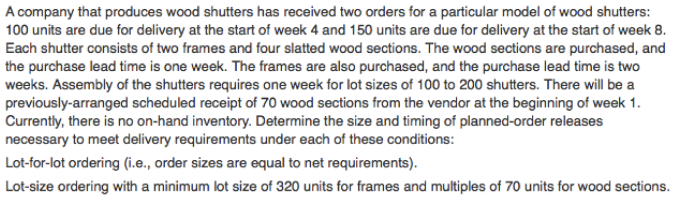

Given:

* Firm makes window shutters.
* Orders taken for shutters in week and shutters in week .
* Each shutter has frames and wood sections.
* Wood section .
* Frame .
* Assembly time for lots of .
* Scheduled receipt of wood sections at the beginning of week .
* No on-hand inventory.

1. Determine the size and timing of planned-order releases with lot-for-lot ordering.
2. Determine the size and timing of planned-order releases with lot-size ordering with minimum lot size of units for frames and multiples of units for wood sections.
3. Lot-for-lot ordering.

Product structure tree:

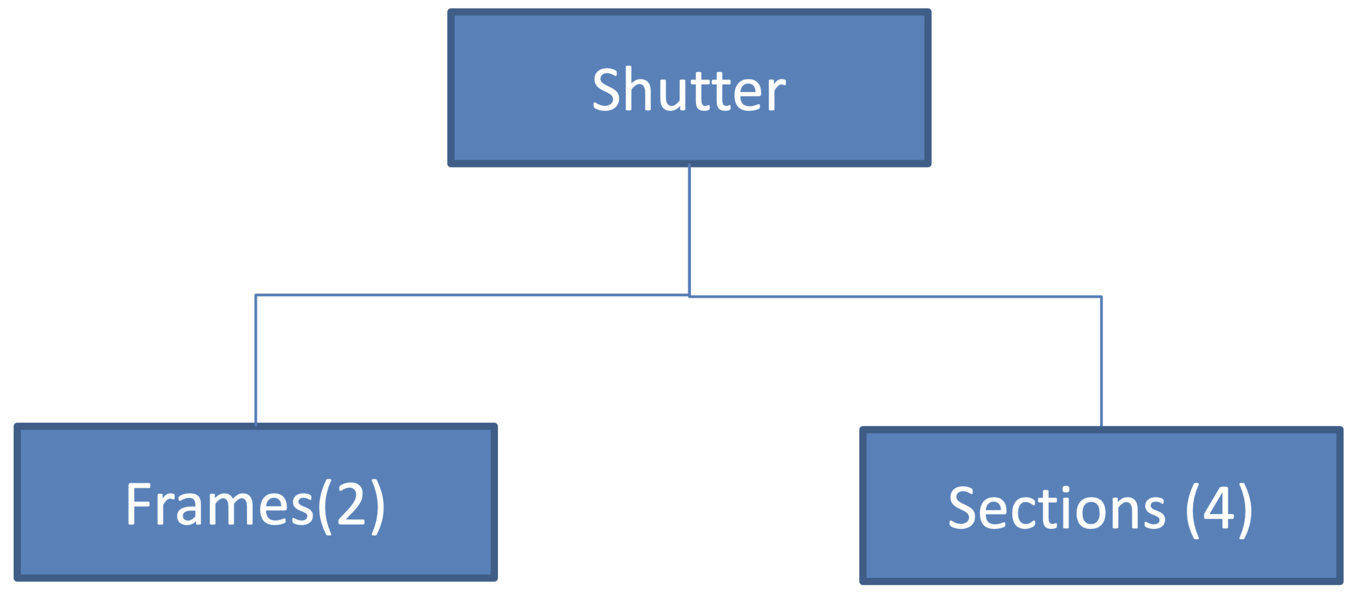

MRP table:

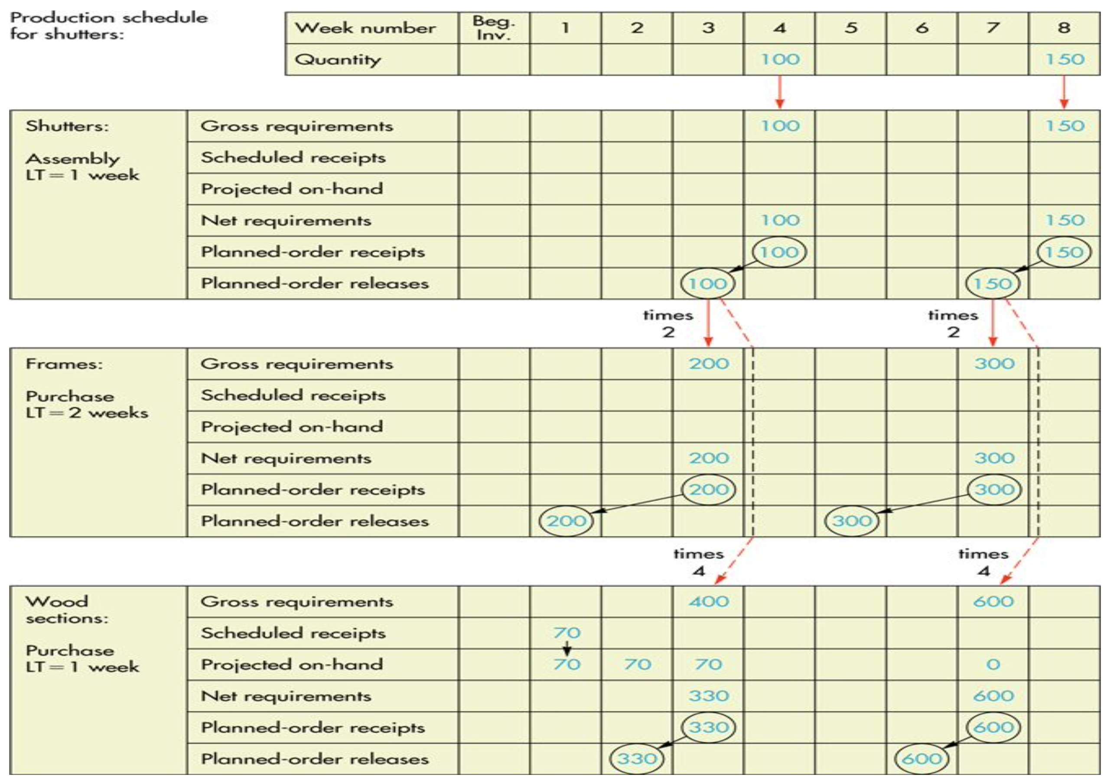

1. Lot-size ordering with lot size of for frames and multiples of for wood sections.

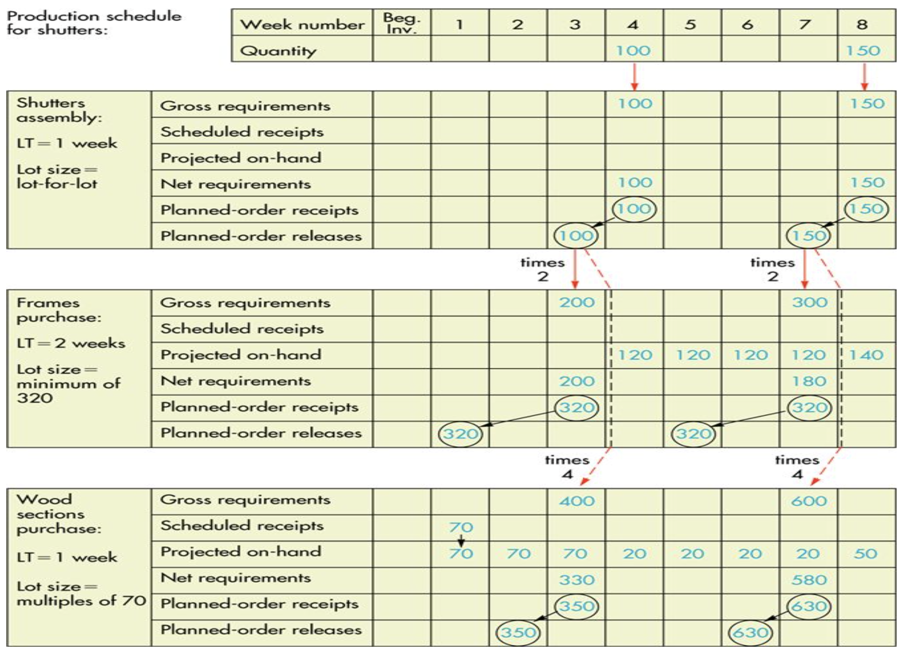

**MRP Table for Component D:**

Consider the two product structure trees shown below:

* Both A and C have D as a component.
* Demand for A is 80 units at the start of week 4.
* Demand for C is 50 units at the start of week 5.
* There is a beginning inventory of 110 units of D on hand.
* All lead times are 1 week.

Determine the size and timing of planned-order releases with lot-to-lot ordering:

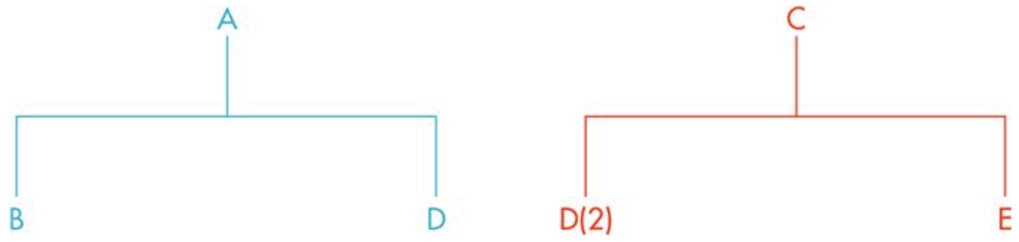

MRP table:

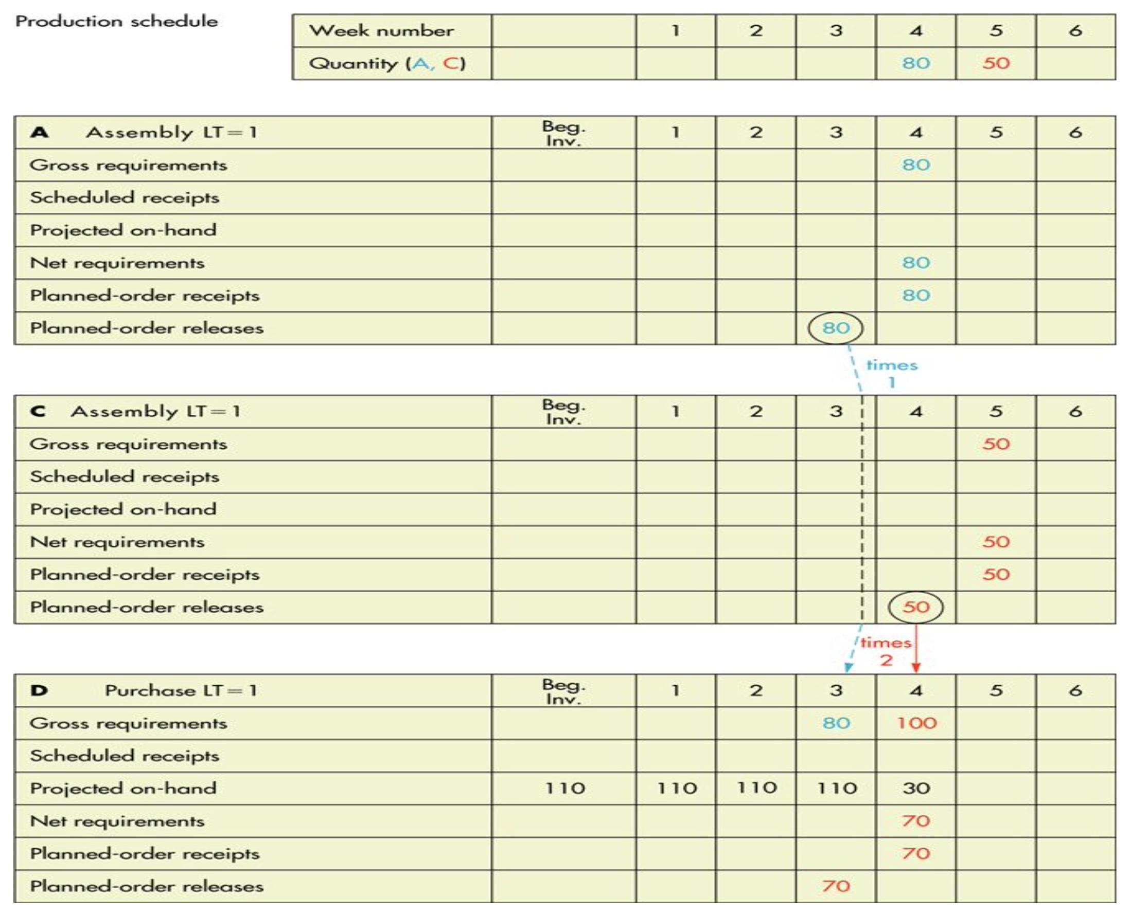

## Review of MRP, Part Period Method, Capacity Requirements Planning

### Review of MRP

**Definitions:**

* **Pegging:** Process of identifying the end product(s) manufactured from a specific part.
* **Non-Static Nature of MRP:** Based on the premise that MRPs are constantly changing to account for such things as short shipments in incoming parts, changes to finished goods orders, the need to rework defective output, etc.
* **Regenerative MRPs:** Synonymous with periodic revision where accumulated changes to materials requirements are updated in a batch-type format.
* **Net-Change MRPs:** Constantly being revised to address ongoing changes.
* **System Nervousness:** Even small changes to an item at the top of the BOM Tree can have large effects on the parts down the tree.
* **Backflushing:** This is nothing more than a method to check usage and to compare what has been estimated to have been used against what is left on hand.

**Primary and Secondary MRP Reports:**

* **Primary (Active) Reports:** Immediate order releases, planned order releases indicate the amount and timing of future orders, reports that detail changes to ongoing MRPs.
* **Secondary (Analysis) Reports:** Performance control reports that evaluate how well the MRP is working in terms of missed orders, demand history reports that are useful in forecasting future dependent demand requirements.

**Safety Stocks, Appropriate Lot Sizing and Ordering Methods:**

* **Safety Stocks:** Theoretically items with dependent demand should not require safety stock, but practically, bottleneck processes or ones with for example varying scrap rates can cause shortage.
* **Lot Sizing:** Minimize holding and ordering (or setup) costs, must take into account the nature of the underlying demand.

### Part Period Method (PPM)

**Definition:**

* PPM attempts to balance holding and ordering costs.
* Refers to holding a part or parts over a number of periods.
* EPP (Economic Part Period) is calculated as:
* Solution method: various order sizes corresponding to various cumulative demands are examined and each one’s number of part periods is determined. The one that comes closest to the EPP is the one chosen.

**Example:**

Given:

|  |  |  |  |  |  |  |  |  |
| --- | --- | --- | --- | --- | --- | --- | --- | --- |
| Period | | | | | | | | |
|  | 1 | 2 | 3 | 4 | 5 | 6 | 7 | 8 |
| Demand | 60 | 40 | 20 | 2 | 30 | - | 70 | 50 |
| Cumulative Demand | 60 | 100 | 120 | 122 | 152 | 152 | 222 | 272 |

Setup Costs

Holding Costs per unit per period

**Question:** Determine production run sizes.

**Solution Process:**

1. Calculate EPP.
2. Try cumulative demand quantities until part periods approximately match the EPP.
3. Repeat process for remaining periods.

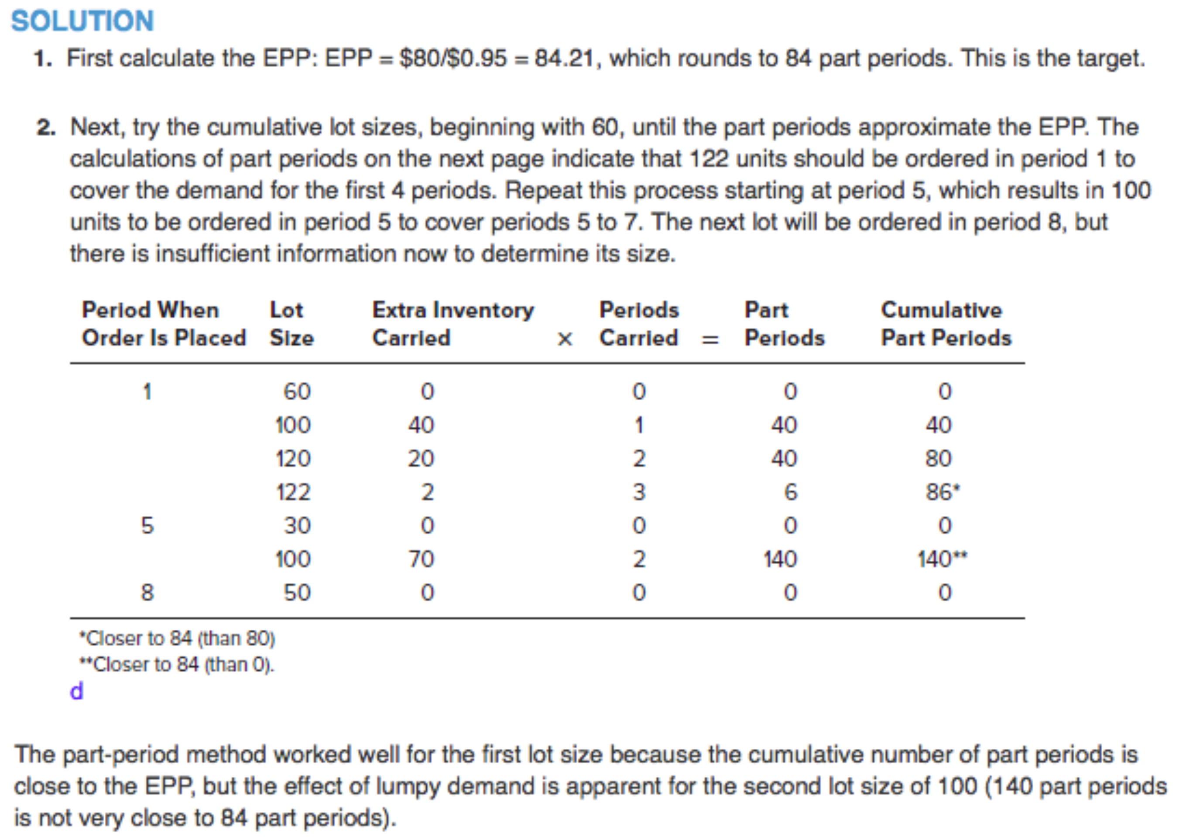

### Capacity Requirements Planning (CRP)

**Definition:**

* Process of determining short-range capacity requirements.
* Can convert quantity requirements into time requirements:
* Ex. scheduled production , standard time , setup time :

**Example:**

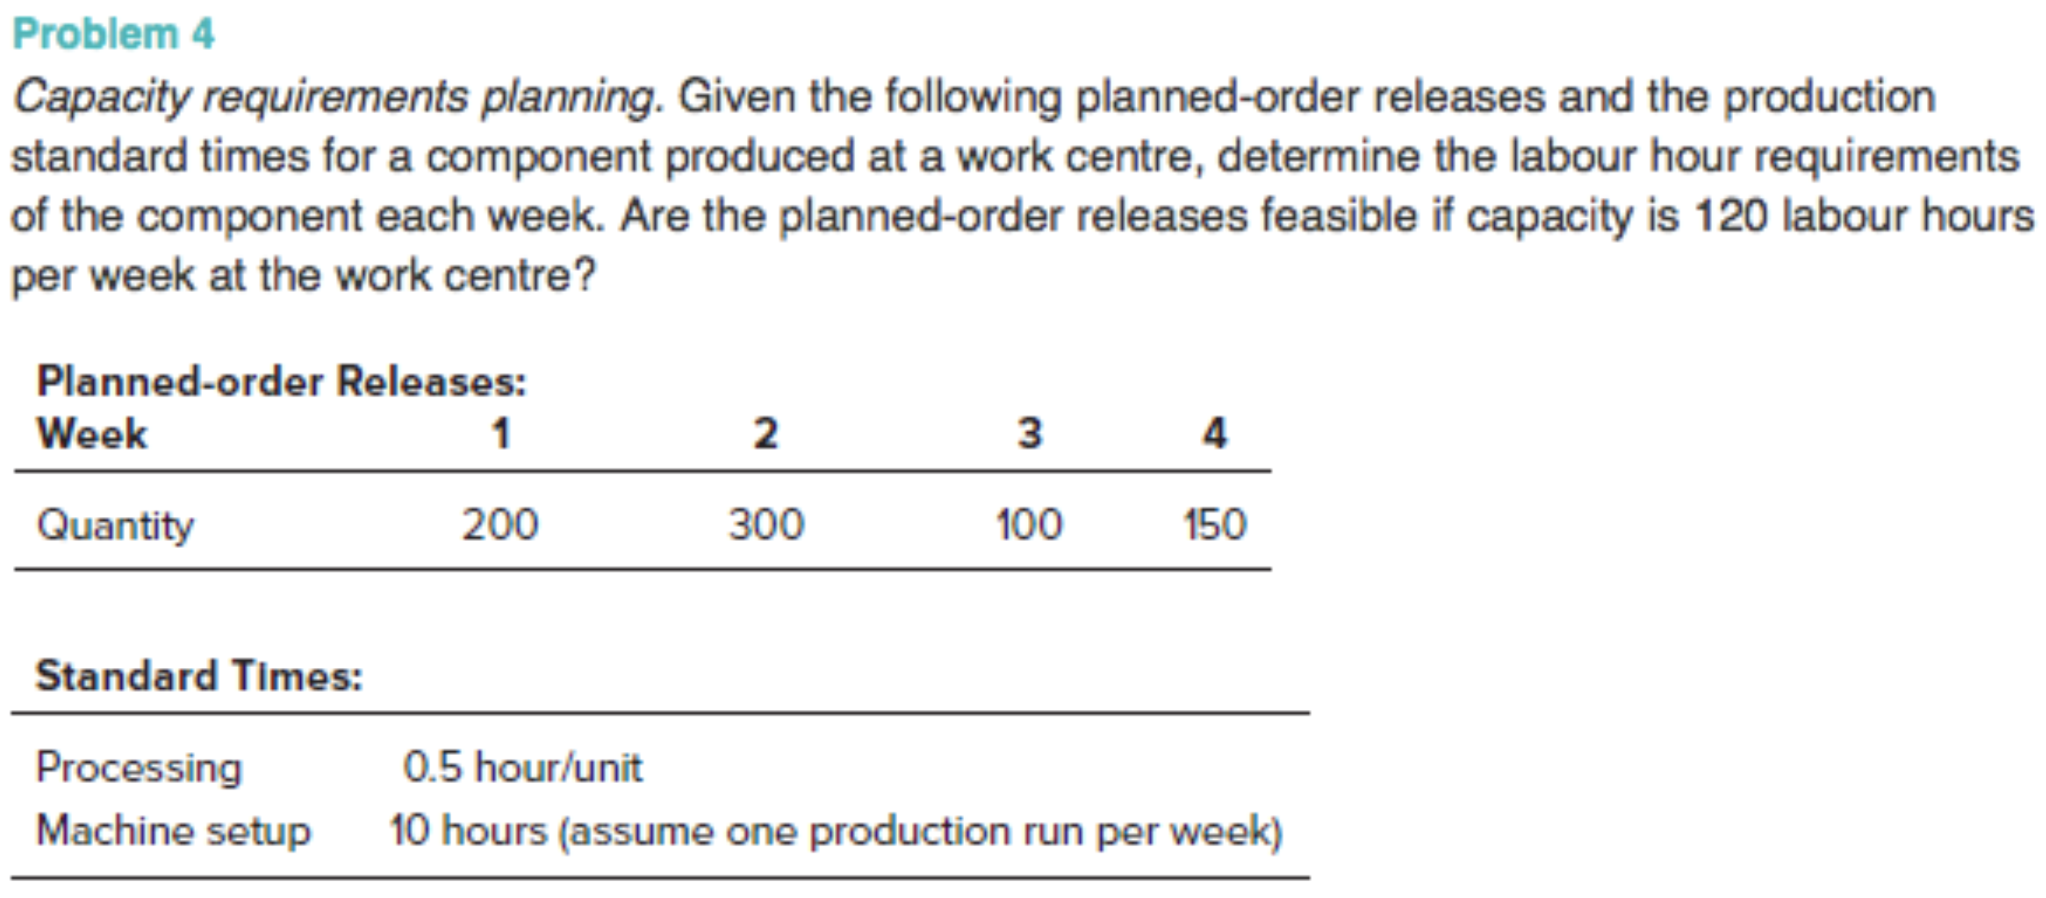

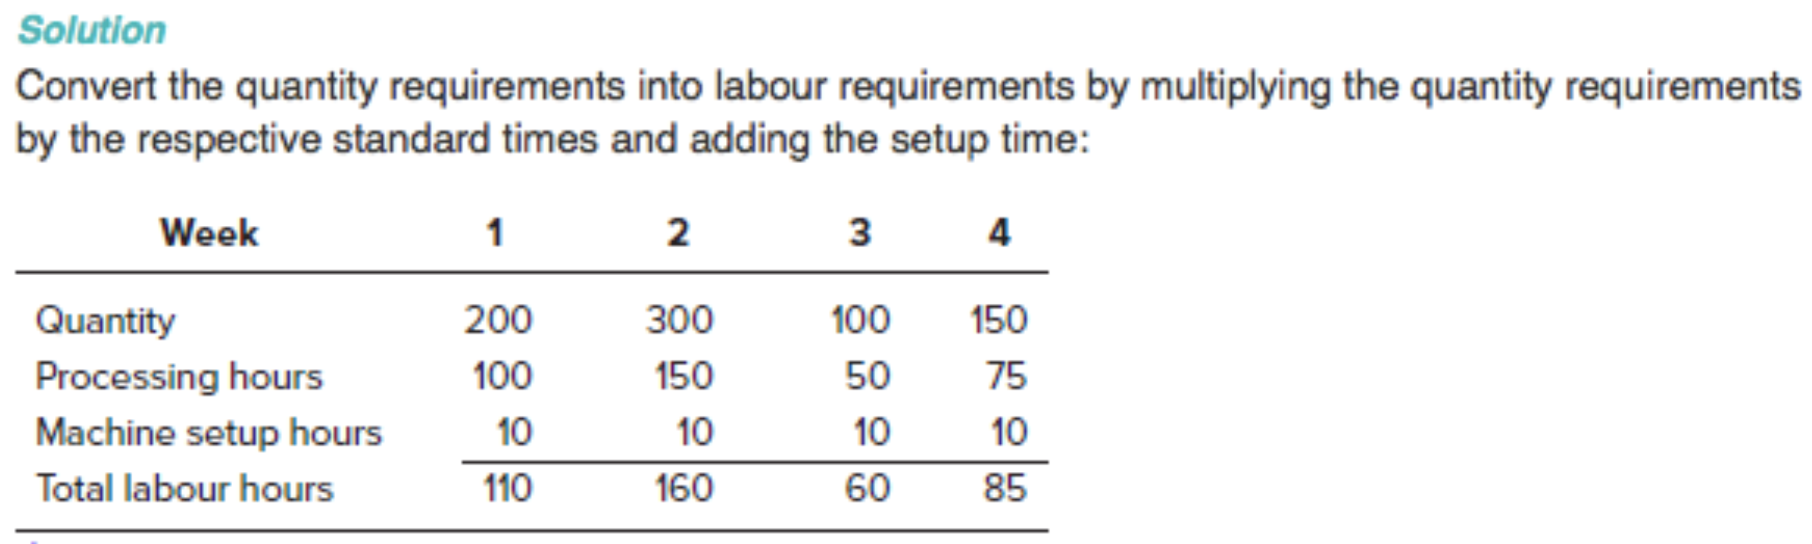

# Just-in-Time, Lean Production and Project Management

## JIT and Lean Production

### JIT and Lean Production

**JIT Definitions:**

* Logistical system where work-in-progress and the receipt of inputs to maintain product flow are timed such that input deliveries coincide with production line requirements.
* Suggests a batch type of production system where the inputs for one batch or unit of a good arrives just as the preceding batch is completed and is leaving the production line.
* Objectives include limiting idle items, co-ordinate material movements, waste reduction.

**Pull vs. Push Production Strategies:**

* **Marketing:** Push strategy involves selling through promotion through the distribution system, while pull strategy is more consumer focused with things such as advertising.
* **Manufacturing:** MPS and MRP schedule production and acquisitions, JIT systems.
* **Overall Objective:** Enhance profitability through increased efficiencies.

**Characteristics of JIT/Lean Production Systems:**

Example: Toyota car plant.

* Produces one high-cost unit at a time.
* Production of each unit is driven by specific consumer demand.
* Objectives: defective-free car, zero waste, high rate of output, safe work environment.

### The Goals of Lean Production

* Balanced flow of product within a production system.
* Elimination of disruptions.
* System flexibility.
* Waste reduction.
* Continuous improvement.

### Product Design

* **Product Design:** Involves engineering quality into product attributes, quality must be designed into goods and services, consumer driven.
* **Science of Product Design:** Balancing the production system (take time calculations), promoting productive flexibility, focusing on small lot sizes, setup time reductions, cellular plant layouts, promoting process quality, process standardization, maintaining minimal inventories.

### Process Design

**A Balanced System:**

Balancing the System: Objective is to even out the work time amongst available workstations.

Takt Time Calculation:

* Maximum time per workstation is called **takt time**.
* Calculate net time available per shift.
* Multiply by the number of shifts on a typical day to get net available time.
* Divide net available time by daily demand to get the maximum time per workstation that will still allow you to satisfy the demand within the aggregate time constraint.

Sample Takt Time Calculation:

Given the following information, calculate the takt time: total time per shift is 480 minutes per day, and there are two shifts per day. There are two 20-minute rest breaks and a 30-minute lunch break per shift. Daily demand is 80 units.

**A Flexible System:**

Increase productive flexibility by decreasing setup times for changeovers, cross-train workers, design plants with multiple workstations, use safety stocks, keep some idle capacity.

**Small Lot Sizes:**

* Reduces inventory.
* Permits switching between different products to match production to customer demand.
* Less rework if defects occur, increased visibility of problems, increased flexibility.

**Setup Time Reduction:**

* **WILL** involve production worker involvement in setup changes.
* Should include as much “external” ahead-of-time setup procedures as is possible.
* Can involve the use of machine-specific jigs to eliminate exacting measurements.

**Cellular Layout:**

* Objective is to create a team approach to manufacturing by creating a specialized and efficient production cell.
* Involves: identifying product families, mapping out operations, addressing capacity requirements, balancing out workloads, determining an acceptable level of WIP.
* Advantages: increased throughput, reduced space requirements and material handling.

**Process Quality:**

* Jidoka: Quality at the source, if a detect is found then correct it before it is passed on.
* Objective here is to assist the operator in making quality products through the use of signals, alarms or the involuntary shutdown of equipment.

**Standardized Processes:**

* Complete work specification.
* Provides the basis for worker training.
* Creates a sense of simplicity and predictability.

**Little Inventory:**

Theory Behind Low Inventory Levels:

* Process control is less of an issue if inventories exist to maintain product flow.
* Lost opportunity to increase efficiency is hidden as it is less critical to make improvements or to repair recurring process problems when we know we have inventory.
* Just-in-Time is synonymous with one-unit lot sizes.

Little Inventory: For example, it is better to investigate the causes of some machine breakdown and focus on eliminating them rather than relying on excess inventory of machine’s output to feed into the next workstation.

### Personnel/Organization

**Level Loading:**

Objective: Smooth out the production in a mixed-model schedule or sequence.

Process:

* Determine due times for each product based upon the daily demand for that good with the aim of smoothing out production throughout the day.
* Sequence their due times for all products by arranging them from the smallest to the longest due times.
* Time starts at “**0**” for the beginning of the day and ends at “**1**” for the end of the day.
* Due times for “n” units of a product .

Sample Question:

Firm produces three goods and therefore needs a mixed-output schedule to smooth out daily production.

|  |  |  |  |  |  |  |  |  |  |  |
| --- | --- | --- | --- | --- | --- | --- | --- | --- | --- | --- |
|  |  |  |  |  |  |  |  |  |  |  |
|  |  |  |  |  |  |  |  |  |  |  |
|  |  |  |  |  |  |  |  |  |  |  |

Determine due times for each product and the daily production sequence.

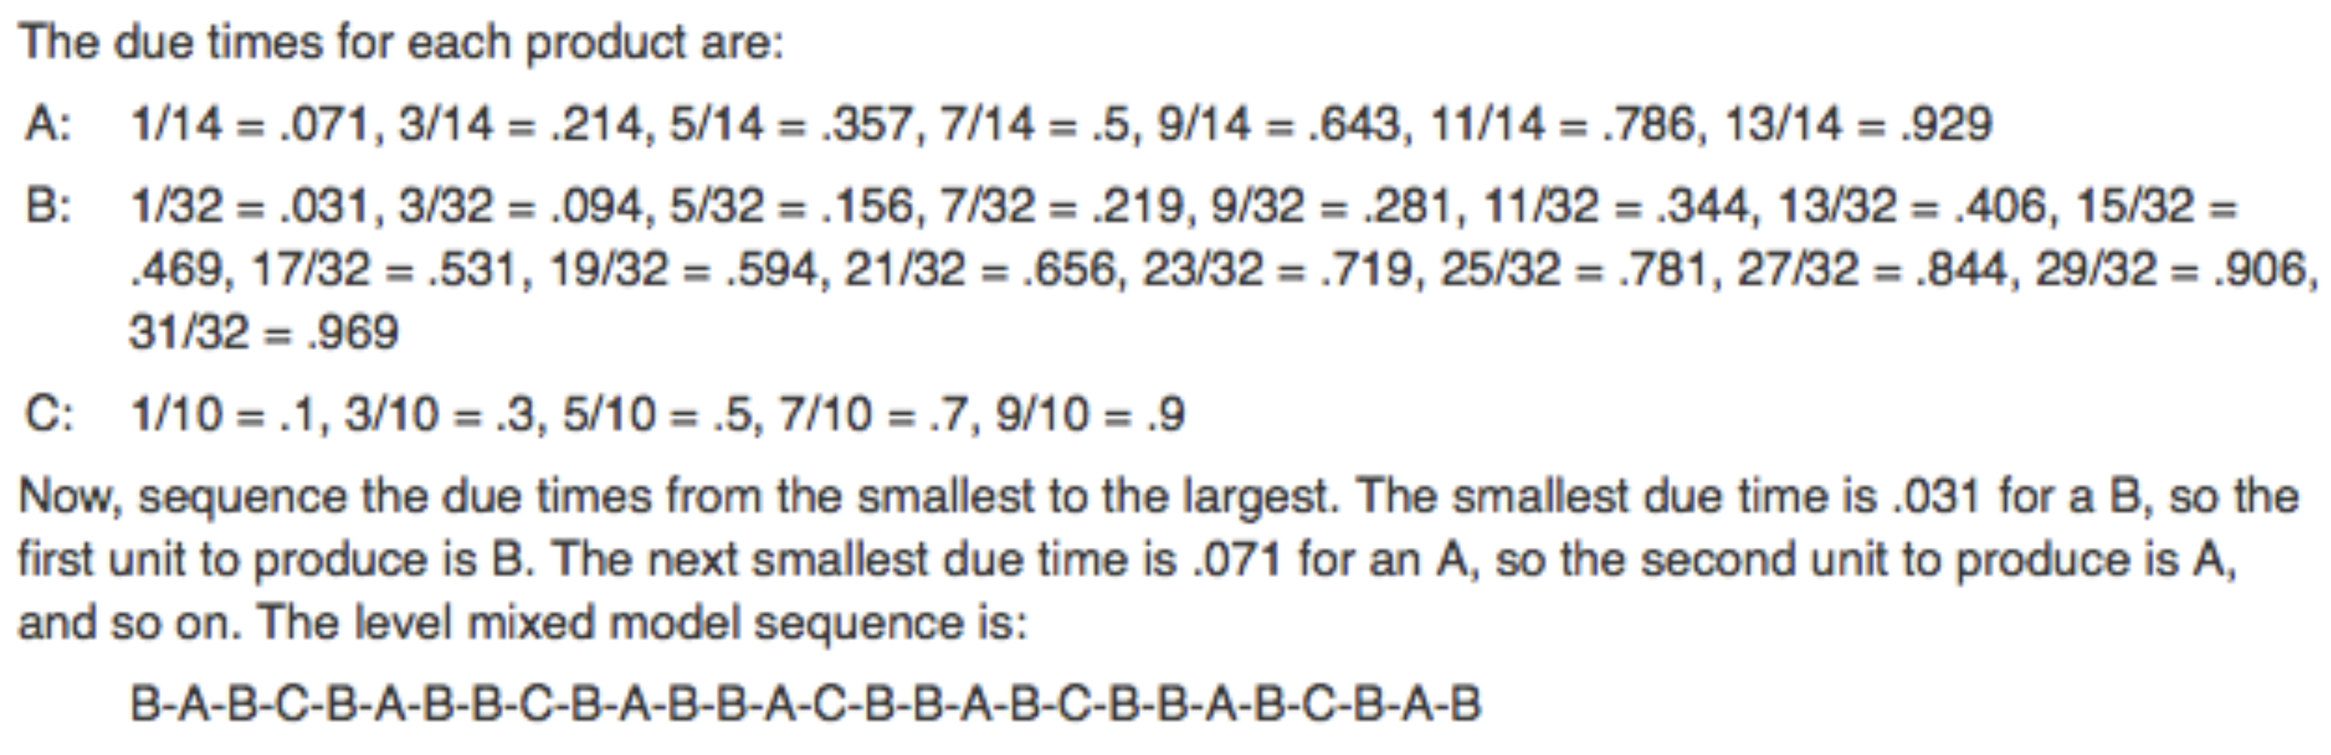

**Pull System and Kanban:**

Kanban System of Pulling Product through the Plant:

* Process works in reverse whereby consumer demand pulls finished product off the end of the line.
* As a result, each workstation pulls work from the work centre that immediately precedes it and so on down the line.
* Objective is to move batches or units of good through the system just as they are needed to minimize work in progress.

Kanban Calculation:

* Periodic adjustments to the number of Kanbans (replenishment order cards) can be made to either shrink or expand buffer inventory levels.
* Calculation of the actual number of Kanbans required in the first place is as follows:
* Where:
  + total number of kanbans (1 kanban per container).
  + average usage rate.
  + lead time for replenishment of one container.
  + safety stock demand as a proportion of average usage during lead time for the replenishment of one container.
  + capacity of a standard container.

Sample Kanban Calculation:

Usage at a work centre is 300 units of a specific part per day, and a standard container holds 25 units. It takes an average of 0.12 days from the time a *kanban* card is posted until the full container is received by the using work centre. Calculate the number of *kanban cards* needed for this part between these two work centres, if .

?, 300 units per day, 0.12 days, 25 units per container, 0.20

round to containers.

## Project Management

### Definition of a Project, Nature of a Project Manager’s Job

* **Projects:** Unique one-time operations, specific set of objectives, limited time frame.
* **Examples:** Building construction, research project, product development, event.
* **Performance Goals:** Time/schedule, cost/budget, performance/quality guidelines.
* **Nature:** Project initiator/sponsor creates project scope, team of people with diverse knowledge and skills contribute as needed, influenced by strategy/culture, output.

### Project Planning

* Project Planning: Analyzing the project into work packages and activities, estimating.
* Quality Planning: How project and product quality is to be assured and controlled.
* Communications Planning: Determining nature of information needed by stakeholders.
* Purchase Planning: What to purchase, specs, supplier evaluation and selection.

### Project Scheduling

Project Management Tools: Work Breakdown Structure (WBS), Gantt chart, CPM/PERT, Software (e.g., Microsoft Project).

### PERT/CPM Technique and Deterministic Activity Durations

**PERT and CPM:**

* PERT (program evaluation and review technique) and CPM (critical path method).
* Techniques used to schedule and control large projects.

**Precedence Network:**

* Critical Path: Longest path from start to end, determines expected project durations.
* Critical Activities: Activities on the critical path.
* Path Slack Time:
  + Allowable slippage for a path.
  + .

**Example: Precedence Network:**

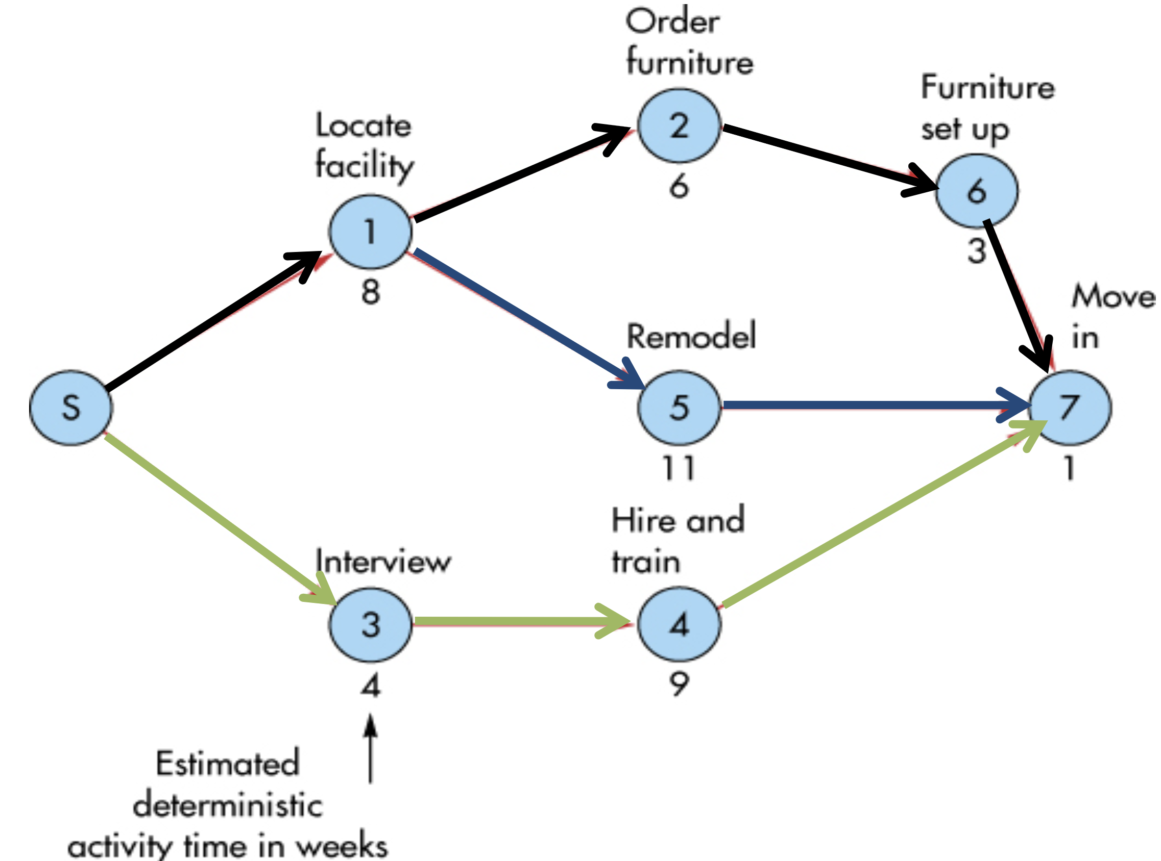

|  |  |  |
| --- | --- | --- |
| **Path** | **Length (weeks)** | **Path Slack (weeks)** |
|  |  |  |
|  |  |  |
|  |  |  |

**Deterministic Activity Durations:**

* Deterministic: Time estimates that are fairly certain.
* Probabilistic: Time estimates that allow for variation.

**Solution Technique:**

* Network activities:
  + : **earliest** time the activity can **start**
  + : **earliest** time the activity can **finish**
  + : **latest** time the activity can **start**
  + : **latest** time the activity can **finish**
* Used to determine expected project duration, activity slack times, critical path.

**PERT/CPM Solution Technique:**

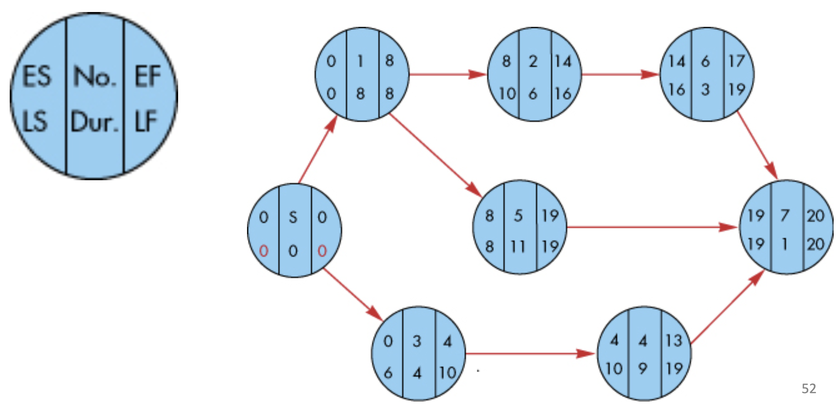

**Forward Pass: Earliest Start and Finish**

* Start at the left side of the precedence network (start node) and work towards right side.
  + For the start activity: .
* If an activity has a *unique* immediately preceding activity:
  + of the immediately preceding activity.
* If an activity has *multiple* immediately preceding activities:
  + largest of immediate predecessors.
* For each activity:
  + activity duration.

**Backward Pass: Latest Start and Finish**

* Start at the right side of the precedence network (end node) and work toward the left side.
  + For the end activity: .
* If an activity has a *unique* immediate follower:
  + of the immediate follower.
* If an activity has *multiple* immediate followers:
  + smallest of immediate followers.
* For each activity:
  + activity duration.

**Slack and the Critical Path:**

* Slack can be computed one of two ways:
  + Slack .
  + Slack .
* Critical path:
  + The critical path is indicated by the activities with zero slack.

**Using Slack Times:**

* Helps planning of allocation of scarce resources.
* Slack is **SHARED**.